**Ambulance Victoria emergency use red blood cell (RBC) access from a transfusion laboratory/health service flowchart**

Adult Retrieval Victoria Clinical Coordinator contacts nearest transfusion laboratory/health service for provision of emergency use RBC.

Adult Retrieval Victoria confirms with transfusion laboratory/health service:

* Number of units to be prepared, either

**2 units RBC**

Packed into 1x Lifeblood R3 shipper (or validated equivalent) [Appendix 1];

**OR**

**4 units RBC**

Packed into 2 Lifeblood shippers, each with 2x units into 2x Lifeblood R3 shipper (or validated equivalent) [Appendix 1: R3 Lifeblood shipping configuration]

* Pickup location (e.g. at the pathology laboratory, Urgent Care Centre, Emergency Department)
* Pickup time
* Ambulance Victoria contact name and number

Pack required blood components into Lifeblood R3 shipper (or validated equivalent) and ensure following details completed on transport label [Appendix 2: Emergency use blood component transport label];

* Ambulance Victoria contact name (if known)
* Patient name/sex or age (if known) and Ambulance Victoria case number (if known)
* Time and date packed
* Initials of person packing the blood
* Time blood must be returned to blood fridge
* Transfusion laboratory/health service sending the blood
* Contact name and number of transfusion laboratory.

Use local laboratory policy for issuing emergency use RBC

Include compatibility report if supplied (as per local policy)

Ambulance Victoria collect the packed emergency use RBC from agreed location at agreed time

Ambulance Victoria notify transfusion laboratory/health service of fate of emergency use RBC:

1. Transfused - will give patient details
2. Discarded at scene
3. Transferred to another facility with patient – will give patient & destination health service details
4. Returned to original health service

Transfusion laboratory or health service to contact Ambulance Victoria if further information required: [patientreview@ambulance.vic.gov.au](mailto:patientreview@ambulance.vic.gov.au)

If no transfusion laboratory on site, health service staff packing RBC must inform transfusion laboratory that emergency use RBC have been packed for Ambulance Victoria pickup.

Transfusion laboratory to arrange replacement emergency use RBC be sent to health service.

**Contact your transfusion laboratory if you require further information**

**Health service receiving unused blood components**

**Do not open the shipper**

* Contact your transfusion laboratory who will advise next steps

**Contact your transfusion service if you require further information**

**Transfusion laboratory receiving unused blood components**

* Are emergency use RBC packed appropriately?
* Has cold-chain been maintained?
* Decide if units are to be retained, or discarded

|  |  |
| --- | --- |
| Yes | * Contact transfusion laboratory/health service who sent the RBC * Ask for copy of fridge records * Arrange BloodNet transfer |
| No | * Contact transfusion laboratory/health service who sent the RBC and inform them of fate of units * Discard in BloodNet as per appropriate discard code, for example;   + “Transport – Incorrect packing”, or   + “Storage – Temperature control unknown”, or   + “Storage – Out of controlled storage for …” * Contact Ambulance Victoria [patientreview@ambulance.vic.gov.au](mailto:patientreview@ambulance.vic.gov.au) inform them of fate of units. Ambuance Victoria to investigate process fault if required. |

|  |  |
| --- | --- |
| **Abbreviation** | **Definition** |
| AV | Ambulance Victoria |
| ARV CC | Adult Retrieval Unit Clinical Coordinator |
| HEMS | Helicopter Emergency Medical Services |
| MICA | Mobile Intensive Care Ambulance |

**Appendix 1: R3 Lifeblood shipping configuration**

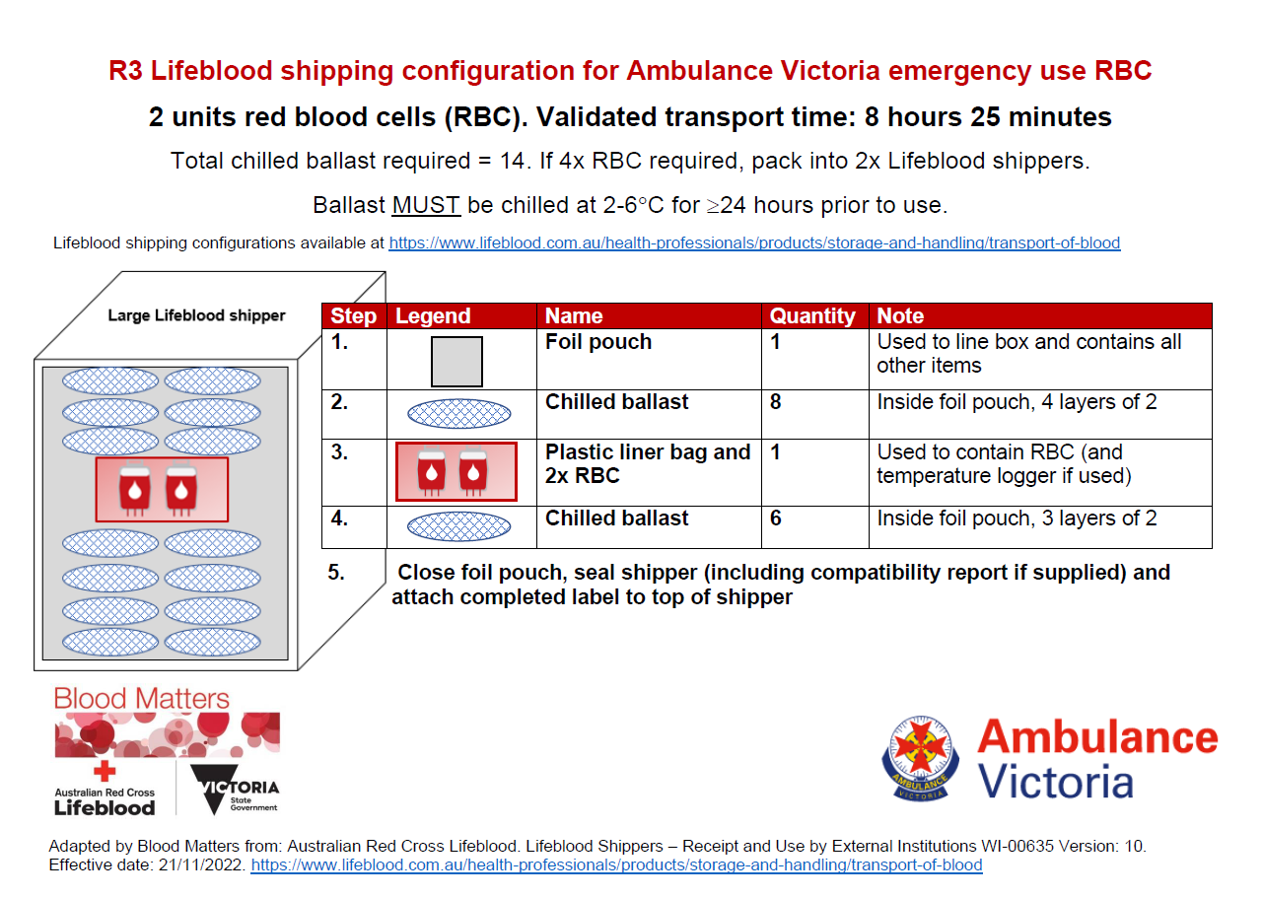

**Appendix 2: Emergency use blood component transport label**

Shipper label to be used when packing RBC for Ambulance Victoria's use. 
Including cold-chain requirements and instructions for staff.