

|  |
| --- |
| Household pesticides |
| Community factsheet  Updated December 2024 |

Sometimes you might have pest problems that require the use of a household pesticide. Using chemicals to treat the problem may create a risk to health. Therefore, you should ensure that you take certain precautions when handling these products.

## What are pesticides?

Pesticides are substances used to manage pests and

include insecticides used for insect control, herbicides

used for weed control, and rodenticides used for rodent

control. Pesticides may contain a mixture of chemicals

but it is the ‘active constituent’ which targets the pest.  
Although pesticides may be easily obtained from supermarkets and hardware stores, they are toxic and if used carelessly they may damage the health of the person applying the pesticide, the health of other people in the community and the environment.

## Pest identification

Pesticides are designed to target different

pests and are often ineffective on other species. Therefore it is important to correctly

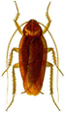

identify the pest causing the problem in your home

so the most appropriate treatment method can

be selected.

If you are having trouble identifying the pest, Museums

Victoria offers an identification service. You can submit an online enquire form via <https://museumsvictoria.com.au/>.

An alternative is to employ a licensed pest control operator trained in the identification and management of pests. For more information about pest control licensing contact the Pest Control Program via email – pesticidesafety@health.vic.gov.au

## Non-chemical pest prevention and control

The best way to control pests is to prevent them from

becoming a problem. Preventative non-chemical

measures are recommended before resorting to the use of pesticides. Avoiding pesticide use reduces the risk of experiencing adverse health effects.

Non-chemical pest prevention and control

measures include:

• keeping the house clean and free of potential sources

of food, water and shelter

• installing screens in doors and windows and sealing

any gaps

• ventilating areas to prevent moisture build up and

fixing any leaks in plumbing

• ensuring that litter does not accumulate around

your home

• keeping tree branches and shrubbery well-trimmed

and clearing gutters regularly

• storing firewood away from the house and off

the ground

• bathing pets regularly and ensuring that their living

environment is clean and tidy

• using manual pest control methods such as fly

swatters and traps.

## Health concerns

Some pests may carry diseases (for example

cockroaches) or cause damage to our homes

(for example termites) while others may just be

irritating or unpleasant (for example daddy long-legs spiders).

If the non-chemical measures fail to control the pest

problem the use of a pesticide may be necessary.

## Applying pesticide safely

Pesticides can take the form of a solid, liquid or

powder. The form will influence the way in which the

pesticide can enter the body through swallowing,

inhaling, or contact with the skin or eyes. The individual

applying the pesticide is at the greatest risk of

exposure and should take precautions when using

pesticide. These include:

• selecting the right type of pesticide for the

pest problem

• reading the label thoroughly before application

and following all label directions including the

safety information

• using the appropriate personal protective equipment as

specified on the label. This may include gloves, boots,

overalls, eye protection, face shield or a respirator.

• ensuring all people and pets leave the area

being treated

• ensuring food, clothes, toys, toothbrushes, bedding,

towels, vegetable gardens, barbeques, pet bowls, fish

ponds, clotheslines and cooking utensils are covered

or removed from the area to be treated

• closing doors and windows before applying

pesticide outdoors

• not spraying outdoors on windy or rainy days as this

may cause harm to other people or the environment

• ensuring adequate ventilation if applying a pesticide

in a confined space

• placing baits only where they cannot be accessed by

children, pets or wildlife

• not eating, drinking or smoking while working

with pesticides

• keeping emergency numbers, such as that for the

poisons information centre (13 11 26) nearby

• if the pesticide has been applied indoors, ensure that

benchtops and kitchen utensils are thoroughly

cleaned prior to food preparation

• washing hands immediately after using pesticides.

## Safe disposal and storage of pesticides

Dispose of empty pesticide containers according to

the directions on the label. When purchasing

pesticides it is important to obtain only the amount

required for immediate use. Never dispose of unused

pesticide down the drain or on the ground. If a spill

occurs it should be cleaned up promptly by covering

it with sand or kitty litter before sweeping it up and

storing it in a sealed, rigid container for appropriate

disposal. For more information regarding disposal of

unused pesticides contact your local council or the

Environment Protection Authority on 1300 372 842.

If necessary, pesticides should be stored according to the instructions on the label. The containers should be closed tightly and placed out of reach of children and pets. They should be stored away from food and medical supplies, in a well-ventilated area and out of direct sunlight.

Flammable liquids should be stored away from

ignition sources. Pesticides should not be transferred

to different containers unless the original container is

damaged. The new container should be clearly

labelled. Never reuse empty pesticide containers.

## Understanding a pesticide label

All pesticide labels contain valuable information. It is important to read and understand this information particularly

instructions relating to application and safety. Following the instructions on the label will ensure that the treatment is effective against your pest problem and minimise the risk of adverse health effects resulting from exposure.

Here is an example of a pesticide label:

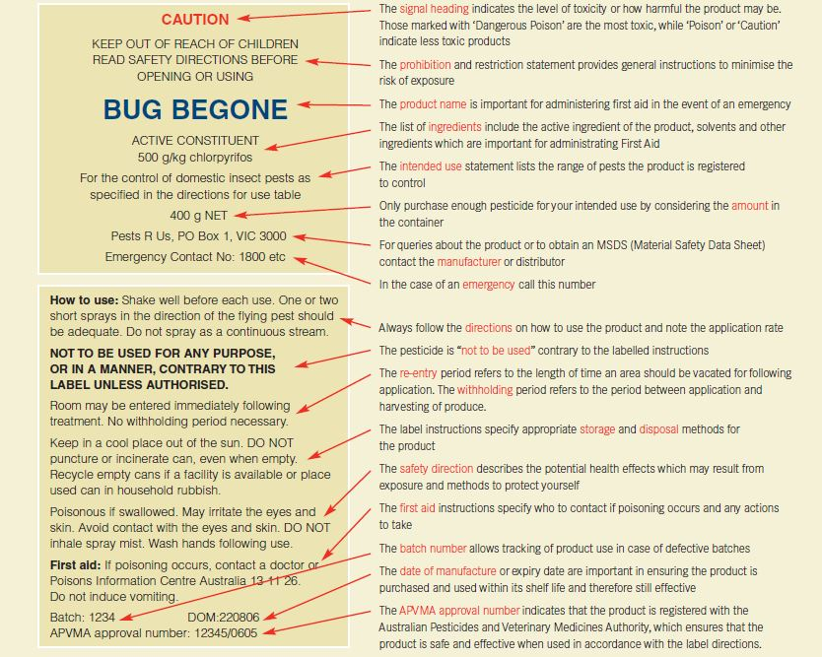

|  |
| --- |
| *To receive this publication in an accessible format email pesticidesafety@health.vic.gov.au*  Authorised and published by the Victorian Government, 1 Treasury Place, Melbourne.  © State of Victoria, Department of Health December, 2024  Available at <https://www2.health.vic.gov.au/public-health/environmental-health/pesticide-use-and-pest-control> |