

|  |
| --- |
| Specifications for revisions to the Agency Information Management System (AIMS) for 2025-26 |
| December 2024 |
|  |

|  |
| --- |
| To receive this document in another format, [email HDSS help desk](mailto:HDSS.Helpdesk@health.vic.gov.au) <HDSS.helpdesk@health.vic.gov.au>.  Authorised and published by the Victorian Government, 1 Treasury Place, Melbourne.  © State of Victoria, Australia, Department of Health, December 2024.  Available at [HDSS annual changes](https://www.health.vic.gov.au/data-reporting/annual-changes) < https://www.health.vic.gov.au/data-reporting/annual-changes> |
|  |

Contents

Executive Summary 4

Introduction 4

Orientation to this document 5

Outcome of proposal 5

Proposal for revisions across multiple data collections [which impact AIMS data collections] for 2025-26: 5

Amend the AIMS Urgent Care Centre data collection 6

AIMS Urgent Care Centre data collection 6

Cease reporting of aggregate non-admitted data collections for periods for which patient-level data reporting has been completed through the VINAH MDS / NADC – applicable for campuses of health services in scope for ABF 13

# Executive Summary

The revisions for the Agency Information Management System (AIMS) for 2025-26 are summarised below:

* **Change to reporting of Patient payment status on the AIMS Urgent Care Centre data collection**:
  + Amend AIMS Urgent Care Centre webform to report more detailed Funding source

In addition to this change to this existing AIMS data collection, health services in scope for activity-based funding (ABF) in the non-admitted stream have been advised that from 2025-26, aggregate non-admitted data submitted via AIMS will not be used for calculating health service activity against NWAU target (Policy and Funding Guidelines 2024-25, Section 10).

From 1 July 2025, health services submitting patient level non-admitted data to the Victorian Non-Admitted Health Minimum Data Set (VINAH MDS) or the Non-admitted Data Collection (NADC) will not be required to complete the AIMS S10, S11, S11A and/or S12 if they have submitted patient level data for the reporting month.

AIMS S10, S11, S11A and S12 will remain assigned to health service campuses currently reporting them, so they can be used to report aggregate data for any calendar month during which patient level data has not been completed for any of those data collection cohorts.

# Introduction

Each year the Department of Health reviews the Agency Information Management System (AIMS) to ensure that these data collections support the department’s business objectives, including national reporting obligations, and reflect changes in hospital funding and service provision arrangements for the coming financial year.

The revisions set out in this document are complete as at the date of publication. Where further changes are required during the year, for example to data validation rules or supporting documentation, these will be advised via the HDSS Bulletin.

An updated AIMS manual will be published in due course. Until then, the current AIMS manual and subsequent HDSS Bulletins, together with this document, form the data submission specifications for 2025-26.

**Victorian health services must ensure their systems allow capture and reporting of all data collections for their health service, and each campus, in accordance with the revised specifications, and ensure reporting capability is achieved to maintain compliance with reporting timeframes set out in the relevant Department of Health policy and funding guidelines or the *Health Services (Health Service Establishments) Regulations 2024.***

## Orientation to this document

* New data elements are marked as (new).
* Changes to existing data elements are highlighted in green
* Redundant values and definitions relating to existing elements are ~~struck through~~.
* Comments relating only to the proposal document appear in *[square brackets and italics].*
* Validations to be changed are marked * when listed as part of a data element or below a validation table.
* Changes are shown under the appropriate manual section headings: the impact of the change is highlighted rather than reproducing the entire entry for the data collection from Section 3 of the AIMS manual.

# Outcome of proposal

## Proposal for revisions across multiple data collections [which impact AIMS data collections] for 2025-26:

**Proposal 1 New data items – Funding source for hospital patient *[AIMS and VEMD]***

The proposal is approved to proceed to implementation.

# Amend the AIMS Urgent Care Centre data collection

The AIMS Urgent Care Centre data collection will be amended to include new data fields (columns) to capture greater detail regarding the funding source for patients attending urgent care centres (UCCs). This additional detail is required for reporting to the Independent Hospital and Aged Care Pricing Authority (IHACPA), and is based on the AIHW MeTEOR code set for Episode of care – source of funding, patient funding source code ([METEOR 780491](https://meteor.aihw.gov.au/content/780491) < https://meteor.aihw.gov.au/content/780491>).

This change is applicable to all campuses reporting to the AIMS Urgent Care Centre data collection, as listed in the [2024-25 AIMS manual](https://www.health.vic.gov.au/data-reporting/agency-information-management-system-aims) < https://www.health.vic.gov.au/data-reporting/agency-information-management-system-aims>.

The following excerpts highlight only the segments of the 2024-25 AIMS manual entry for the AIMS Urgent Care Centre data collection that will be amended due to implementation of this change. Other details relating to the AIMS Urgent Care Centre data collection will remain as published in the 2024-25 AIMS Manual.

## AIMS Urgent Care Centre data collection

### Reporting guidelines

The AIMS Urgent Care Centre data collection reports aggregate data on number of presentations, by visit type, triage category and departure status, for selected payment categories, at urgent care centres (UCCs) at selected campuses. This collection ~~provides more details on the models of care and demand for UCC services than the monthly aggregate service event data reported in the S10 Non-admitted Clinic Activity form, and~~ supports transition to funding emergency care using Urgency Disposition Group (UDG) as part of the National Health Reform.

Health services listed in Table 1 are required to submit this collection for each listed campus.

Table 1: List of health service campuses reporting to the Urgent Care Centre data collection

| Health Service | Campus |
| --- | --- |
| Alexandra District Health | Alexandra District Health |
| Alpine Health | Alpine Health [Bright] |
| Alpine Health | Alpine Health [Mount Beauty] |
| Alpine Health | Alpine Health [Myrtleford] |
| Barwon Health | Barwon Health North |
| Bass Coast Health | Phillip Island Health Hub |
| Beaufort & Skipton Health Service | Beaufort & Skipton Health Service [Beaufort] |
| Beaufort & Skipton Health Service | Beaufort & Skipton Health Service [Skipton] |
| Beechworth Health Service | Beechworth Health Service |
| Benalla Health | Benalla and District Memorial Hospital |
| Boort District Health | Boort District Health |
| Casterton Memorial Hospital | Casterton Memorial Hospital |
| ~~Central Gippsland Health~~ | ~~Central Gippsland Health [Maffra]~~ |
| Central Highlands Rural Health | Central Highlands Rural Health [Creswick] |
| Central Highlands Rural Health | Central Highlands Rural Health [Daylesford] |
| Central Highlands Rural Health | Central Highlands Rural Health [Kyneton] |
| Cohuna District Hospital | Cohuna District Hospital |
| Colac Area Health | Colac Area Health |
| Corryong Health | Corryong Health |
| Dhelkaya Health | Dhelkaya Health [Castlemaine] |
| ~~Dhelkaya Health~~ | ~~Dhelkaya Health [Maldon]~~ |
| East Grampians Health Service | East Grampians Health Service [Ararat] |
| East Wimmera Health Service | East Wimmera Health Service [Birchip] |
| East Wimmera Health Service | East Wimmera Health Service [Charlton] |
| East Wimmera Health Service | East Wimmera Health Service [Donald] |
| East Wimmera Health Service | East Wimmera Health Service [St Arnaud] |
| East Wimmera Health Service | East Wimmera Health Service [Wycheproof] |
| Gippsland Southern Health Service | Gippsland Southern Health Service [Korumburra] |
| Gippsland Southern Health Service | Gippsland Southern Health Service [Leongatha] |
| Grampians Health | Grampians Health [Edenhope] |
| Grampians Health | Grampians Health [Dimboola] |
| Grampians Health | Grampians Health [Stawell] |
| Great Ocean Road Health | Great Ocean Road Health [Apollo Bay] |
| Great Ocean Road Health | Great Ocean Road Health [Lorne] |
| Heathcote Health | Heathcote Health |
| Hesse Rural Health | Hesse Rural Health [Winchelsea] |
| Heywood Rural Health | Heywood Rural Health |
| Inglewood & Districts Health Service | Inglewood & Districts Health Service |
| Kerang District Health | Kerang District Health |
| ~~Kooweerup Regional Health Service~~ | ~~Kooweerup Regional Health Service~~ |
| Kyabram and District Health Service | Kyabram and District Health Service |
| Mallee Track Health and Community Service | Mallee Track Health and Community Service [Ouyen] |
| Mallee Track Health and Community Service | Mallee Track Health and Community Service [Sea Lake] |
| Mansfield District Hospital | Mansfield District Hospital |
| Maryborough District Health Service | Maryborough District Health Service [Maryborough] |
| Moyne Health Services | Moyne Health Services [Port Fairy] |
| NCN Health | NCN Health [Cobram] |
| NCN Health | NCN Health [Nathalia] |
| NCN Health | NCN Health [Numurkah] |
| Northern Health | Northern Health [Kilmore] |
| Omeo District Health | Omeo District Health |
| Orbost Regional Health | Orbost Regional Health |
| Portland District Health | Portland District Health |
| Robinvale District Health Services | Robinvale District Health Services [Manangatang] |
| Robinvale District Health Services | Robinvale District Health Services [Robinvale] |
| Rochester & Elmore District Health Service | Rochester & Elmore District Health Service [Rochester] |
| Rural Northwest Health | Rural Northwest Health [Hopetoun] |
| Rural Northwest Health | Rural Northwest Health [Warracknabeal] |
| Seymour Health | Seymour District Memorial Hospital |
| South Gippsland Hospital | South Gippsland Hospital [Foster] |
| South West Healthcare | South West Healthcare [Camperdown] |
| Tallangatta Health Service | Tallangatta Health Service |
| ~~Terang & Mortlake Health Service~~ | ~~Terang & Mortlake Health Service [Terang]~~ |
| Timboon & District Healthcare Service | Timboon & District Healthcare Service |
| West Wimmera Health Service | West Wimmera Health Service [Jeparit] |
| West Wimmera Health Service | West Wimmera Health Service [Kaniva] |
| West Wimmera Health Service | West Wimmera Health Service [Nhill] |
| West Wimmera Health Service | West Wimmera Health Service [Rainbow] |
| West Wimmera Health Service | West Wimmera Health Service [Rupanyup] |
| ~~Western District Health Service~~ | ~~Western District Health Service [Coleraine]~~ |
| Western Health | Western Health [Bacchus Marsh] |
| Western Health | Western Health [Melton] |
| Yarram & District Health Service | Yarram & District Health Service |
| Yarrawonga Health | Yarrawonga Health |
| Yea & District Memorial Hospital | Yea & District Memorial Hospital |

### Data Definitions

The following data items and definitions are applicable to the Urgent Care Centre data collection.

### ~~Patient payment status~~ Funding source

The funding source for each patient~~Patient payment status of the~~ UCC presentation.

Not all funding sources listed may be applicable to all health care settings. The most appropriate source of funding should be assigned based on a best estimate of where the majority of funds come from.

If there is an expected funding source followed by a finalised actual funding source (for example, in relation to compensation claims), then the actual funding source known at the end of the reporting period should be recorded.

The expected funding source should be reported if the fee has not been paid but is not to be waived.

|  |  |
| --- | --- |
| MBS ~~presentation~~ | Medicare Benefits Schedule: Medicare eligible patients in scope for collection for whom services are billed to Medicare. Includes both bulk-billed patients and patients with out-of-pocket expenses. The clinician bills Medicare for the patient’s treatment. This is not applicable for admitted patients. |
| Public | Health service budget (not covered elsewhere): patients who are ~~Eligible for~~ Medicare eligible for whom there is no other funding arrangement. These are patients for whom ~~where~~ the hospital provides care by means of its own staff, or by other agreed arrangements, without charge to the patient.  Public patients are further categorised by the profile of UCC staff the patient was seen by:  **Nurse only**   * Public patient seen by a nurse only.   **Doctor with or without a nurse**   * Public patient seen by a nurse and doctor. |
| DVA | Eligible Department of Veterans’ Affairs veterans and war widow(er)s whose charges are met by the Department of Veterans’ Affairs. |
| Worker’s Comp | Worker’s compensation claim |
| TAC | Motor vehicle third party personal claim |
| Other Compensable~~/Other~~ | Entitled to claim damages under ~~Motor Vehicle Third Party insurance or worker’s compensation,~~ (eg public liability, criminal injury and common law cases, and medical negligence) ~~members of the Defence Forces and~~ seamen, ~~and patients who are not eligible under Medicare and not exempt from fees.~~ |
| Defence | Department of Defence |
| Corrections | Correctional facility |
| S19(2) Exemptions | Eligible for Medicare where the hospital provides care by its own eligible staff under the Section 19(2) Exemptions Initiative – Improving Access to Primary Care in Rural and Remote Areas. Information about Section 19(2) Exemption can be found [here](https://www.health.vic.gov.au/improving-access-to-primary-care-in-rural-and-remote-areas) < https://www.health.vic.gov.au/improving-access-to-primary-care-in-rural-and-remote-areas> |
| RHCA  (Reciprocal Health Care Agreement) | Health service budget (due to eligibility for Reciprocal Health Care Agreement (RHCA)): patients who are overseas visitors from countries covered by RHCAs.  Australia has RHCAs with the United Kingdom, the Netherlands, Italy, Malta, Sweden, Finland, Norway, Belgium, Slovenia, New Zealand and Ireland. The RHCAs provide for free accommodation and treatment as a public patient in public hospital services, but do not cover treatment as a private patient in any kind of hospital.  The RHCAs with Finland, Italy, Malta, the Netherlands, Norway, Sweden, Belgium, Slovenia and the United Kingdom provide free care as a public patient in public hospitals, subsidised out-of-pocket medical treatment under Medicare, and subsidised medicines under the Pharmaceutical Benefits Scheme.  The RHCAs with New Zealand and Ireland provide free care as a public patient in public hospitals and subsidised medicines under the Pharmaceutical Benefits Scheme, but do not cover out-of-hospital medical treatment.  Visitors from Italy and Malta are covered for a period of six months from the date of arrival in Australia only.  Visitors from Belgium, the Netherlands and Slovenia require their European Health Insurance card to enrol in Medicare. They are eligible for treatment in public hospitals until the expiry date indicated on the card, or to the length of their authorised stay in Australia if earlier.  Excludes: overseas visitors who elect to be treated as private patients or under travel insurance. |
| Self-funded | Funded by the patient, the patient’s family or friends, or by other benefactors |
| Other | Other funding source: includes overseas visitors for whom travel insurance is the major funding source |
|  |  |

**~~Urgent Care Centre data collection sample form:~~**

**~~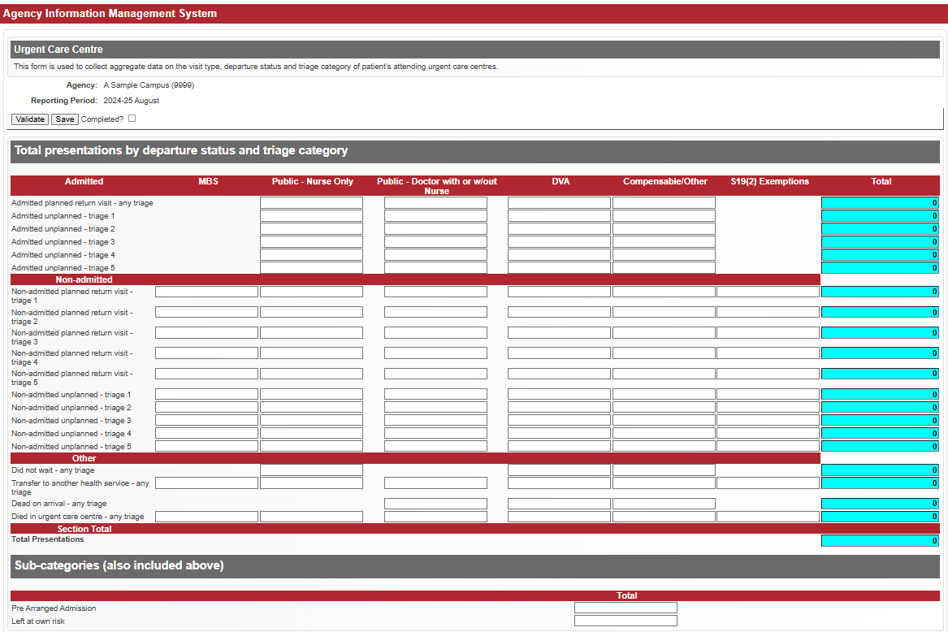~~**

**Urgent Care Centre data collection sample form new funding source fields (columns) highlighted in green:**

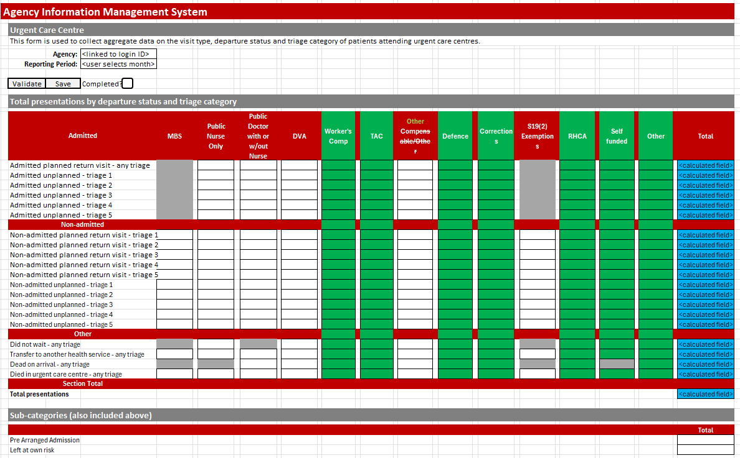

# Cease reporting of aggregate non-admitted data collections for periods for which patient-level data reporting has been completed through the VINAH MDS / NADC – applicable for campuses of health services in scope for ABF

Health services in scope for ABF in the non-admitted stream, and for which patient-level data for all non-admitted services for the reporting period has been submitted through the VINAH MDS or the NADC by the due date, can cease reporting aggregate non-admitted data using the following AIMS data collections:

* S10 Acute Non-Admitted Clinic Activity
* S11 Sub Acute Non-Admitted Activity
* S11A Sub Acute Non-Admitted Multidisciplinary case conferences (MDCC) when patient not present
* S12 Self-delivered Non-admitted Services

This change takes effect for activity from 1 July 2025.

These four AIMS data collections will remain assigned to all health service campuses currently reporting them, so that for any month when non-admitted patient-level data is not able to be reported completely or by the due date through the VINAH MDS or NADC, aggregate reporting must be completed by the due date published in the relevant AIMS manual.

Health services must continue to manage acute non-admitted clinic registrations using the Non Admitted Clinic Management System (NACMS).

Other health services (eg small rural health services and other block funded health services) must continue to report aggregate data on non-admitted activity using the AIMS S10, S11, S11A, S12 as well as the AIMS Urgent Care Centre data collections, in accordance with the AIMS manual and this Specifications document.

Questions about this can be directed to the [HDSS HelpDesk](mailto:hdss.helpdesk@health.vic.gov.au) <hdss.helpdesk@health.vic.gov.au>.