

|  |
| --- |
| Specifications for revisions to the Victorian Cost Data Collection (VCDC) for 2024-25 |
| December 2024 |
| OFFICIAL |

|  |
| --- |
| To receive this document in another format, [email HDSS help desk](mailto:HDSS.Helpdesk@health.vic.gov.au) <HDSS.helpdesk@health.vic.gov.au>.  Authorised and published by the Victorian Government, 1 Treasury Place, Melbourne.  © State of Victoria, Australia, Department of Health, December 2024.  Available at [HDSS annual changes](https://www.health.vic.gov.au/data-reporting/annual-changes) < https://www.health.vic.gov.au/data-reporting/annual-changes> |

Contents

Executive Summary 4

Introduction 4

Orientation to this document 4

Outcome of proposal 5

Specifications for changes from 1 July 2024 6

Reference Files 6

VCDC Data Definition Specification (DDS) 6

Specification – Episode Entity 6

Episode Entity data items (remove) 6

# Executive Summary

The revisions for the Victorian Cost Data Collection (VCDC) for 2024-25 are:

Remove the following fields

* Fund - Funding Source Type
* Optype - Contact Session Type
* Opmode - Contact Delivery Mode

# Introduction

Each year the Department of Health (the department) reviews the VCDC to ensure that the data collection supports the department’s business objectives, including national reporting obligations, and reflects changes in hospital funding and service provision arrangements for the coming financial year.

Comments provided by the health sector in response to Proposals for revisions to VCDC for 2024-25 and have been considered, and where possible, suggestions have been accommodated, resulting in changes to the proposal.

The revisions set out in this document are complete as at the date of publication. Where further changes are required during the year, for example data validation rules or supporting documentation, these will be advised via the HDSS Bulletin.

Updated VCDC documentation will be published in due course. Until then, the current VCDC documentation and subsequent HDSS Bulletins, together with this document, form the data submission specifications for 2024-25.

**Victorian health services must ensure their software can create a submission file in accordance with the revised specifications and ensure reporting capability is achieved to maintain compliance with reporting timeframes set out in the relevant Department of Health policy and funding guidelines.**

## Orientation to this document

* New data elements are marked as (new).
* Changes to existing data elements are highlighted in green
* Redundant values and definitions relating to existing elements are ~~struck through~~.
* Comments relating only to the proposal document appear in *[square brackets and italics].*
* New validations are marked ### if number has not yet been allocated
* Validations to be changed are marked * when listed as part of a data element or below a validation table.
* Changes are shown under the appropriate manual section headings.

# Outcome of proposal

The department considered one proposed change.

**Proposal 5 - Remove redundant fields from VCDC that are recorded in other collections**

Outcome: Proposal proceeds with modification. The agreed fields to be removed are:

* + Fund - Funding Source Type
  + Optype - Contact Session Type
  + Opmode - Contact Delivery Mode

# Specifications for changes from 1 July 2024

# Reference Files

## VCDC Data Definition Specification (DDS)

## Specification – Episode Entity

## Episode Entity data items (remove)

~~Fund - Funding Source Type,~~

~~Optype - Contact Session Type, and~~

~~Opmode - Contact Delivery Mode.~~

Fund – Funding Source Type

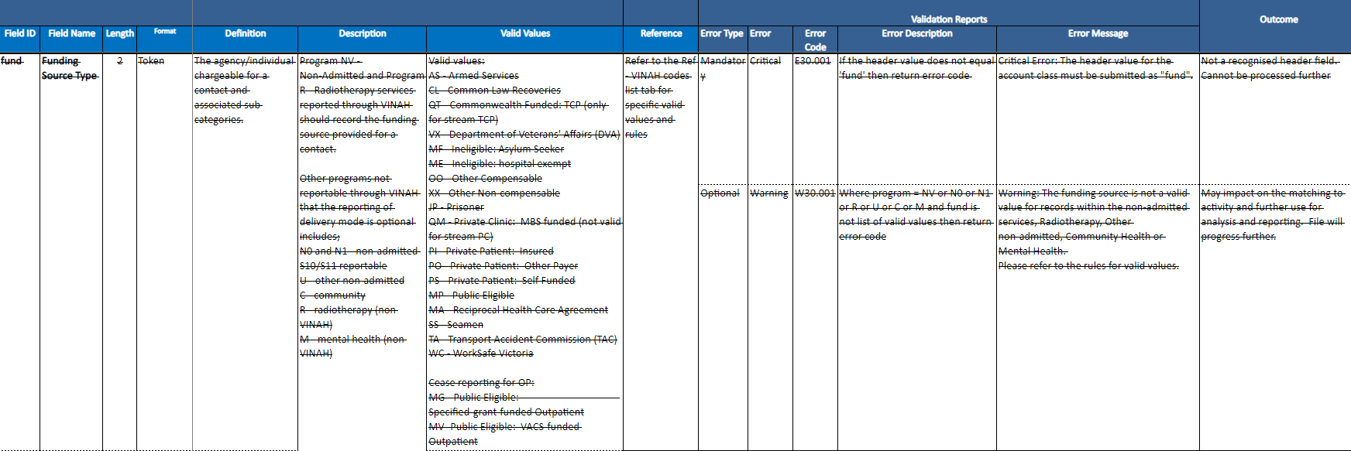

Optype - Contact Session Type

Opmode - Contact Delivery Mode

