

|  |
| --- |
| Secondary School Immunisation Program |
| Key messages for schools to distribute to parents/guardians in Term 1, 2025 |
|  |

# **What is the Secondary School Immunisation Program?**

The [National Immunisation Program](https://www.health.gov.au/topics/immunisation/when-to-get-vaccinated/national-immunisation-program-schedule?language=und) <https://www.health.gov.au/topics/immunisation/when-to-get-vaccinated/national-immunisation-program-schedule?language=und> aims to protect the community from vaccine preventable diseases. As part of the program, free vaccines are offered to Year 7 and Year 10 secondary school students.

The following vaccines are recommended:

**Year 7**

* Diphtheria, tetanus, and whooping cough (pertussis) vaccine
* Human papillomavirus (HPV) vaccine

**Year 10**

* Meningococcal ACWY vaccine

# Key messages for parents/guardians

* Parents/guardians of students in Year 7 and Year 10 should **look out for vaccine and consent information** coming home from school with your child or via newsletters.
* **Read** the vaccine information, **complete and return** the signedconsent information by [insert date].
* **Return** the consent information even if you don’t want your child to be vaccinated.
* Vaccines given as part of the Secondary School Immunisation Program are delivered at school by nurse immunisers from the local council immunisation service.
* For further information contact the local council immunisation service [insert details].
* To learn more about the Secondary School Immunisation Program in Victoria visit: [www.betterhealth.vic.gov.au/health/healthyliving/immunisation-in-secondary-schools](http://www.betterhealth.vic.gov.au/health/healthyliving/immunisation-in-secondary-schools)

Image for use in school communications Term 1, 2025

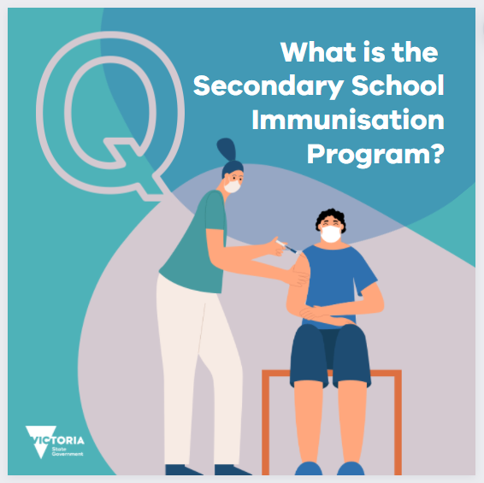

|  |
| --- |
| To receive this document in another format, email the Immunisation Program <immunisation@health.vic.gov.au>  Authorised and published by the Victorian Government, 1 Treasury Place, Melbourne. © State of Victoria, Australia, Department of Health, January 2025. |