## Standards for Safe and Timely Ambulance and Emergency Care for Victorians

Version 1 Updated: 10/02/2025

## Purpose and scope

The new Standards for Safe and Timely Ambulance and Emergency Care for Victorians (the Standards) seek to improve whole-of-hospital flow so that patients arriving via ambulance can be consistently transferred to the care of a hospital in a timely manner.

The Standards apply to **Ambulance Victoria** and **major publicly funded hospitals with an emergency department** (ED) in metropolitan Melbourne and regional Victoria.[1] Sub-regional public hospitals with an ED and urgent care centres are encouraged to adapt actions from the Standards for their local circumstances. Ambulance Victoria must also ensure that the **relevant standards** apply to **unplanned** **non-emergency patient transport services (NEPT)**.[2]

The Standards focus on actions that can be implemented across the system, including:

* **prior to transport**,so paramedics, Ambulance Victoria and NEPT staff are supporting patients to access the right care,
* **prior to the arrival of an ambulance**, with hospital staff well-prepared for ambulance arrivals,
* while **paramedics** and ambulance staff are **at hospital,** to most efficiently transfer patient care and undertake clearing,
* **in the ED** to support the progression of care,
* **beyond the ED** to create capacity for new admissions and balance demand pressures, and
* **across the organisation** to embed the Standards as a key priority.

This first version of the Standards reflects insights from paramedics, health service clinicians, operational staff and senior leaders, and industrial partners on good practice in supporting safe and timely ambulance and emergency care. The Standards will be reviewed and updated annually, to ensure they are having the intended impact, and are adaptable to any implementation challenges, or system changes. The first review will occur in mid-2025.

The Department of Health (the department) will work with hospitals and Ambulance Victoria from early 2025 to refine the approach to implementation and monitoring.

## Related documents:

* Appendix one: Key terms
* Appendix two: Case studies.

To guide implementation, the Standards should be considered in conjunction with supporting documents including:

* How-to guides:
  + Implementing internal agreements and standards (Standard 1)
  + Early senior decision making in ED (Standard 7)
  + Optimising ED short stay units (Standard 7)
  + Optimising the fast-track model in ED (Standard 7)
  + Optimising transit lounge use (Standard 9)
  + Afternoon discharge planning huddles (Standard 9)
  + Optimising ward rounding (Standard 9)

These can be accessed via the [landing page](https://www.health.vic.gov.au/patient-care/standards-for-safe-and-timely-ambulance-and-emergency-care-for-victorians) <<https://www.health.vic.gov.au/patient-care/standards-for-safe-and-timely-ambulance-and-emergency-care-for-victorians>>.

Further documents and tools to support local implementation will also be shared directly with in-scope health services.

## Guiding principles

|  |  |
| --- | --- |
| **1** | **QUALITY PATIENT CARE** | Supporting Victorians to access timely emergency care when and where they need it. |

|  |  |
| --- | --- |
| **2** | **SAFE AND SUPPORTED WORKFORCE** |Staff are supported to work in safe and calm environments and operate within and to their scope of practice. |

|  |  |
| --- | --- |
| **3** | **SHARED COMMITMENT** |A shared commitment across the system to improve the timely transfer of patient care and clearing times with clear roles and responsibilities for Ambulance Victoria, hospitals and the department. |

|  |  |
| --- | --- |
| **4** | **CLEAR EXPECTATIONS** |Transparent standards set the minimum expectations for Ambulance Victoria and hospitals to ensure consistency and accountability across the health system. |

|  |  |
| --- | --- |
| **5** | **EVIDENCE-BASED SOLUTIONS** |Proven solutions are implemented in a tailored way, reflective of local community needs and Ambulance Victoria’s and hospitals’ operating context. |

|  |  |
| --- | --- |
| **6** | **CONTINUOUS IMPROVEMENT** |A commitment to learning and improvement, where best practices are shared, and challenges are addressed collaboratively. |

|  |  |
| --- | --- |
| **7** | **BALANCED RISK** |Clinical resources, patient needs, and clinical risk are balanced and shared across the care continuum, minimising an unsafe concentration of risk at the ambulance-emergency department interface and in the community, as people wait for an ambulance response. |

## Summary: Standards for Safe and Timely Ambulance and Emergency Care for Victorians

|  |
| --- |
| **Accountabilities for Ambulance Victoria and hospitals** |
| **1. Leadership**: Timely patient transfer of care is an organisational priority demonstrated by accountabilities, a continuous improvement culture and system-wide collaboration (standard one) |

|  |
| --- |
| **Accountabilities for Ambulance Victoria** |
| ***Prior to transport*** |
| **2. Alternative care settings:** Alternatives to emergency department care are prioritised where clinically appropriate (standard two) |
| ***Prior to ambulance arrivals*** |
| **3. Efficient ambulance distribution**: Effective ambulance distribution ensures the efficient use of system resources (standard three) |
| ***While paramedics and ambulance staff are at hospital*** |
| **4. Enhanced patient transfer**: Routine patient cohorting and proactive management by senior infield staff helps enhance ambulance availability (standard four)  **5. Efficient clearing processes**: Patients are transferred to a clinically appropriate setting as soon as practicable (standard five) |

|  |
| --- |
| **Accountabilities for hospitals** |
| ***In the emergency department*** |
| **6. Timely transfer of care**: Patients are transferred to a clinically appropriate setting as soon as practicable (standard six)  **7. Early, definitive emergency care**: Early and definitive treatment for lower acuity patients supports effective emergency department flow (standard seven) |
| ***Beyond the emergency department, in inpatient wards*** |
| **8. Timely inpatient admissions**: Inpatient wards are accountable for the timely transfer of admitted patients from emergency departments (standard eight)  **9. Early discharges**: Timely and effective discharge practices are embedded to maximise the matching of capacity and demand (standard nine) |
| ***Across the organisation*** |
| **10. Effective operational management and escalation**: Escalation processes effectively address transfer of care delays by activating hospital-wide accountabilities for flow (standard 10) |

## Standard 1 | Leadership

**Ambulance Victoria and hospital accountabilities**

|  |
| --- |
| **Overview**:Timely ambulance patient transfer of care is an organisational priority supported by accountability, an improvement culture, and collaboration. Improvement in clearing times is a priority for Ambulance Victoria.  **Outcome**: Implementation of local improvements that respond to performance drivers, resulting in: decreased delays in patient transfers of care; and decreased delays in paramedic clearing times. |

**Key expectations**

|  |
| --- |
| **1.1 Active leadership and prioritisation** |
| * Timely transfers of patient care is a safety and quality priority for the organisation and is reinforced by leaders. * In addition, Ambulance Victoria prioritises and champions efficient clearance processes. |
| **1.2 Whole-of-organisation accountabilities** |
| The Standards are translated into local protocols to ensure that, across the organisation:   * roles, responsibilities, systems and processes are clear * accountabilities are measurable and track implementation of the Standards, including improvements and issues * escalation arrangements are in place where local protocols are not being followed. |
| **1.3 No ambulance patient transfers of care will take longer than two hours** |
| * Hospitals adopt a principle that ‘no patient will wait more than two hours’ to have their care transferred from an ambulance to a hospital. * This principle is a ‘never event’ and internal investigations occur when it is breached, or consistently nearly breached. |
| **1.4 No paramedic crew will take more than 40-minutes to clear a hospital** |
| * Ambulance Victoria adopts a principle that ‘no paramedic crew will take more than 40 minutes to clear a hospital’ after transfer of care has been completed. * This principle is a ‘never event’ and internal investigations occur when it is breached, or consistently nearly breached. |
| **1.5 Single source of truth for patient transfer performance and improvement** |
| * Ambulance Handover Complete times (reported in VEMD)[3] are used as the basis for all local performance discussions. * The department provides access to weekly health service VEMD data to ensure a single operating picture is available to Ambulance Victoria and hospitals. * An Ambulance Handover Complete time is agreed between the nurse and paramedic at the point of patient transfer and entered into the Victorian Ambulance Clinical Information System. |
| **1.6 Participation in system-wide learning and collaboration** |
| * Ambulance Victoria and hospitals participate in cross-sector collaboration events to identify shared challenges and spread evidence-based practice to improve timely patient transfers and reduce clearing times. |

**Monitoring**

|  |
| --- |
| Implementation of Standard 1 is measured by:   * Weekly mean and median transfer of care times. * Weekly mean and median clearing times. |

See Appendix 2 for a [case study](https://dhhsvicgovau.sharepoint.com/sites/AmbulanceEmergencyCareandAccess-GRP/Shared%20Documents/System-wide%20Reform/1.%20Key%20projects/11%20AV%20Improvement%20(AVTEC2%20and%20AV%20Handover)/1.%20AV%20Handover%20(Health%20Services)%20Aug%202024/3%20Policy%20development/Handover%20Standards/The#_Case_study:_) on leadership.

## Standard 2 | Alternative care settings

**Ambulance Victoria accountabilities**

|  |
| --- |
| **Overview**:Alternative pathways are always prioritised, where clinically safe, to connect patients to the right care and reduce avoidable emergency department demand.  **Outcome**: All patients transported by Ambulance Victoria to emergency departments have a clinical need that requires hospital-based care. |

**Key expectations**

|  |
| --- |
| **2.1 Safe non-conveyance and infield referral of patients not requiring in-person emergency department care** |
| * Patients that do not require transport to a hospital emergency department remain at home (or equivalent), including referrals to clinically appropriate alternatives. * Clinical Practice Guidelines (CPGs) guide paramedic decision-making to support non-conveyance and infield referral options, including up-to-date information on available alternative pathways and referral processes. * CPGs are reviewed annually to strengthen decision-making criteria about non-conveyance and infield referral of patients. |
| **2.2 Standardised approach to referring suitable patients to the Victorian Virtual Emergency Department (VVED)** |
| * Paramedics and other Ambulance Victoria clinicians, such as those working in the Secondary Triage Service, use the VVED for all clinically appropriate referrals. * CPGs or work instructions are reviewed annually to strengthen the VVED referral criteria to ensure maximum uptake. |
| **2.3 Standardised approach to using video-assisted technology by Ambulance Victoria Secondary Triage Services** |
| * Patients referred to Ambulance Victoria’s Secondary Triage Service are assessed via video-assisted technology where possible. * A standardised approach to using video-assisted technology is outlined in CPGs or work instructions and reviewed annually. * Over time, video-assisted technology is an established tool used to support triage by Secondary Triage clinicians. |

**Monitoring**

|  |
| --- |
| Implementation of Standard 2 is measured by:   * Percentage of triple zero cases where the caller receives advice or is referred to another health provider, as an alternative to an emergency ambulance response, by Secondary Triage clinicians. * Number of patients who call Triple Zero within 24 hours after non-conveyance. * Percentage of referrals to the VVED for conditions that are known to have high rates of diversion away from an in-person emergency department presentation after assessment by the VVED, from Ambulance Victoria’s Secondary Triage Service and infield Ambulance Victoria paramedics (respectively). * Percentage of ambulance cases treated on scene and not transported. * Percentage of assessments undertaken by Ambulance Victoria’s Secondary Triage Service via video-assisted technology. |

See Appendix 2 for a case study on alternative care settings.

## Standard 3 | Efficient ambulance distribution

**Ambulance Victoria accountabilities**

|  |
| --- |
| **Overview**:Ambulances are effectively and efficiently distributed across hospitals, supported by load levelling and demand data.  **Outcome**: Time-critical patients are delivered to the closest, most suitable hospital. All other patients are taken to a hospital that meets their needs, while system demand is balanced and avoidable interhospital patient transfers are reduced. |

**Key expectations**

|  |
| --- |
| **3.1 Improved ambulance distribution across the health system** |
| * Ambulance Victoria updates protocols to support and improve load levelling across hospitals. Updated protocols are developed in partnership with hospitals and the department and communicated to hospitals. * Ambulance Victoria uses the new performance and improvement data dashboard to inform decision-making, understand hospital capacity, and support load levelling. * Ambulance distribution also takes into consideration hospital capability to meet patient needs, as well as patient history, if relevant. For example, if the patient has or is being treated at a specific hospital. |
| **3.2 Patient transport aligns with hospital capability** |
| * Ambulance Victoria annually updates guidance for paramedics and ambulance staff on hospital capability (or when changes are made). * Regular reviews occur to identify interhospital patient transfers that could have been avoided. |
| **3.3 An enhanced Ambulance Arrivals Board** |
| * In partnership with hospitals, Ambulance Victoria improves the accuracy of the Ambulance Arrivals Board (AAB), including enhancing paramedic compliance for updating it. * The AAB informs planning, responses and escalations across the system.   The AAB is updated to include:   * pending cases in the community (i.e., people who are waiting for an ambulance) * clearing times (i.e., the time from patient transfer of care being completed to an ambulance being available for dispatch). |

**Monitoring**

|  |
| --- |
| Implementation of Standard 3 is measured by:   * Percentage of days where a hospital receives a high demand of ambulances (as defined by the hospital but not lower than eight ambulances) in any given hour. * Number of occurrences where eight or more ambulances arrive within 60 minutes |

See Appendix 2 for a case study on efficient ambulance distribution.

## Standard 4 | Enhanced patient transfer

**Ambulance Victoria accountabilities**

|  |
| --- |
| **Overview**:Paramedics consistently deploy patient cohorting as a temporary measure to address ambulance transfer delays and there is proactive management of ambulance arrivals at hospitals.  **Outcome**: Increased ambulance fleet availability to respond to emergencies in the community. |

**Key expectations**

|  |
| --- |
| **4.1 Routine patient cohorting** |
| Clinical Practice Guidelines are updated to support routine cohorting, where clinically appropriate, and ensure that:   * paramedics assess the patient’s clinical suitability to be cohorted, when the patient cannot be transitioned to the waiting room or other clinical space * patients are cohorted in an appropriate space * the most appropriate ambulance crew is prioritised for release * health services are aware of the guidance. |
| **4.2 Proactive at-hospital management and escalation** |
| * Senior infield Ambulance Victoria staff work with hospital staff and crews at hospitals, such as overseeing patient cohorting, during peak periods of demand. * Hospitals clarify a single-point-of-contact for paramedics and ambulance staff to engage with. * Ambulance Victoria documents a statewide escalation procedure for managing issues at the ambulance-emergency department interface. This sets out the pathway for escalating issues with frontline Ambulance Victoria managers first, and then to senior Ambulance Victoria operational leaders. * Escalation procedures are agreed and shared at the local level through existing Ambulance Victoria-hospital governance arrangements. * The escalation procedures outline the process to manage if a patient arriving via ambulance waits at hospital for more than two hours (standard 1.3). |

**Monitoring**

|  |
| --- |
| Implementation of Standard 4 is measured by:   * Mean clearing time. * Use of cohorting. * Average ambulance Victoria code 1 response times.[4] |

See Appendix 2 for a case study on enhanced patient transfer.

## Standard 5 | Efficient clearing processes

**Ambulance Victoria accountabilities**

|  |
| --- |
| **Overview**:Operational policies are strengthened to assist paramedics and ambulance staff to complete the clearance process as efficiently as possible.  **Outcome**: Increased ambulance fleet availability to respond to emergencies in the community. |

**Key expectations**

|  |
| --- |
| **5.1 Efficient clearing processes** |
| Ambulance Victoria strengthens its operational policies to support timely clearances, including:   * documented processes and roles and responsibilities * public improvement targets, and performance against these targets, to progress towards achieving an average statewide clearing time of 20 minutes * targeted initiatives to address root causes of delays, such as streamlining administrative processes, improving communication channels, and piloting digital tools for faster information sharing * monitoring and reporting of clearance times, with breakdowns by hospital and region * regular reviews of clearance performance, including engagement with ambulance staff and hospitals to identify issues and develop corrective actions for Ambulance Victoria. |

**Monitoring**

|  |
| --- |
| Implementation of Standard 5 is measured by:   * Mean clearing time. * Percentage of cases that meet clearing time improvement targets. * Average Ambulance Victoria code 1 response times.[5] |

See Appendix 2 for a case study on efficient clearing processes.

## Standard 6 | Timely transfer of care

**Hospital accountability**

|  |
| --- |
| **Overview**:Hospitals optimise alternative spaces beyond emergency department cubicles, including emergency department waiting rooms, Short Stay Units, and direct admission pathways.  **Outcome**: Patients are transferred to a clinically appropriate setting as soon as practicable. Additional temporary capacity in the emergency department manages risk across the system. |

**Key expectations**

|  |
| --- |
| **6.1 Dedicated oversight and coordination of ambulance arrivals** |
| * During peak periods of demand, hospitals appoint an additional senior nurse or equivalent to transfer patients from ambulances. * The role coordinates the triaging of ambulance arrivals; works with the emergency department nurse; and escalates for additional triaging support where possible. |
| **6.2 Agreed approach to transfer patients to clinically appropriate spaces other than an emergency department cubicle** |
| * Local protocols are in place to support the movement of patients to alternative emergency department areas, such as the waiting room, with appropriate senior staffing profiles. * Local arrangements are aligned with statewide policy and guidance <<https://www.health.vic.gov.au/patient-care/standards-for-safe-and-timely-ambulance-and-emergency-care-for-victorians>>. |
| **6.3 Direct admission pathways aligned to local demand profiles** |
| * Direct admission pathways for agreed and specified patient cohorts who require acute, but not emergency, care aligned with local demand profiles. * Paramedics and NEPT staff are enabled to identify patients suitable for direct admission. |
| **6.4 Surge spaces that provide flexible emergency department capacity** |
| * Additional spaces are temporarily activated during peak periods of demand to increase emergency department capacity and create additional space for people waiting for admission. Spaces are clinically appropriate and suitably staffed and may include Short Stay Units and underutilised areas of the emergency department. * Models are localised, to reflect available local infrastructure. * Processes for activating additional capacity for temporary use during peak periods, including identifying suitable patients and hospital-wide resources, are documented. |

**Monitoring**

|  |
| --- |
| Implementation of Standard 6 is measured by:   * Percentage of ambulance transfers of care occurring within 40 minutes. * Mean transfer time. |

See Appendix 2 for a case study on improving timely transfer of care.

## Standard 7 | Early, definitive emergency care

**Hospital accountability**

|  |
| --- |
| **Overview**:Emergency departments provide early clinical direction and optimise non-admitted models of care.  **Outcome**: Early and definitive treatment for lower acuity patients reduces emergency department length of stay for non-admitted patients and improves emergency department patient flow. |

**Key expectations**

|  |
| --- |
| **7.1 Early senior review** |
| * During peak periods of demand, a senior decision-maker (and/or multidisciplinary team) rapidly assesses patients presenting to emergency departments to commence and progress their care. * The senior decision-maker oversees regular reassessment of patients arriving by ambulance and in the emergency department waiting room. |
| **7.2 Optimised Short Stay Units and Fast Track models of care** |
| * Hospitals optimise the use of emergency department Short Stay Units (SSUs)[6] for all appropriate patients. * A designated Fast Track model of care[7] within the emergency department is implemented and optimised to mitigate overcrowding. |

**Monitoring**

|  |
| --- |
| Implementation of Standard 7 is measured by:   * Time from arrival to clinical decision to admit. * Non-admitted length of stay (emergency department). * Length of stay (emergency department SSU). * SSU patients per bed per day ratio. |

See Appendix 2 for a case study on early, definitive emergency care.

## Standard 8 | Timely inpatient admissions

**Hospital accountability**

|  |
| --- |
| **Overview**:Emergency department clinicians have the authority to determine if, when, and where patients should be admitted. Inpatient models balance the risk to patients when emergency departments are crowded.  **Outcome**: Emergency department patients requiring admission are admitted to an inpatient bed within agreed timeframes. Clinical risk is balanced across the entire hospital. |

**Key expectations**

|  |
| --- |
| **8.1 Emergency department right to admit** |
| * Emergency physicians have the authority to admit patients who require inpatient care within the capabilities of their local hospital. These decisions are supported by local standardised criteria. * Emergency physicians are accountable for deciding to admit a patient within two hours. * Inpatient wards are accountable for transferring patients requiring admission from the emergency department to an available bed within agreed timeframes, but not exceeding one hour (being the time between a patient being ready and a patient leaving the emergency department). |
| **8.2 Interim admission orders** |
| * During periods of peak demand, admitted patients, who are stable, are transferred to the ward on interim admission orders until review by an inpatient service within an agreed timeframe. * Inpatient wards are accountable for transferring patients with an interim admission order to an available ward bed within agreed timeframes not exceeding one hour (being the time between a patient being ready and a patient leaving the emergency department). * Bed management principles outline processes to manage patients that have been transferred to an outlier ward on interim admission orders (standard 10.4). |
| **8.3 Planned and flexible inpatient capacity** |
| * Hospitals implement flexible inpatient capacity models to reflect their emergency department demand profile and available local infrastructure. * Models are appropriately resourced and operate within clinical guidelines. * These models are documented, including activation principles, accountability, and processes to quickly move admitted patients to appropriate wards, once capacity is available. * During periods of peak demand, other spaces (such as, transit or discharge lounges) are temporarily used to support emergency department patients requiring admission, after triage and assessment. |

**Monitoring**

|  |
| --- |
| Implementation of Standard 8 is measured by:   * Time from arrival to clinical decision to admit. * Time from clinical decision to admit to inpatient admission. * Time from arriving at the emergency department to leaving the emergency department. * Utilisation of flexible inpatient capacity (for example transit or discharge lounges). * Number of admissions where right to admit pathways are used; and number of admissions where interim admission orders are used. |

See Appendix 2 for a case study on timely inpatient admissions.

## Standard 9 | Early discharges

**Hospital accountability**

**Overview**:Inpatient wards are accountable for optimising existing inpatient capacity to meet the demand of new admissions.

**Outcome**: Hospitals align existing inpatient capacity to inpatient demand for beds.

**Key expectations**

|  |
| --- |
| **9.1 Discharge planning and management** |
| * Hospitals understand all estimated discharges for the next day (standard 9.2). * Afternoon discharge planning huddles proactively identify patients suitable for next day discharges (to meet expected demand) and address discharge barriers. * Afternoon discharge planning huddles support planning on Thursdays and Fridays for weekend discharges. * Regular reviews of delayed discharges are undertaken to improve processes and predictions. |
| **9.2 Workflows prioritise patients for discharge** |
| * An estimated discharge date (EDD) is set for each patient to coordinate care and reduce unnecessary delays in admissions. * Patients not requiring review by a senior doctor are discharged by an appropriate clinical staff member, such as a nurse, without delay. * Patients requiring review before discharge are prioritised in daily ward rounds to create inpatient capacity. * Rounding teams prioritise the review and preparation of patients who are expected to be ready for discharge, and the planning and prioritisation of pre-discharge requirements to support timely departures. * Patients who are ready for discharge are prioritised for care by all other team members (including nursing, pharmacy and allied health) on the day before, and of, discharge, to enable discharge as early as possible in the morning. |
| **9.3 Optimised utilisation of the transit (or discharge) lounge where available** |
| * Hospitals utilise transit or discharge lounges as the default destination for appropriate patients ready for discharge. * Transit or discharge lounge operating hours align with demand for inpatient beds. |

**Monitoring**

|  |
| --- |
| Implementation of Standard 9 is measured by:   * Proportion of discharges before 12pm (inpatient wards). * Proportion of patients discharged through the transit or discharge lounge. |

See Appendix 2 for a case study on early discharges.

## Standard 10 | Effective operational management and escalation

**Hospital accountability**

|  |
| --- |
| **Overview**:Current and predicted hospital capacity and demand is used to manage daily patient flow. Hospital-wide escalation procedures are in place to manage demand.  **Outcome**: Resourcing and capacity are matched to demand. Delays in ambulance transfers of care are resolved quickly and collaboratively across the hospital. |

**Key expectations**

|  |
| --- |
| **10.1 Data-driven planning and decisions** |
| * Data is used daily to ensure a hospital-wide understanding of patient flow. This includes the times of day related to greatest emergency department (ED) demand and hospital-wide occupancy pressures, and the optimal number of daily discharges needed to match inpatient demand. * These metrics are captured in a dashboard and discussed by staff at regular meetings, including tiered huddles (standard 10.2). |
| **10.2 Effective Daily Operating System** |
| * A Daily Operating System (DOS) is implemented that involves leadership, tiered huddles, visual management practices and daily readiness assessments. * The daily readiness assessments consider the hospital’s demand and capacity; rolling averages or predictive analytics on demand and occupancy; discharge performance; and resourcing. * Leadership supports daily tiered huddles[8] to identify, resolve and escalate issues, coordinate efforts, and consider key metrics. |
| **10.3 Hospital-wide escalation procedures** |
| Hospitals document escalation procedures for periods of peak demand, including:   * hospital-wide roles and responsibilities * thresholds for peak ED demand, including ED cubicle availability; hospital-wide occupancy pressure; and the number and wait times for patients to be transferred from ambulances * pathways for escalating issues within first, and then outside, the ED * escalated response if an ambulance patient transfer exceeds two hours (standard 1.3) * pathways to activate additional hospital capacity. |
| **10.4 Well-defined, agreed and documented bed management principles** |
| Hospital-wide bed management principles are documented, including:   * expectations about how beds and inpatient treatment spaces are allocated * escalation processes when principles are not applied * the prioritisation of patients with long ED stays, patients in the ED SSUs who require a ward admission, and patients in high acuity areas, such as the ICU, who are ward ready * processes to manage outlier patients. |

**Monitoring**

|  |
| --- |
| Implementation of Standard 10 is measured by:   * Ambulance transfer of care time. * Non-admitted length of stay (EDs). * Admitted length of stay (EDs). * Bed variance between predicted inpatient admissions and hospital beds available. |

See Appendix 2 for a case study on effective operational management and escalation.

## Appendix one: Key terms

**‘Ambulance Handover Complete’ time**

‘Ambulance Handover Complete’ time reflects the definition outlined in the Victorian Emergency Minimum Dataset (VEMD) and is the time when:

* clinical information has been given to the emergency department clinician, and
* the patient has been moved from the ambulance stretcher to the hospital bed, care area or waiting room.

**Cohorting**

‘Cohorting’ refers to one ambulance crew monitoring multiple patients who are waiting to have the responsibility of their care transferred to hospital staff, allowing more ambulances to be available for the next dispatch.

**Clearing time**

‘Clearing time’ refers to the time from ‘ambulance handover complete’ to the completion of all tasks by paramedics (such as patient documentation and cleaning) when the paramedic crew are marked clear of the case in the Ambulance Victoria dispatch system.

**Patient transfer of care**

‘Patient transfer of care’ refers to the point at which responsibility for patient care has been transferred to hospital staff, including communicating relevant information at transitions of care.

**Periods of peak demand**

‘Periods of peak demand’ refers to elevated local demand at a hospital site. For example, demand generated through ambulance arrivals, ‘walk-ins’ to emergency departments, and admissions. Each hospital should have its own threshold for what constitutes ‘peak’ demand articulated in its local escalation processes. Thresholds for ‘peak’ demand are expected to fluctuate throughout the day and week as resourcing profiles change. Thresholds for ‘peak’ demand should be reviewed and updated in line with *Standard 10. Effective operational management and escalation.* Respective thresholds should be shared with Ambulance Victoria, to ensure it has an understanding of local operating contexts.

## Appendix two: Case studies

**Standard 1** | Leadership

|  |
| --- |
| Case study: “The way we do things” at University Hospitals of North Midlands In 2018, the University Hospitals of North Midlands in the United Kingdom published internal professional standards to support good patient care. These standards provide a clear description of the behaviours expected across the organisation to enable safe, effective and timely care—for example, outlining expectations for referring patients and working collaboratively to support progression of care.  To be most effective, internal agreements need to be developed and agreed by clinical leaders and openly supported by the executive team. The internal agreements should justify the *clinical value* of improving ambulance patient transfer, and outline *how* the principles of good patient flow will be operationalised across the organisation. Evidence shows the presence of clear, regularly communicated and supported patient flow standards is a common factor in hospitals with the lowest emergency department length of stays. |

**Standard 2** | Alternative care settings

|  |
| --- |
| Case study: Ambulance Victoria referrals to the Victorian Virtual Emergency Department (VVED) The VVED offers a dedicated pathway for Ambulance Victoria paramedics and ambulance staff to access the service when infield or via the Secondary Triage Service. Patients receive a clinical assessment, medical advice, treatment and, when required, local referrals to appropriate services for ongoing management. Around 77% of patients referred to the VVED by Ambulance Victoria do not require transport to an emergency department.  The collaboration with the VVED has been commended by Ambulance Victoria: in a 2024 survey, on-road paramedics noted that the *“VVED is great to keep patients at home”* and a *“a huge step forward in channelling the right patients away from the ED”,* while another noted that the VVED “*gives us some more autonomy and backup with our choices. If you have that backup to make the decision together, it works really well”.* |

**Standard 3** | Efficient ambulance distribution

|  |
| --- |
| Case study: Real-time dashboard to support efficient ambulance distribution in NSW The NSW Government is developing a dashboard to identify the most appropriate emergency departments for ambulance patient transfers. This dashboard will consider patient presentation, location and emergency department capacity to determine the nearest, most clinically appropriate emergency department. For higher acuity cases, this will mean faster medical care, while lower acuity cases can be strategically distributed. This approach will equip ambulance crews with accurate information about hospital capabilities, improve the efficient use of system resources, avoid clustering of arrivals and minimise interhospital patient transfers. |

**Standard 4** | Enhanced patient transfer

|  |
| --- |
| Case study: Patient cohorting in the National Health Service The National Health Service (NHS) in the United Kingdom has identified patient cohorting as one temporary measure to address ambulance transfer delays. The NHS defines ‘cohorting’ as the transfer of patient care to other ambulance service clinical colleagues, prior to the formal transfer of care to the hospital. That is, one ambulance crew looking after several patients simultaneously. This allows for the release of an ambulance crew to attend to incidents in the community.  In advice released in 2017, the NHS advised that a clear de-escalation plan is still needed, and that the safest form of cohorting is after assessment to ensure emergency departments are fully aware of the patients and their risk. They also note that cohorting requires appropriate equipment, facilities and privacy for effective patient care. |

|  |
| --- |
| Case study: Improving clearing of ambulances from hospital emergency departments Clearing of ambulances from hospital emergency departments makes a significant impact to the availability of ambulances and paramedics to respond to patients within the community.  Efficient processes, supported by up-to-date technology, enable paramedics to complete critical patient care documentation and restock ambulance equipment in 20 minutes for most cases.  Statewide, these changes are anticipated to deliver more than 6,500 hours of additional ambulance availability each month, meaning ambulances and paramedics are available to respond quicker to patients that need them most. On-road paramedics noted in a 2024 survey; “I want to be in the community servicing people who need me with the skills that I’ve been trained with… not stuck at hospital” and that, “if paramedics can leave the ED in a timely manner, we will be able to get the right resources to the patient”.  With some areas and health services already demonstrating that efficient clearing times are possible, Ambulance Victoria is committed to extending learnings from these areas to ensure these practices are embedded across Victoria. |

**Standard 5** | Efficient clearing processes

**Standard 6** | Timely transfer of care

|  |
| --- |
| Case study: Improvements at Austin Health to support timely patient movement to the emergency department waiting room Austin Health has taken steps to increase the number of suitable patients moved from the ambulance to the waiting room. For example:   1. Rigidity in criteria was challenged for fit-to-sit, guided by clinical assessment. 2. A cognitive bias that was present in patients stretchered into the emergency department, who were suitable for the waiting room, was corrected by walking or transferring the patient via a wheelchair from the ambulance.   Through addressing the accountability of the triage and team leader roles, and a philosophy that prioritises ‘getting ambulances back into the community quickly,’ Austin Health has seen marked improvements. |

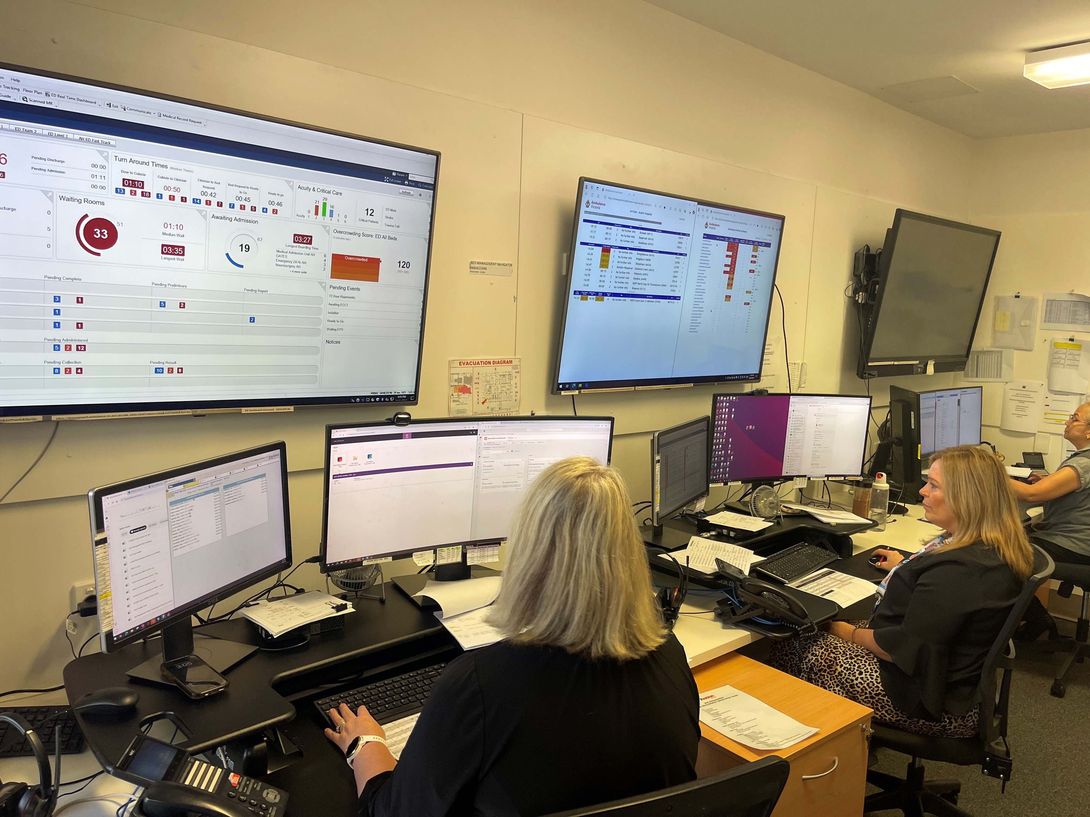

**Standard 7** | Early, definitive emergency care

|  |
| --- |
| Case Study: Fast-tracking non-admitted emergency care at Goulburn Valley Health Goulburn Valley Health improved flow through its Fast Track area by protecting Fast Track cubicles for patients requiring low complexity care, gradually increasing the number of protected cubicles to five. Goulburn Valley Health reviewed its model of care to allocate dedicated staffing resources to Fast Track (a nurse practitioner and senior decision maker) between 9am and midnight. It also reconfigured equipment and the layout of the Fast Track area to improve staff efficiency and effectiveness, including setting up a Fast Track waiting room. As a result, Goulburn Valley Health’s Fast Track throughput more than doubled, the Fast Track length of stay reduced by 2.2 hours, and non-admitted emergency department length of stay showed a sustained improvement of 20 minutes. |

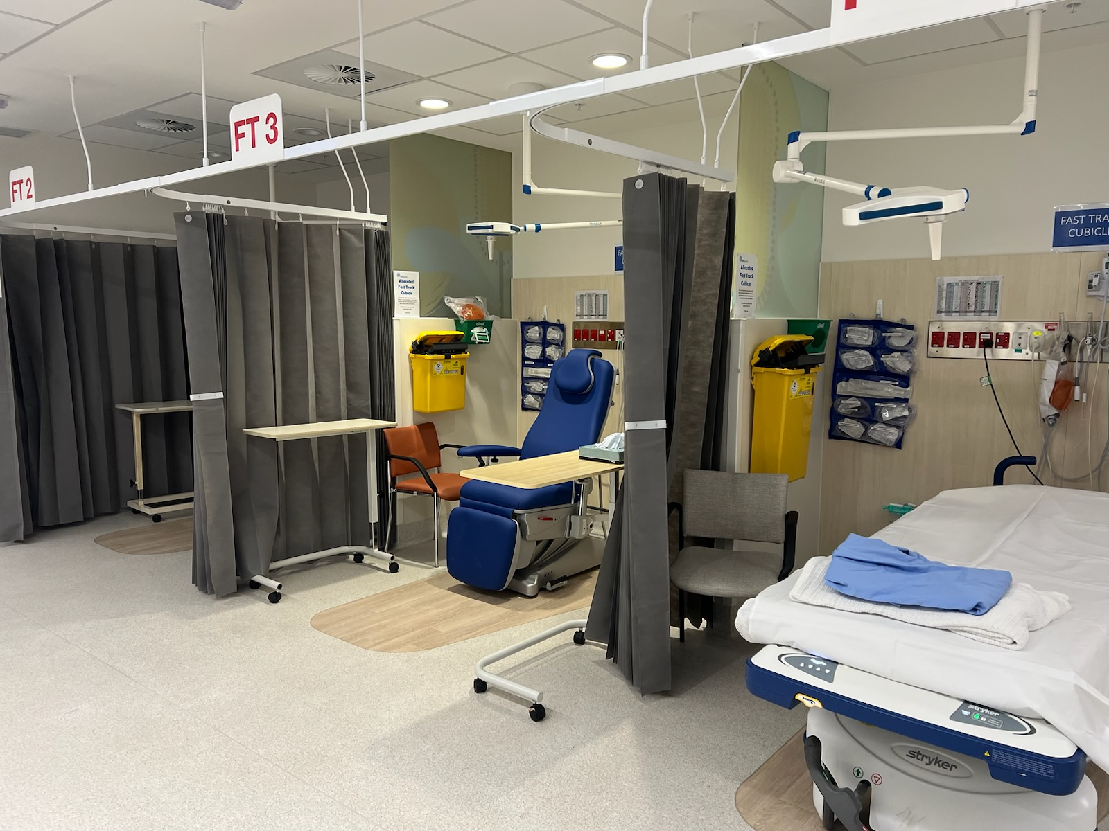

**Standard** 8 | Timely inpatient admissions

|  |
| --- |
| **Case study: Pre-10am admissions at Alfred Health**  Alfred Health operates a pre-10am admission model for patients requiring inpatient care from the emergency department overnight. This involves patients being transferred automatically to wards at a pre-determined time to create flow in the emergency department prior to the typical afternoon surge in arrivals. To enable this, each ward has a daily admissions target, which acts to plan early discharges and free up capacity for new patients requiring an admission. If wards go over profile, operational staff work together to find a suitable solution, whilst meeting nursing ratios at all times. This is one of several approaches that helps the entire system to start the wheels turning early to support the emergency department to start the day with a ‘fresh slate’ rather than moving into the peak afternoon period already at capacity. Alfred Health’s view is ‘patient access and flow is everyone’s business, and all components of the system must work in synchrony’. |

**Standard 9** | Early discharges

|  |
| --- |
| Case study: Optimising use of the transit lounge at Eastern Health Eastern Health successfully implemented a project aimed at increasing the use of its under-utilised transit lounge. This aimed to make the transit lounge the default destination for discharges through several actions including refreshing exclusion and inclusion criteria, and pre-booking confirmed and predicted discharges the day prior. As a result, early discharges on the test ward by 10am increased from an average of 6.8 to 8.75 (a 29% increase). |

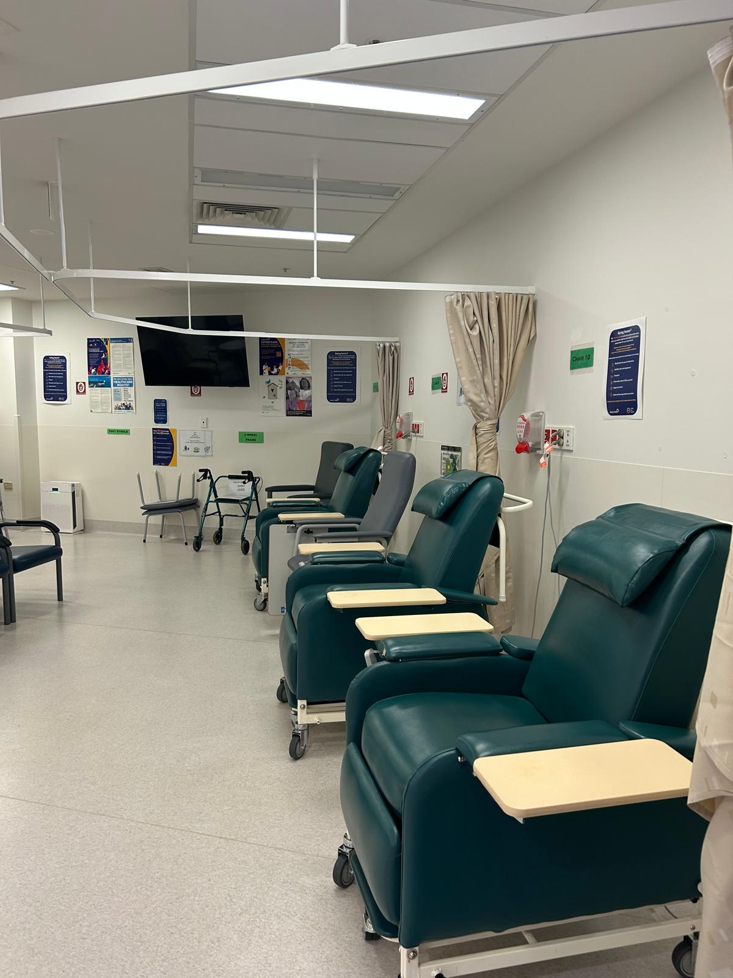

**Standard 10** | Effective operational management and escalation

|  |
| --- |
| Case study: The Royal Melbourne Hospital’s demand and escalation processes The Royal Melbourne Hospital reviewed, improved and updated its Daily Operating System (DOS) tiered huddle system. The DOS at the Royal Melbourne Hospital has a focus on clear lines of accountability, a hospital-wide escalation process and has built-in feedback mechanisms. The DOS is supported by real-time data dashboards to identify key priorities and progress decision-making.  The Royal Melbourne Hospital also established a Demand and Escalation Procedure which outlined the three levels of escalation according to risk and capacity and includes respective escalation responses. Roles and responsibilities for clinical and non-clinical staff are outlined for each level of escalation in Action Cards. Escalation status is communicated to the organisation each day.  After testing and implementing the Demand and Escalation Procedure, the Royal Melbourne Hospital launched the Digital Coordination Centre (DCC). The DCC co-locates staff responsible for patient flow into a central hub with access to real-time situational dashboards that provide visibility of demand, and access and flow, across the organisation, including in the emergency department. The DCC is a component of the DOS structure and coordinates the standard and additional escalation huddles.  The DCC enables staff to monitor and proactively respond to issues impacting hospital-wide access and flow, as well as patient care. For example, alongside a clear escalation policy, staff in the DCC can proactively allocate additional resourcing to the emergency department during periods of peak demand.  This example demonstrates the benefit of using real-time data-driven metrics to inform resource allocation and hospital-wide escalation. For further information on implementing a DOS please review [Safer Care Victoria’s factsheet and implementation guide](https://www.safercare.vic.gov.au/best-practice-improvement/getting-started/getting-your-service-ready/implement-a-daily-operating-system), at <https://www.safercare.vic.gov.au/best-practice-improvement/getting-started/getting-your-service-ready/implement-a-daily-operating-system> |

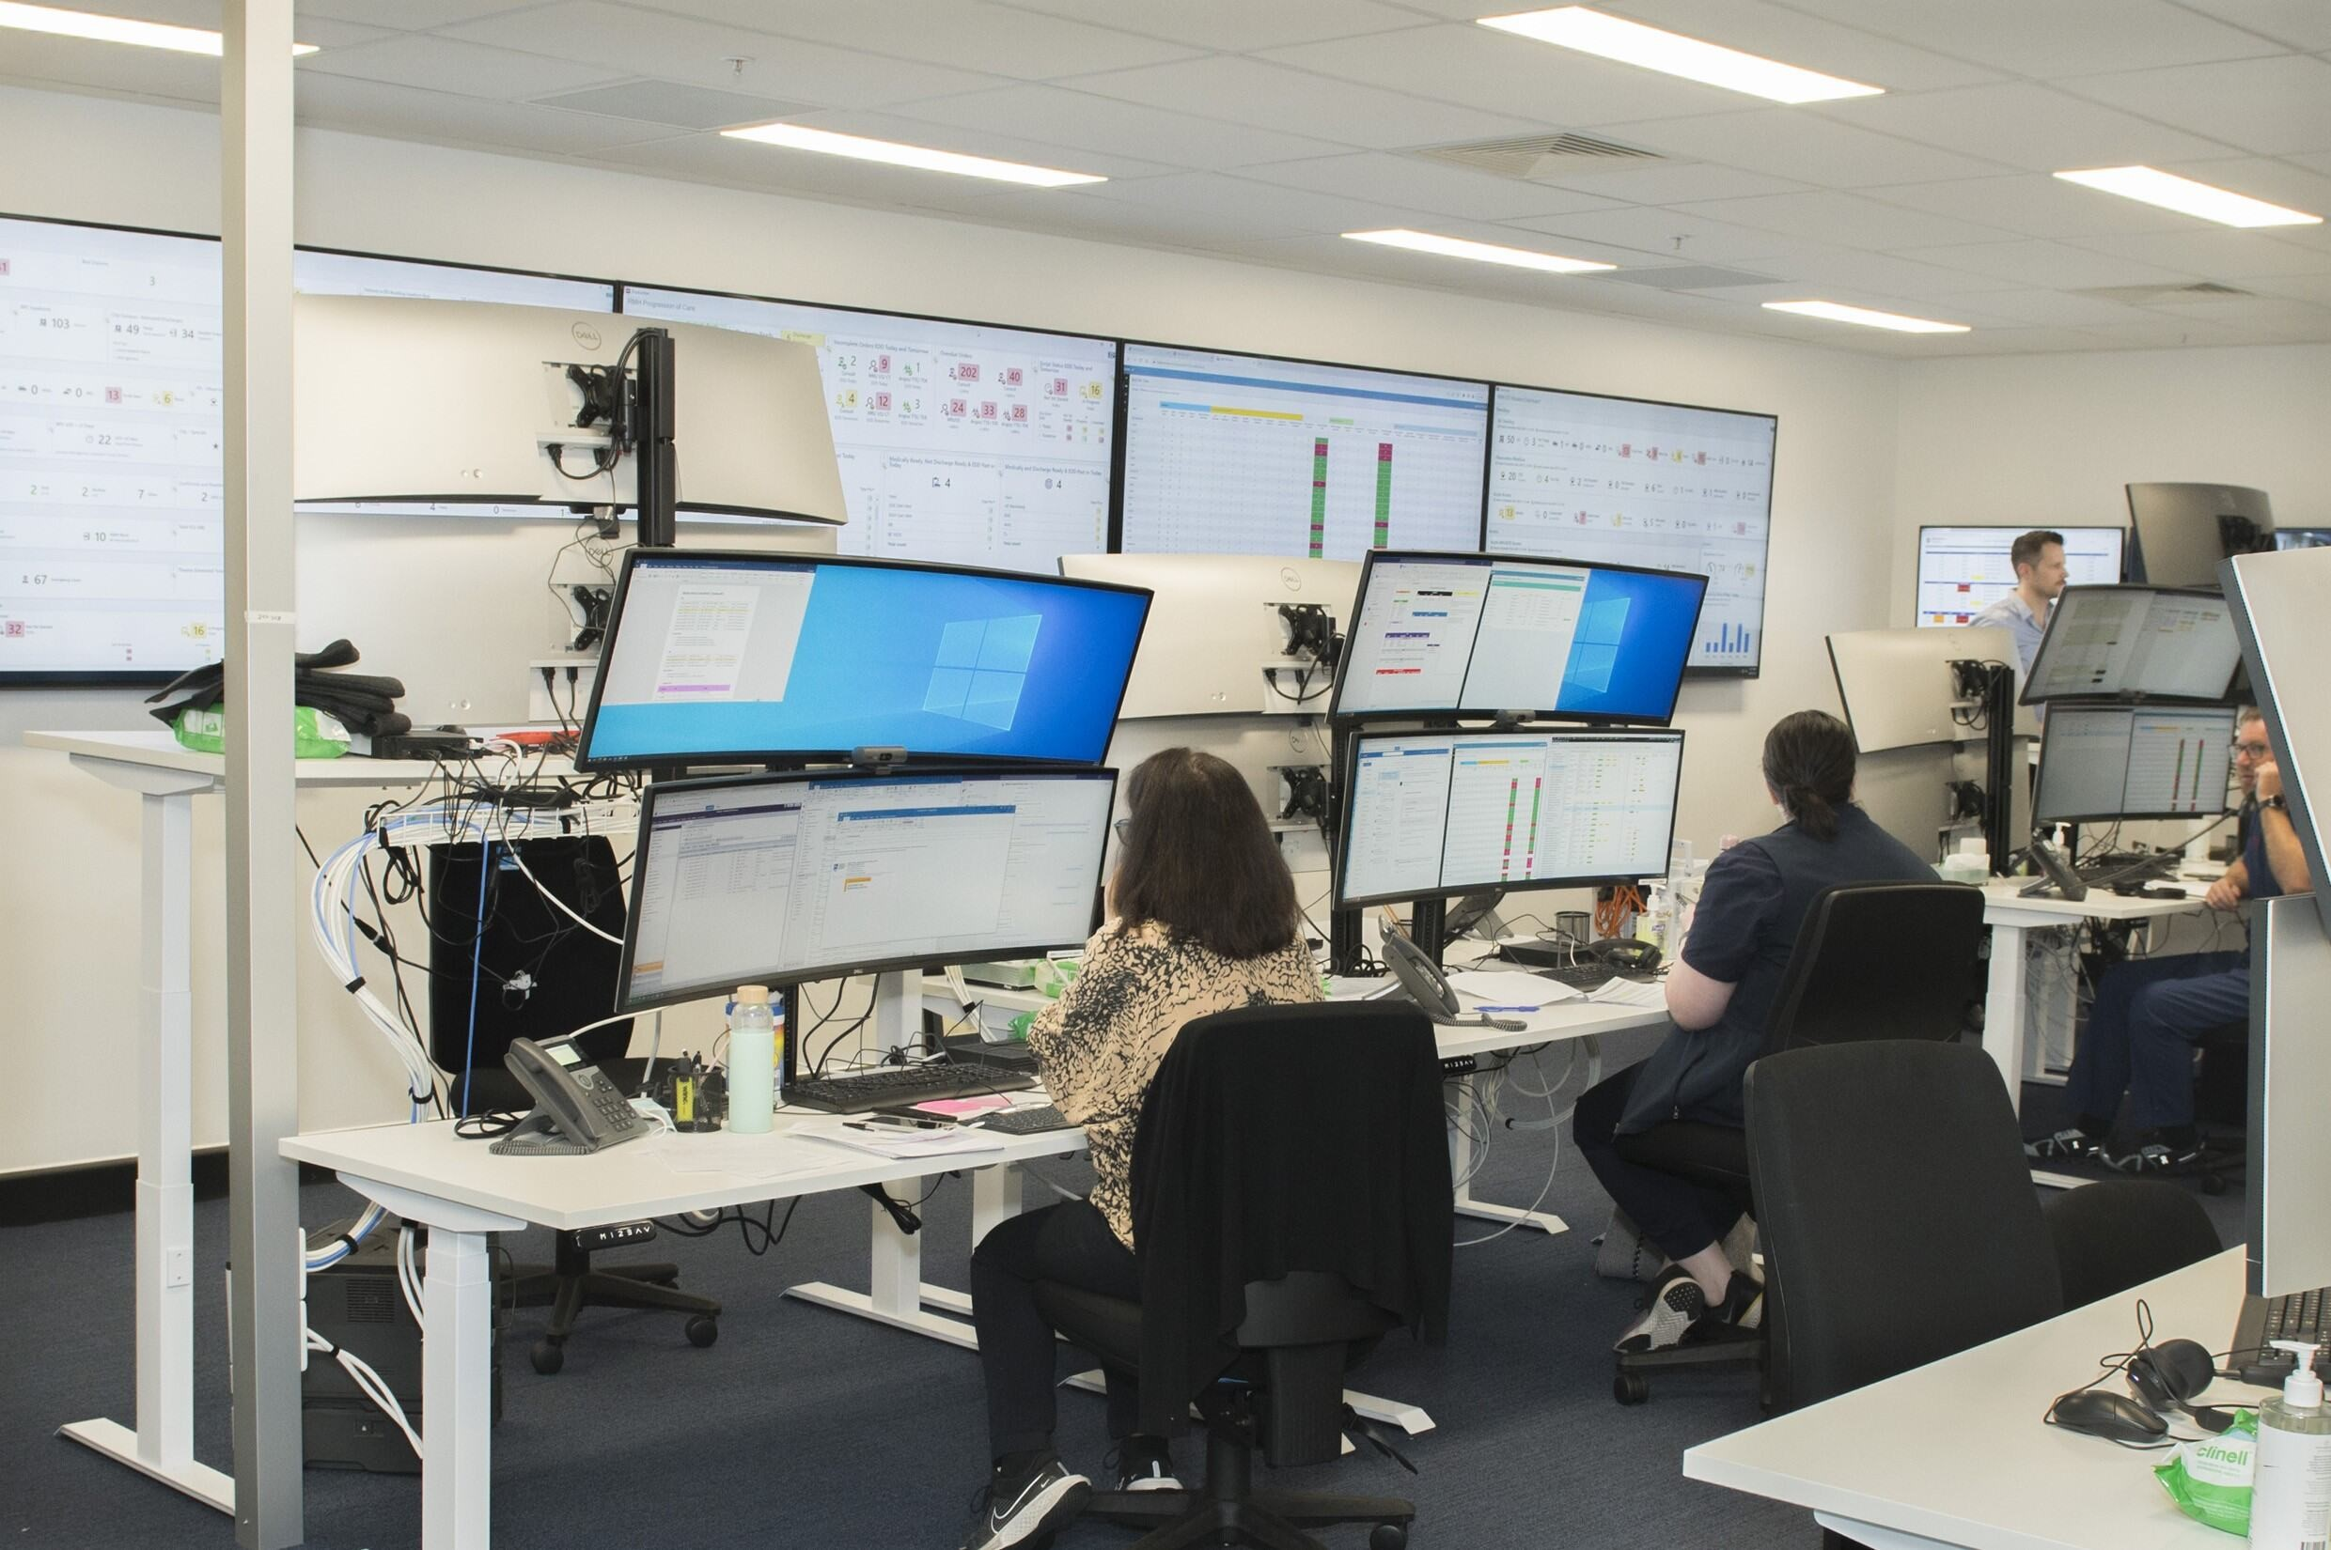

|  |
| --- |
| To receive this document in another format email [Ambulance Victoria](mailto:ambulance@health.vic.gov.au) <ambulance@health.vic.gov.au>.  Authorised and published by the Victorian Government, 1 Treasury Place, Melbourne.  © State of Victoria, Australia, Department of Health, February 2025.  ISBN/ISSN number (online/PDF/Word) or (print)  Available at [Standards for safe and timely ambulance and emergency care for Victorians](https://www.health.vic.gov.au/patient-care/standards-for-safe-and-timely-ambulance-and-emergency-care-for-victorians) <https://www.health.vic.gov.au/patient-care/standards-for-safe-and-timely-ambulance-and-emergency-care-for-victorians> |

1. In-scope hospitals will be identified and named in the accompanying implementation approach.
2. Unplanned non-emergency patient transport (NEPT) are services for patients originating from Triple Zero (000) calls that are identified by Ambulance Victoria’s paramedics and nurses in Secondary Triage Services, as lower acuity, less urgent and are suitable for a NEPT response.
3. VEMD – Victorian Emergency Minimum Dataset. See Appendix one for information on Ambulance Handover Complete times.
4. To capture paramedic availability to respond to people in the community.
5. To capture paramedic availability to respond to people in the community.
6. Short Stay Units care for patients who have arrived via the emergency department and require a short admission for investigation, observation or treatment and who are unlikely to require admission to an inpatient ward.
7. A Fast Track model of care supports non-admitted patients with minor injuries or illnesses, for example, patients who may be discharged within four hours.
8. Daily tiered huddles bring cross-functional groups together to understand issues and cascade information to the next tier.