

|  |
| --- |
| Forensic Leave Panel |
| Annual report 2023 |
|  |

|  |
| --- |
| To receive this document in another format, phone 1800 222 987, using the National Relay Service 13 36 77 if required, or [email the Forensic Leave Panel](mailto:flp@dhhs.vic.gov.au) flp@health.vic.gov.au.  Authorised and published by the Victorian Government, 1 Treasury Place, Melbourne.  © State of Victoria, Australia, Department of Health, September 2023  ISSN 2206-5962 (Online/PDF/Word)  Available from the [Forensic Leave Panel’s webpage](https://www2.health.vic.gov.au/mental-health/mental-health-services/services-by-type/forensic-mental-health-services/forensic-leave-panel) <https://www2.health.vic.gov.au/mental-health/mental-health-services/services-by-type/forensic-mental-health-services/forensic-leave-panel> |
|  |



31 July 2024

Jaclyn Symes MP  
Attorney-General  
Level 26, 121 Exhibition Street  
Melbourne VIC 3000

Dear Attorney-General

In accordance with section 63 of the *Crimes (Mental Impairment and Unfitness to be Tried) Act 1997* (Vic), I am pleased to submit the annual report on the operations of the Forensic Leave Panel for the year ending 31 December 2023 for tabling in parliament.

A copy of this report has also been provided to the Minister for Mental Health, the Hon. Ingrid Stitt MP, and the Minister for Disability, the Hon. Lizzie Blandthorn MP, who are also responsible in part for the operation of the Act.

Yours sincerely

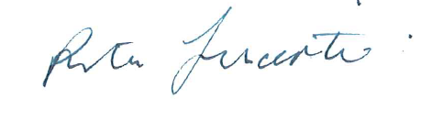

**The Hon Justice Rita Incerti**  
President  
Forensic Leave Panel

Contents

President’s report 6

Online hearings 6

Statistical data 6

Acknowledgements 6

Definitions 8

Forensic Leave Panel 9

Who we are 9

What we do 9

How we do it 9

Our people 10

Membership 10

Changes to our membership 11

The leave framework 12

On-ground leave and limited off-ground leave 12

Criteria for granting leave 12

Conditions attached to leave 13

Purpose of leave 14

Progression of leave 14

Suspension of limited off-ground leave 14

The hearing process 15

Hearings 15

Applications for leave 15

Supporting documentation 15

Conduct of hearings 16

Decisions about leave 16

Operational report 18

The year in review 18

Our finances 20

Appendix 1: The legal framework 21

Legal framework for progression under the Act 22

Appendix 2: Panel membership as at 31 December 2023 23

Supreme Court judges 23

County Court judges 23

Chief Psychiatrist and nominees 24

Psychiatrist members 24

Psychologist members 24

Community members 25

Appendix 3: Historical data 27

General information 27

Type of leave applications 27

Leave requests granted, suspended, appealed and revoked 28

Applicant demographics 29

Sentencing information 29

# President’s report

I am pleased to present the annual report of the Forensic Leave Panel for 2023 – my second annual report as president of the panel in my sixth year as a judicial panel member.

I would like to thank the former Chief Psychiatrist, Dr Neil Coventry, for his assistance and Dr David Huppert in his role as Acting Chief Psychiatrist.

## Online hearings

In 2020 the panel moved its operations online due to the COVID-19 pandemic. Since then, the panel has continued to operate online.

We have continued to make ongoing efforts to refine and improve the experience of online hearings for all participants. Forensic patients and residents continue to benefit from the participation of their support people (including family members), legal representatives and interpreters in online hearings.

Online hearings have proven to be an effective method to enable broader panel attendance (for example, panel members have been able to attend from regional and interstate locations), support hearings to run uninterrupted and ensure hearings are conducted in a safe way for all participants. Other positive impacts of holding hearings online have included enabling more support people (including family members) to participate in hearings where they may not have otherwise been able to attend due to distance and/or other considerations. Online hearings have also resulted in an increase in the number of occasions on which interpreters and legal representatives have been able to attend. Holding meetings online also makes it easier to respond to late and unforeseen changes to attendance.

## Statistical data

During 2023 the panel conducted 41 hearings (seven for forensic residents and 34 for forensic patients). Overall, during 2023, there was a 4% increase in the number of forensic patients and residents that applied for leave. This correlates with a 24% growth in the patient population since 2018 and the ongoing increased demand for hearings each year. It is increasingly difficult to meet the demand for hearings, within the limited resourcing constraints.

Whilst on-ground leave ceased in late 2021,[1] in 2023, 113 forensic patients and residents made applications for limited off-ground leave. In comparison, in 2022, there was a total of 109 applicants for limited off-ground leave.

The panel considered 226 applications for limited off-ground leave and granted 92 per cent of those applications. The proportion of leave granted in 2023 slightly decreased compared to 2022 (96 per cent), however it is consistent with leave granted in previous years.

The data contained in this report shows that rates of granting and refusing applications have been fairly consistent since 2014 (refer to Appendix 3: Historical data).

## Acknowledgements

I would like to acknowledge the expertise and skill of the panel members and thank them for their invaluable contribution to its operation.

I want to acknowledge the important role of the lawyers from Disability Justice Australia Inc., Kurnai Legal Practice, Mental Health Legal Centre and Victoria Legal Aid in providing legal representation and advice to applicants at panel hearings.

Finally, I wish to express my appreciation of the work and commitment of the staff ofForensic Residential Services, the Thomas Embling Hospital and the Department of Health’s Mental Health and Wellbeing Division.



The Hon Justice Rita Incerti  
President  
Forensic Leave Panel

# Definitions

Throughout this report, unless otherwise specified:

* ‘The Act’ refers to the *Crimes (Mental Impairment and Unfitness to be Tried) Act 1997*.
* ‘The panel’ refers to the Forensic Leave Panel.
* ‘Forensic patient’ or ‘patient’ is a person remanded in or committed to custody in a designated mental health service under the *Mental Health and Wellbeing Act 2022[2]*.
* ‘Forensic resident’ or ‘resident’ is a person remanded in or committed to custody in a residential treatment facility or a residential service under the *Disability Act 2006*.
* ‘Types of leave’ refers to limited off-ground leave.
* ‘Purpose of leave’ refers to activities undertaken while a forensic patient or resident is on leave.
* ‘Forensic Residential Services’ or ‘FRS’ is a network of secure and non-secure services and includes two secure residential treatment facilities, the Intensive Residential Treatment Program (IRTP) and the Long-Term Residential Program (LTRP). FRS is a part of the Victorian Department of Families, Fairness and Housing. In this report, FRS refers to the IRTP and LTRP.[3]
* ‘Forensicare’ refers to the Victorian Institute of Forensic Mental Health, which is a statutory body established by the *Mental Health and Wellbeing Act 20222*. Thomas Embling Hospital is a campus of Forensicare.
* ‘CSO’ refers to a custodial supervision order, which commits a person to custody in a designated mental health service under the *Mental Health and Wellbeing Act 20222* or to a residential treatment facility or residential service under the *Disability Act 2006*.
* ‘NCSO’ refers to a non-custodial supervision order, which allows the person to live in the community, subject to conditions decided by the court and specified in the order.

# Forensic Leave Panel

## Who we are

The panel is an independent statutory tribunal established under the Act to support the rehabilitation of forensic patients and residents and assist with their reintegration into the community.

The panel comprises members of the judiciary, the Chief Psychiatrist and nominees, psychiatrists, psychologists and members from the community.

## What we do

The main role of the panel is to hear applications for limited off-ground leave from patients and residents to enable them to take part in a range of activities in the community to aid their rehabilitation. Prior to 2022, the panel’s role also included hearing applications for on-ground leave from patients and residents for the same purposes. The panel also hears appeals from patients and residents regarding refusal of special leave and transfers from one designated mental health service to another.

## How we do it

The panel conducts hearings online, at the Thomas Embling Hospital campus of Forensicare and at Forensic Residential Services (FRS) to consider applications for limited off-ground leave from forensic patients and residents.

The panel considers applications from forensic patients and residents over the duration of their custody or detention.

Over time, the panel may grant incremental increases to a person’s leave into the community when it is appropriate to do so. Leave is granted for a maximum of six months at any time.

Since 2020, panel hearings have been held online via video link with attendance by participants, their support people (including family members), legal representatives, treating team and interpreters. Patients, residents and their treating teams continued to attend from their facility, and provision was also made for support people (including family members), legal representatives and translators to attend at the facility where requested and possible.

‘Appendix 1: The legal framework’ provides an overview of how a patient or resident may progress under the Act. It also identifies the panel’s responsibilities in the detention, management and release framework.

# Our people

## Membership

As of 31 December 2023, the panel comprised:

* six judicial members from the Supreme Court of Victoria;
* three judicial members from the County Court of Victoria;
* the Chief Psychiatrist;
* six nominees of the Chief Psychiatrist;
* four registered medical practitioners with experience in forensic psychiatry;
* three registered psychologists with experience in intellectual disability and forensic psychology; and
* six members to represent the views and opinions of the community.

The panel is supported by an executive officer, who works from the Mental Health and Wellbeing Division of the Victorian Department of Health.

The structure of the panel is outlined in   
Figure 1.

Figure 1: Panel membership

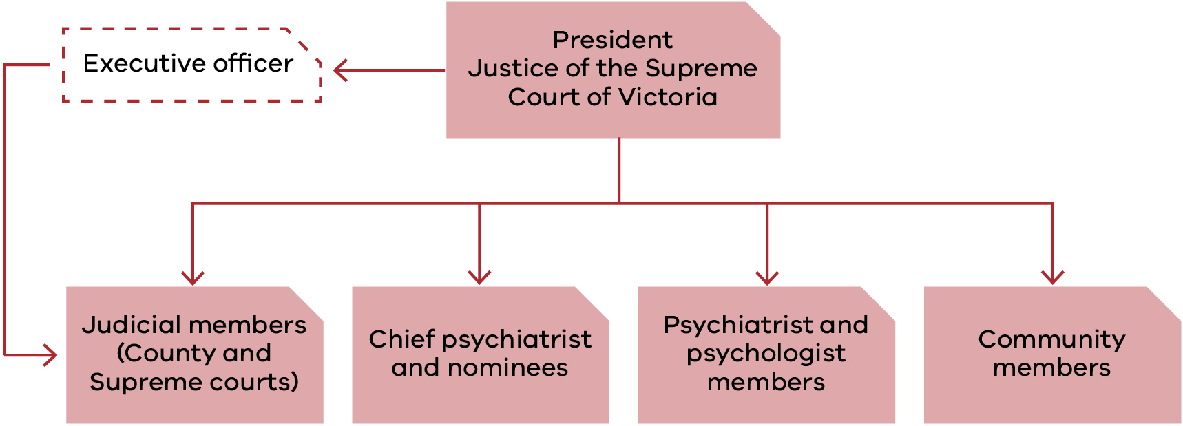

*‘Appendix 2: Membership as of 31 December 2023’ contains a complete list of members, including their terms of appointment.*

## Changes to our membership

### Supreme Court judicial members

* Justice Rita Incerti was appointed as the Forensic Leave Panel President on 6 August 2023.
* The former Justice Terry Forrest’s appointments as the President of the Forensic Leave Panel and Supreme Court judicial member concluded on 16 April 2023.
* Judge James Parrish resigned from the panel on 16 April 2023.

### Chief Psychiatrist members

* Dr Neil Coventry resigned from his role as the Chief Psychiatrist on 1 December 2023.
* Dr Leeanne Fisher was appointed to the panel on 12 December 2022.
* Dr Paul Robertson was appointed to the panel on 12 December 2022.[4]

### Psychiatrist member

* Dr Leon Turnbull resigned from the panel on 21 February 2023.
* Dr Jennifer Torr was reappointed for her third term on 2 October 2023.

### Psychologist member

* Dr Marilyn McMahon was reappointed for her third term on 3 October 2023.

### Community member

* Mr Paul Newland was reappointed for his eighth term on 3 October 2023.
* Dr Genevieve Grant was reappointed for her fifth term on 3 October 2023.
* Dr Leslie Cannold was reappointed for her second term on 3 October 2023.

### 

# The leave framework

## On-ground leave and limited off-ground leave

The panel has jurisdiction under the Act to grant on-ground and limited off-ground leave to forensic patients and forensic residents.

In late 2021, on-ground leave was no longer required and was ceased. The areas that used to be accessed through on-ground leave can still be accessed under other provisions.

The maximum period for which limited off-ground leave can be granted is six months.[5] At the end of this period, a patient or resident may reapply to the panel.

### On-ground leave

On-ground leave allowed forensic patients and residents to be absent from the place of custody but within a defined area around the place of custody, known as ‘the surrounds’.

Forensic residents at the Long-Term Residential Program (LTRP) in Bundoora used to make extensive use of on-ground leave. However, in late 2021, the LTRP increased the grounds within its secure perimeter. At this time, it became a Resident Treatment facility and the area surrounding the facility, some of which was previously accessed via on-ground leave, became part of the secure perimeter of the facility. Other areas that used to be accessed via on-ground leave but are not part of the secure perimeter of the facility can now be accessed via limited off-ground leave. For this reason, the Forensic Leave Panel no longer receives applications for on-ground leave.

Forensic patients at the Thomas Embling Hospital campus of Forensicare and forensic residents at the Intensive Residential Treatment Program (IRTP) did not require on-ground leave because there were enough grounds within the secure perimeter. Accordingly, no grounds were declared under section 52 of the Act in relation to Thomas Embling Hospital or IRTP.

### Limited off-ground leave

Limited off-ground leave permits patients and residents to be absent from the place of custody between 6:00 am and 9:00 pm, or outside those hours for a maximum of three days in any seven-day period.

## Criteria for granting leave

The panel may grant limited off-ground leave if it is satisfied that both:

* the proposed leave will contribute to the patient’s or resident’s rehabilitation; and
* the safety of the person or members of the public will not be seriously endangered as a result of the patient or resident being allowed leave.

In determining whether to grant an application for leave or variation of leave, the panel must consider:

* the person’s current mental condition or pattern of behaviour;
* the person’s clinical history and social circumstances; and
* the applicant’s profile and leave plan or statement, prepared in accordance with the Act.

The above criteria for granting leave applied to applications made to the panel prior to 2022 for on-ground leave.

## Conditions attached to leave

The panel can place any conditions on leave that it considers appropriate. Conditions commonly relate to:

* how many, if any, escorts are required;
* the duration and frequency of leave;
* where a patient or resident may go (or where they may not go);
* the people a patient or resident can meet while on leave;
* how a patient or resident is to travel to their leave destination;
* drug and alcohol testing following leave.

# Purpose of leave

The purpose of leave is to assist the rehabilitation process and provide a gradual progression towards a return to community living that is consistent with the needs of the individual and with community safety.

Patients and residents can apply to the panel to take part in a broad range of activities. All leave must form part of an overarching treatment and recovery plan. Common purposes of leave granted include leave to:

* attend medical, legal, dental or allied health appointments;
* undertake activities of daily living such as personal shopping, banking and physical exercise;
* build or maintain relationships with family and friends in the community;
* participate in therapeutic and rehabilitation groups, activities or programs;
* attend educational and vocational activities, groups or courses;
* participate in or seek voluntary and/or paid employment.

## Progression of leave

The panel takes a graduated approach to granting leave. Initially, a patient or resident is granted a small amount of leave and is escorted by two or three staff members. This could include leave to attend medical appointments or may allow a patient or resident to attend a nearby facility (such as a park or a café) for one hour a week.

If a patient or resident can successfully participate in leave over a sustained period, the panel may decrease the number of escorts and increase the number of approved locations and purposes, as well as the duration, of further leave. This process allows patients or residents to gradually increase their participation in a wide variety of activities that form part of everyday living to prepare them for release back into the community. This slow approach to leave allows for a steady reintroduction into the community and provides staff with a valuable opportunity to monitor how the person copes and adapts in a community setting.

A patient’s or resident’s progression depends on individual circumstances. The progression outlined above may not be the path followed by all patients and residents, and some may move backwards and forwards between various stages of this process, depending on their progress and response to treatment.

## Suspension of limited off-ground leave

Regular monitoring and review of leave takes place to ensure the safety of each patient or resident and to ensure members of the public are not seriously endangered. Before forensic residents or patients may access leave granted by the panel, they are subject to a clinical assessment.

The Act contains provisions that allow the Chief Psychiatrist (in the case of patients) and the Secretary of the Department of Families, Fairness and Housing (in the case of residents) to suspend leave granted by the panel if they are satisfied that the safety of the person or members of the public will be seriously endangered if leave is not suspended. The panel is required to record and report any suspensions of leave.

In 2023, the Secretary suspended leave for one resident. There were four instances of leave being partially or wholly suspended by the Chief Psychiatrist during 2023.

# The hearing process

## Hearings

The panel must conduct its hearings at the place where the patient or resident is detained to enable the person to attend and participate fully in the proceedings, unless the president determines otherwise. Since 2020 hearings have been held online, with the patients and residents attending from their corresponding service.

Patient hearings are generally held at Thomas Embling Hospital and the panel is made up of:

* a judge from the Supreme or County Court (depending on the patient’s original court of disposition);
* the Chief Psychiatrist or nominee;
* a registered medical practitioner with experience in forensic psychiatry; and
* a community member.

Resident hearings are held at FRS and the panel is made up of:

* a judge from the Supreme or County Court (depending on the resident’s original court of disposition);
* a registered psychologist with experience in intellectual disability and forensic psychology; and
* a community member.

## Applications for leave

A forensic patient or resident may apply to the panel for limited off-ground leave. Each type of leave can include one or more purposes of leave.

All applications must specify:

* the type of leave;
* the purpose(s) of leave (for example, grocery shopping);
* the duration and frequency of each purpose (for example, two hours, once per week);
* the destination for each purpose (for example, the name of the shopping centre); and
* the relationship to the person’s rehabilitation (for example, to build or maintain daily living skills).

## Supporting documentation

Other documentation that must be submitted to the panel includes:

* an applicant profile;
* a report from the consultant psychiatrist or psychologist; and
* a detailed leave plan prepared by the patient’s or resident’s treating team.

These are described below.

### Applicant profile

The profile must contain the following information:

* the person’s impairment, condition or disability;
* the relationship between the impairment, condition or disability and the offending conduct;
* the person’s clinical history and social circumstances;
* the person’s current mental state or pattern of behaviour;
* the offence that led to the supervision order being made; and
* the date of the supervision order, its nominal term and the day from which the nominal term had been declared to run.

### Report from the consultant psychiatrist or psychologist

This report provides information on the person’s current mental state, medication, a risk assessment and any conditions that the clinician recommends should be placed on the leave. The clinician will also indicate if they support all or some of the purposes of leave being applied for by the patient or resident.

### Detailed leave plan

This plan is intended to show how any previous grants of leave have progressed and how the present leave applied for may contribute to the person’s rehabilitation goals. The plan also allows the person’s treating team to recommend any leave conditions or to recommend that leave should not be granted.

## Conduct of hearings

Hearings are closed to the public unless the panel directs otherwise on the basis that it is in the best interest of the person or is in the public interest. Open hearings rarely occur, although the panel may occasionally allow an observer to be present for training or professional development purposes. No open hearings were conducted in 2023.

The panel must act according to equity and good conscience and is bound by the rules of natural justice.

The panel is not required to conduct its hearings in a formal manner. It is not bound by rules or practice relating to evidence and may inform itself on matters as it sees fit. This may include requests for extra information or, by way of summons, request that others attend.

During the hearing the panel discusses the leave application with the patient or resident and their treating team. Discussions focus on such things as the person’s current mental state and pattern of behaviour, any notable achievements or incidents since the person’s last panel hearing and how any previous leaves granted by the panel have progressed.

If the patient or resident needs assistance during a hearing, the panel will engage an interpreter or other specialist, as necessary. During 2023, the panel engaged an interpreter on 17 occasions, in the following languages:

* Arabic;
* Auslan;
* Cantonese;
* Dinka;
* Filipino;
* Mandarin;
* Turkish; and
* Vietnamese.

This was a slight decrease from 20 occasions in 2022.

Applicants have a right to legal representation at hearings. Fourteen patients and five residents chose to be legally represented over the course of the year on 23 separate occasions. On most occasions, the legal representatives for patients and residents have attended the hearings remotely.

Whilst there has been consistently been a high proportion of residents accessing legal representation for hearings over recent years, in 2023, there was a significant increase of legal representation for patients with fourteen patients accessing legal representation on at least one occasion each. In comparison, since 2018, patients accessed legal representation on four or less occasions in total each year and legal representation was provided to patients on two occasions each year during both 2021 and 2022.

## Decisions about leave

At the end of each hearing the panel advises the patient or resident of its decision and gives verbal reasons. A written determination is issued to the patient or resident after the hearing outlining the leave that was granted or refused and any conditions attached to the leave.

A patient or resident has the right to request a written statement of reasons for the decision. In 2023 no requests were made for a written statement of reasons.

Otherwise, no written statements of reasons are provided.

# Operational report

## The year in review

### Forensic patients

| Measure | 2023 | 2022 | Change |
| --- | --- | --- | --- |
| Applicants | 105 | 102 | +3 |
| Male applicants | 92 | 87 | +5 |
| Female applicants | 13 | 15 | -2 |
| Applicants on Supreme Court orders | 57 | 59 | -2 |
| Applicants on County Court orders | 48 | 43 | +5 |
| First-time applicants | 13 | 14 | -1 |
| Hearings | 34 | 26 | +8 |
| Applications received | 213[6] | 210 | +3 |
| Individual leave purposes requested | 928 | 898 | +30 |
| Applications for on-ground leave | 0 | 0 | - |
| Applications for limited off-ground leave | 213 | 210 | +3 |
| Leave granted without modification | 70% | 74% | -4% |
| Leave granted with modification | 21% | 22% | -1% |
| Total leave granted[7] | 92% | 96% | -4% |
| Leave refused | 10% | 5% | +5% |
| Leave suspensions by the Chief Psychiatrist | 4 | 4 | - |
| Leave suspensions by the Secretary of the Department of Families, Fairness and Housing | N/A | N/A | N/A |
| Times a patient was assisted by an interpreter | 17 | 20 | -3 |
| Languages used | 8 | 8 | - |
| Legal representation | 16 | 2 | +14 |
| Appeals against refusal of special leave | 0 | 0 | - |

### Forensic residents

| Measure | 2023 | 2022 | Change |
| --- | --- | --- | --- |
| Applicants | 8[8] | 7 | +1 |
| Male applicants | 8 | 7 | +1 |
| Female applicants | 0 | 0 | - |
| Applicants on Supreme Court orders | 3 | 2 | +1 |
| Applicants on County Court orders | 5 | 5 | - |
| First-time applicants | 2 | 1 | +1 |
| Hearings | 7 | 8 | -1 |
| Applications received | 13 | 20 | -7 |
| Individual leave purposes requested | 85 | 117 | -32 |
| Applications for on-ground leave | 0 | 0 | - |
| Applications for limited off-ground leave | 13 | 20 | -7 |
| Leave granted without modification | 87% | 63% | +25% |
| Leave granted with modification | 13% | 37% | -24% |
| Total leave granted[9] | 100% | 100% | - |
| Leave refused | 0% | 1% | -1% |
| Leave suspensions by the Chief Psychiatrist | N/A | N/A | N/A |
| Leave suspensions by the Secretary of the Department of Families, Fairness and Housing | 1 | 1 | - |
| Times a resident was assisted by an interpreter | 0 | 0 | - |
| Languages used | N/A | N/A | N/A |
| Legal representation | 7 | 11 | -4 |
| Appeals against refusal of special leave | 0 | 0 | - |

The panel’s statistical information has remained relatively constant over recent years. Although variations occur in the number of hearings, applicants and applications, these differences are generally consistent with changes in the forensic patient and resident population.

In 2023, there continued to be an increased demand for hearings for forensic patients, which was consistent with the growth in the patient population. Over the past five years, the number of patients applying for leave has increased by 24%. In 2018, 85 patients applied for leave and in 2023, 105 patients applied for leave. There were 213 applications made to the panel with a request for a further eight patients to be listed for a hearing during the year. Due to panel member availability, it was not possible to meet this request and the eight patients were listed for a hearing in January 2024 instead.

In total, there were 34 hearings for forensic patients, which reflected an increase in the number of hearings compared to 2022 (26 hearings). The increased number of hearings reflected different rostering arrangements compared to 2022.[10] Accordingly, the data showed that there was only a very slight increase in the number of applicants, applications received (and considered by the panel), and individual leave purposes requested.

For forensic residents, there was a slight increased population size (nine residents) that accessed off-ground leave during 2023.[11] The decreased number of applications per resident (13) across the year compared to 2022 (20) was due to changes in the resident population during the year (including first time applicants and residents that were granted extended leave) and the timing of hearings.[12]

In 2023, forensic residents submitted an average of 1.4 applications per resident during the year. In contrast, in 2022, most residents submitted three applications each.

Individual applications for leave slightly decreased from 230 in 2022 to 226 in 2023. Overall, requests for distinct leave purposes very slightly decreased from 1015 in 2022 to 1013 in 2023. Resident requests for distinct leave purposes decreased from 117 in 2022 to 85 in 2023. In contrast, patient requests for leave purposes increased from 898 in 2022 to 928 in 2023. This is consistent with changes in the forensic resident and patient population. The number of leave applications per applicant varied from one to three, with an average of 2 leave applications by each forensic patient or resident.[13] Out of the 113 applicants over the calendar year:

* Nineteen made one application.
* Seventy-five made two applications.
* Nineteen made three applications.

‘Appendix 3: Historical data’ contains more information on the number of patients and residents, hearings, leave applications and other demographic data for the period from 2014 to 2023.

## Our finances

The Department of Health’s Mental Health and Wellbeing Division provided all operational support to the panel, managed the panel’s budget and maintained accounts and records. The department’s audited financial statements include the panel’s expenditure, which is reported in the department’s annual report.

# Appendix 1: The legal framework

The Act provides for the management, supervision and release of people found unfit to stand trial or not guilty of an offence because of mental impairment.

Under the Act, a court can impose several different supervision orders if it finds a person unfit to plead or not guilty because of mental impairment:

* custodial supervision orders (CSOs) which commit a person to custody in a designated mental health service under the *Mental Health and Wellbeing Act 2022[14]* or to a residential treatment facility or residential service under the *Disability Act 2006*;
* CSOs which commit a person to custody in a prison but only if the court is satisfied that no practicable alternative exists; and
* non-custodial supervision orders (NCSOs), which allow the person to live in the community, subject to conditions decided by the court and specified in the order.

The court also has the discretion to release a person unconditionally.

Figure 2 presents a brief overview of how a person may progress through the system under the Act and shows where the panel is situated within this framework.

## Legal framework for progression under the Act

Figure 2: Legal framework for progression under the Crimes (Mental Impairment and Unfitness to be Tried) Act

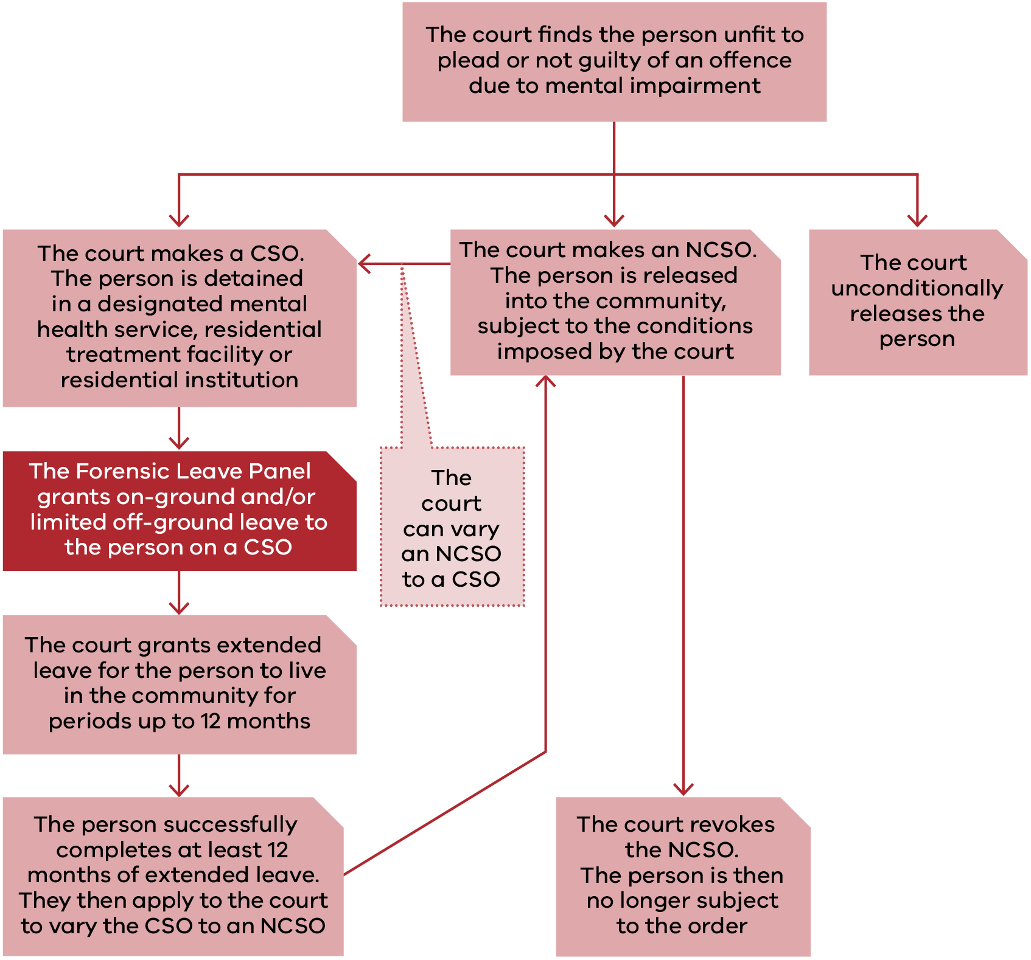

# Appendix 2: Panel membership as of 31 December 2023

## Supreme Court judges

| Panel member | Current appointment | Previous term(s) of appointment |
| --- | --- | --- |
| The Hon Justice Rita Incerti  President of the Forensic Leave Panel from 6 August 2023 | 28 May 2019  to 27 May 2024 | N/A |
| The former Hon Justice Terry Forrest President of the Forensic Leave Panel from February 2020 to  16 April 2023 | N/A | 17 April 2018  to 16 April 2023  26 February 2013  to 25 February 2018 |
| The Hon Justice Christopher Beale | 17 February 2020  to 16 February 2025 | 17 February 2015  to 16 February 2020 |
| The Hon Justice Michael Croucher | 17 February 2020  to 16 February 2025 | 17 February 2015  to 16 February 2020 |
| The Hon Justice Andrew Keogh | 18 October 2022 to  17 October 2027 | 25 July 2017  to 24 July 2022 |
| The Hon Justice Jane Dixon | 18 October 2022 to  17 October 2027 | 25 July 2017  to 24 July 2022 |
| The Hon Justice Richard Niall | 24 February 2020  to 23 February 2025 | N/A |

## County Court judges

| Panel member | Current appointment | Previous term(s) of appointment |
| --- | --- | --- |
| Her Honour Judge Sandra Davis | 7 July 2022 to 6 June 2024 | 4 October 2016  to 3 October 2021  4 October 2011  to 3 October 2016  5 September 2006  to 4 September 2011 |
| His Honour Judge Douglas Trapnell | 31 October 2022 to  31 October 2027 | 31 October 2017  to 30 October 2022 |
| The former Honour Judge James Parrish | 17 April 2018  to 16 April 2023 | N/A |
| Her Honour Judge Rosemary Carlin | 12 May 2020  to 11 May 2025 | N/A |

## Chief Psychiatrist and nominees

| Panel member | From | To |
| --- | --- | --- |
| Dr Neil Coventry (Chief Psychiatrist) | 20 November 2014 | 1/12/2023 |
| Dr David Huppert  Acting Chief Psychiatrist from 2 December 2023 | 4 September 2020 | Ongoing |
| Dr Steve Macfarlane | 9 November 2012 | Ongoing |
| Dr Daniel O’Connor | 27 April 2016 | Ongoing |
| Dr Vinay Lakra | 18 July 2016 | Ongoing |
| Dr Jennifer Babb | 11 March 2020 | Ongoing |
| Dr David Huppert | 4 September 2020 | Ongoing |
| Dr Paul Robertson | 12 December 2022 | Ongoing |
| Dr Leeanne Fisher | 12 December 2022 | Ongoing |

## Psychiatrist members

| Panel member | Current appointment | Previous term(s) of appointment |
| --- | --- | --- |
| Dr Teresa Flower | 7 June 2022 to 6 June 2024 | 27 March 2018  to 26 March 2022  30 August 2013  to 29 August 2017  30 August 2009  to 29 August 2013 |
| Dr Jennifer Torr | 3 October 2023 to 2 October 2027 | 2 June 2019  to 1 June 2023  2 June 2015  to 1 June 2019 |
| Dr Leon Turnbull | 7 June 2022 to 6 June 2024 (resigned 21 February 2023) | 27 March 2018  to 26 March 2022 |
| Dr Ahmed Mashhood | 1 July 2022 to 30 June 2026 | 1 July 2018  to 30 June 2022 |
| Dr Daniel O’Connor | 1 March 2022 to 1 March 2024 | N/A |

## Psychologist members

| Panel member | Current appointment | Previous term(s) of appointment |
| --- | --- | --- |
| Ms Janina Tomasoni | 1 July 2022 to 30 June 2026 | 1 July 2018  to 30 June 2022  24 October 2014  to 30 June 2018  24 October 2010  to 23 October 2014  24 October 2006  to 23 October 2010  10 September 2002  to 9 September 2006 |
| Dr Michelle Noon | 1 July 2022 to 30 June 2026 | 1 July 2018  to 30 June 2022 |
| Dr Marilyn McMahon | 3 October 2023 – 2 October 2027 | 30 August 2019  to 29 August 2023  30 August 2017  to 29 August 2019 |

## Community members

| Panel member | Current appointment | Previous term(s) of appointment |
| --- | --- | --- |
| Mr Paul Newland | 3 October 2023 to 2 October 2023 | 30 August 2019  to 29 August 2023  30 August 2017  to 29 August 2019  30 August 2013  to 29 August 2017  30 August 2009  to 29 August 2013  30 August 2005  to 29 August 2009  12 December 2000  to 11 December 2004  21 April 1998  to 20 April 2000 |
| Mr Jack (Kyriakos) Nalpantidis | 1 July 2022 to 30 June 2026 | 1 July 2018  to 30 June 2022  24 October 2014  to 30 June 2018  24 October 2010  to 23 October 2014  24 October 2006  to 23 October 2010 |
| Dr Genevieve Grant | 3 October 2023 to 2 October 2027 | 30 August 2019  to 29 August 2023  30 August 2017  to 29 August 2019  30 August 2013  to 29 August 2017  30 August 2009  to 29 August 2013 |
| Mr Jie (George) Jiang | 1 July 2022 to 30 June 2026 | 1 July 2018  to 30 June 2022  15 July 2014  to 30 June 2018 |
| Dr Patricia Mehegan | 1 July 2022 – 30 June 2026 | 1 July 2018  to 30 June 2022 |
| Dr Leslie Cannold | 3 October 2023 to 2 October 2027 | 30 August 2019  to 29 August 2023 |

# Appendix 3: Historical data

The table below provides information on the number of patients and residents, hearings, leave applications and other demographic data for the period from 2014 to 2023.

## General information

| Application information | 2023 | 2022 | 2021 | 2020 | 2019 | 2018 | 2017 | 2016 | 2015 | 2014 |
| --- | --- | --- | --- | --- | --- | --- | --- | --- | --- | --- |
| Forensic patients | 105 | 102 | 91 | 91 | 93 | 85 | 88 | 74 | 74 | 76 |
| Forensic residents | 8 | 7 | 9 | 11 | 10 | 7 | 8 | 6 | 4 | 3 |
| Hearings[15] | 41[16] | 34 | 36 | 29 | 30 | 27 | 27 | 26 | 26 | 21 |
| Hearing days[17] | 32 | 30 | 31[18] | 25 | 26 | 24 | 23 | 21 | 21 | 18 |
| Total leave applications made to the panel | 226 | 230 | 210 | 197 | 216 | 216 | 228 | 201 | 180 | 227 |
| Average leave applications made per hearing | 5.5 | 6.8 | 5.8 | 6.8 | 7.2 | 8 | 8.4 | 7.7 | 6.9 | 10.8 |
| Average leave applications by each forensic patient or resident | 2 | 2.1 | 2.1 | 1.9 | 2.1 | 2.3 | 2.4 | 2.5 | 2.3 | 2.9 |
| Average leave purposes per application | 4.5 | 4.4 | 4.4 | 4.8 | 4.5 | 4.8 | 4.9 | 4.9 | 4.8 | 5 |

## Type of leave applications

| Type of leave | 2023 | 2022 | 2021 | 2020 | 2019 | 2018 | 2017 | 2016 | 2015 | 2014 |
| --- | --- | --- | --- | --- | --- | --- | --- | --- | --- | --- |
| On-ground | 0 | 0 | 9 | 7 | 5 | 4 | 17 | 12 | 7 | 6 |
| Off-ground | 226 | 230 | 210 | 197 | 216 | 216 | 211 | 189 | 173 | 221 |
| Leave purposes | 1013 | 1015 | 920 | 949 | 974 | 1025 | 1,107 | 980 | 874 | 1,139 |

## Leave requests granted, suspended, appealed and revoked

| Leave measure[19] | 2023 | 2022 | 2021 | 2020 | 2019 | 2018 | 2017 | 2016 | 2015 | 2014 |
| --- | --- | --- | --- | --- | --- | --- | --- | --- | --- | --- |
| Granted | 92% | 96% | 92% | 97% | 96% | 90% | 85% | 86% | 91% | 90% |
| Modified and granted | 20% | 24% | 14% | 16% | 8% | 7% | 9% | 7% | 4% | 4% |
| Refused | 9% | 4.6% | 7.6% | 4% | 5% | 4% | 6% | 7% | 5% | 6% |
| Times applicants were assisted by interpreters | 17 | 20 | 15 | 14 | 16 | 14 | 9 | 7 | 8 | 18 |
| Times applicants were legally represented | 23 | 13 | 11 | 22 | 11 | 11 | 20 | 29 | 14 | 36 |
| Number of occasions patients or residents had limited off-ground leave suspended | 5 | 5 | 3[20] | 164 | 9 | 9 | 17 | 10 | 14 | 10 |
| Appeals against refusal to grant special leave by the authorised psychiatrist or the Secretary of the Department of Health | 0 | 0 | 0 | 0 | 0 | 0 | 0 | 0 | 1 | 0 |
| Appeals against the transfer of a forensic patient from one designated mental health service to another | 0 | 0 | 0 | 0 | 0 | 0 | 0 | 0 | 0 | 0 |
| Patients and residents granted extended leave by a court | 12[21] | 14 | 16 | 9 | 4 | 11 | 10 | 9 | 6 | 6 |
| Revocation of extended leave by the court | 0[22] | 2 | 1 | 0 | 2 | 1 | 1 | 0 | 1 | 0 |

## Applicant demographics

| Demographic | 2023 | 2022 | 2021 | 2020 | 2019 | 2018 | 2017 | 2016 | 2015 | 2014 |
| --- | --- | --- | --- | --- | --- | --- | --- | --- | --- | --- |
| Male | 100 | 94 | 85 | 86 | 87 | 77 | 81 | 67 | 64 | 67 |
| Female | 13 | 15 | 15 | 16 | 16 | 15 | 15 | 13 | 14 | 12 |
| Average age of applicants (years) | 45.5 | 45.7 | 46.6 | 52 | 43.6 | 44.7 | 43 | 43.1 | 42.5 | 42.7 |

## Sentencing information

| Sentencing court/period | 2023 | 2022 | 2021 | 2020 | 2019 | 2018 | 2017 | 2016 | 2015 | 2014 |
| --- | --- | --- | --- | --- | --- | --- | --- | --- | --- | --- |
| County Court | 53 | 48 | 41 | 42 | 44 | 36 | 37 | 26 | 24 | 24 |
| Supreme Court | 60 | 61 | 59 | 60 | 59 | 56 | 59 | 54 | 54 | 55 |
| Average length of custody (years)[23] | Not available | 8.5[24] | 8.8[25] | 8.4 | 7.9 | 8.6 | 8.4 | 9.0 | 9.0 | 8.2 |
| Longest period of custody (years)[26] | 34 | 33 | 32 | 31 | 30 | 29.4 | 41.4 | 40.4 | 39.4 | 38.4 |

1. In late 2021, on-ground leave ceased and as a result, forensic residents did not apply for on-ground leave from 2022 onwards.
2. At the commencement of the period covered by this report, Custodial Supervision Orders (CSOs) were made under the *Mental Health Act 2014*.  The *Mental Health and Wellbeing Act 2022*  commenced on 1 September 2023.
3. In August 2021, following a restructure, the former Disability Forensic Assessment and Treatment Services (DFATS) became part of the newly formed FRS. In previous annual reports, DFATS referred to the IRTP and LTRP.
4. The 2022 FLP Annual Report omitted information regarding the appointments of Dr Fisher and Dr Robertson in error.
5. The same maximum period (six months) applied to granting on-ground leave.
6. There was a request for a further eight patients to be listed for a hearing in 2023 and these applications were considered in 2024.
7. The percentage of leaves granted, modified or refused by the panel may not always total 100 per cent because at hearings applicants may withdraw leave requests, the panel may grant modified leave requests or, on occasion, grant additional leave requests.
8. In 2023, there was a total of 9 forensic residents that had access to off-ground leave granted by the Forensic Leave Panel. Of these, eight had applications in 2023 and one was granted off-ground leave in late 2022.
9. The percentage of leaves granted, modified or refused by the panel may not always total 100 per cent because at hearings applicants may withdraw leave requests, the panel may grant modified leave requests or, on occasion, grant additional leave requests.
10. In 2023, due to panel member availability, there was an increased use of smaller hearings (with fewer applicants) whereas in 2022, there were multiple substantially longer hearings held during the year.
11. This is inclusive of a resident who was granted off-ground leave in late 2022, but did not make an application to the panel in 2023.
12. In 2022, the Forensic Leave Panel granted residents off-ground leave that was also used in 2023.
13. These figures are for the 113 forensic patients and residents who applied for leave in 2023. It is noted that some forensic patients and residents did not apply for leave.
14. At the commencement of the period covered by this report, Custodial Supervision Orders (CSOs) were made under the *Mental Health Act 2014*.  The *Mental Health and Wellbeing Act 2022*  commenced on 1 September 2023."
15. The total number of times the panel convened for hearings for forensic patients and forensic residents.
16. In 2023, there were nine days in which more than one panel hearing was held.
17. Prior to 2021, hearings at Thomas Embling Hospital and the former DFATS were scheduled (when possible) to coincide so relevant members of a division of the panel could attend both hearings.
18. In 2021, there were four days in which more than one panel hearing was held.
19. The percentage of leaves granted, modified or refused by the panel may not always total 100 per cent because at hearings applicants may withdraw leave requests, the panel may grant modified leave requests or, on occasion, grant additional leave requests.
20. The data includes patients and residents who did not have a panel hearing in 2021. In these circumstances, a patient or resident was granted leave in 2020 that was later suspended in 2021 and the patient or resident did not apply for leave in 2021.
21. Data provided by Forensicare.
22. Data provided by Forensicare.
23. The reference date used to calculate the average length of custody was 31 December in each year.
24. The average length of custody relates to 101 panel applicants only, rather than the 109 applicants who applied for leave in 2022. It excludes people who were not in custody as of 31 December 2022 for various reasons including, but not limited to death or being granted extended leave. The decrease in 2022 is due to long term forensic patients and residents receiving extended leave.
25. The average length of custody relates to 97 panel applicants only, rather than the 100 applicants who applied for leave in 2021. It excludes people who were not in custody as of 31 December 2021 for various reasons including but not limited to death or being granted extended leave.
26. The decrease in 2018 is due to a long-term forensic patient receiving extended leave.