

|  |
| --- |
| Uploading Immunisation Encounters to the Australian Immunisation Register (AIR) |
| Tips for uploading to the AIR factsheet |
|  |

Contents

Importance of reporting to the AIR 1

Which vaccines need to be reported 2

Accurate vaccine details 2

Personal information 2

Infant naming 2

Immunisation provider information 3

Vaccine information 4

Vaccine codes 4

Batch numbers 4

Vaccine type field and antenatal status 4

RSV immunisation AIR code 5

This fact sheet provides guidance for immunisation providers on how to accurately report immunisation encounters to the Australian Immunisation Register (AIR).

For more information about the AIR, refer to the webpages:

* [Services Australia](https://www.health.gov.au/topics/immunisation/immunisation-information-for-health-professionals/using-the-australian-immunisation-register) <https://www.health.gov.au/topics/immunisation/immunisation-information-for-health-professionals/using-the-australian-immunisation-register> webpage.
* [Services Australia](https://www.servicesaustralia.gov.au/manage-immunisation-records-air?context=20) <https://www.servicesaustralia.gov.au/manage-immunisation-records-air?context=20> guide to managing immunisation records.
* the [National Centre for Immunisation Research and Surveillance (NCIRS](https://ncirs.org.au/air-tips)) <https://ncirs.org.au/air-tips> for helpful tips on using the AIR.

# Importance of reporting to the AIR

Immunisation is a highly effective population health strategy. Reporting timely, high quality and accurate vaccination information ensures the Australian Immunisation Register (AIR) contains a complete and reliable dataset to enable:

* clinical assessment of the individual’s immunisation history and needs
* monitoring of immunisation coverage and administration
* monitoring of the effectiveness and safety of vaccines and vaccination programs, such as the National Immunisation Program (NIP), influenza and other respiratory vaccines and programs
* inform public health management and research of vaccine-preventable diseases.

Keeping the AIR up to date also means that individuals have a complete record of their vaccinations (through their [immunisation history statement](https://www.servicesaustralia.gov.au/what-immunisation-history-statement?context=22436) <https://www.servicesaustralia.gov.au/what-immunisation-history-statement?context=22436>) and can manage their health more effectively.

# Which vaccines need to be reported

Under the [*Australian Immunisation Register Act*](https://www.legislation.gov.au/C2015A00138/latest/text) <https://www.legislation.gov.au/C2015A00138/latest/text>, it is mandatory for immunisation providers to report the following immunisations to the AIR:

* COVID-19 vaccinations administrated on or after 20 February 2021
* Influenza vaccinations administered on or after 1 March 2021
* NIP vaccinations administered on or after 1 July 2021, and
* Japanese encephalitis (JE) virus vaccines administered on or after 21 December 2022.

Providers are strongly encouraged to report all immunisation encounters to the AIR to provide a complete history of an individual’s immunisations.

Administration of vaccines **must** be reported within 24 hours, and no more than 10 working days after the vaccination.

# Accurate vaccine details

Each immunisation encounter should have accurate vaccine details recorded.

## Personal information

Ensure that the patient’s information is accurate in the AIR, including:

* Full name
* Medicare number (if applicable)
* Contact details
* Date of birth
* Gender

### Infant naming

Infant immunisations under the NIP (including hepatitis B birth dose) **must** be reported to the AIR within 24 hours or 10 business days of administration.

The AIR should be searched for the infant’s record before creating a new one. If a new record needs to be created, it is important to report as much detail about the infant as possible to aid in future matching of the record to Medicare.

* Surname – Infant’s surname or if unknown, default to mother’s surname
* First name – Infant’s first name or if unknown, enter as “Baby of” or “BO” followed by mother’s first name. For a multiple birth, use ‘Baby 1 of’, ‘Baby 2 of’.
* Date of birth
* Gender
* Address – Infant’s address or if unknown, default to mother’s address

Please refer to the [[Services Australia fact sheet](https://hpe.servicesaustralia.gov.au/INFO/AIR/AIRM04INFO5.pdf)](https://hpe.servicesaustralia.gov.au/INFO/AIR/AIRM04INFO5.pdf) for full details <https://hpe.servicesaustralia.gov.au/INFO/AIR/AIRM04INFO5.pdf> or [NCIRS AIR tip](https://ncirs.org.au/air-tip-20-july-2023) <https://ncirs.org.au/air-tip-20-july-2023>.

## Immunisation provider information

For providers using software integrated with the AIR, encounters should automatically report under the provider number that administered the encounter.

Providers manually reporting to AIR **must** enter who performed the encounter. This refers to the provider that you are acting on behalf of.

Options available:

* I performed this encounter
* Another provider performed this encounter in Australia
* This encounter was performed overseas

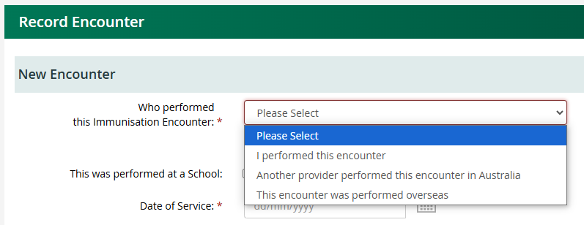

Figure 1. Screenshot of question from PRODA

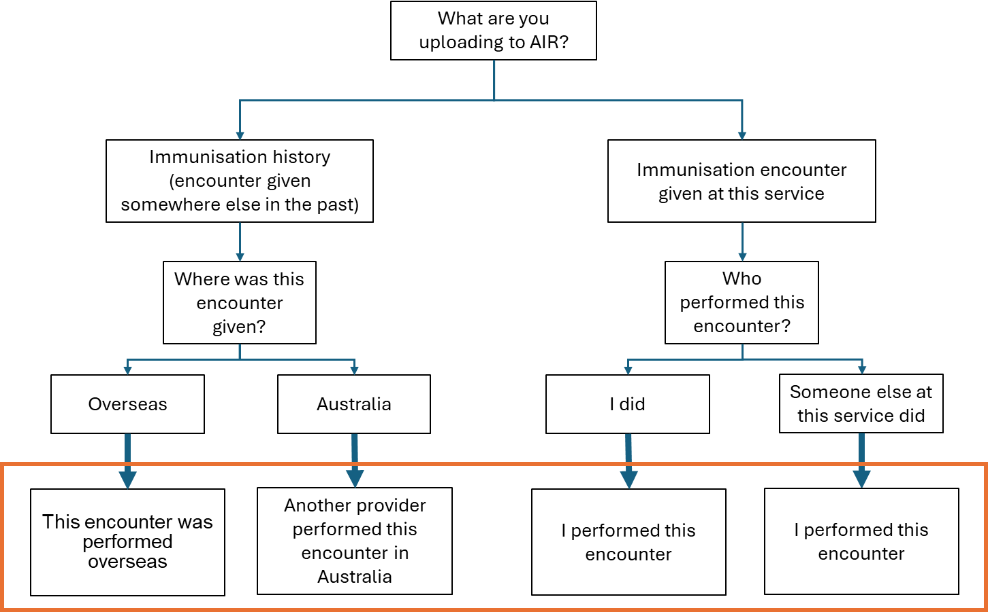

Figure 2. Decision making tree for answering provider question

* Example 1: if a doctor performed an encounter at a hospital or GP clinic and this record is uploaded to the AIR by another staff member, the questions are answered from the perspective of the service as a whole – “I performed this encounter”.
* Example 2: if a nurse performs an encounter in a GP clinic under the authorisation of a GP and the nurse uploads to the AIR, the questions are answered from the perspective of the GP – “I performed this encounter”.
* Example 3: if a nurse immuniser reviews an immunisation history and notices that previous immunisations performed at another Victorian service are missing from AIR, the questions are answered from the perspective of their service – “Another provider performed this encounter in Australia”.

## Vaccine information

### Vaccine codes

* It is important that the correct vaccine code is recorded in the AIR.
* Generic vaccine codes should be avoided unless uploading historic encounters of unknown brands.
* Software may require updating to include newly implemented vaccine codes.
* All vaccine codes available in the AIR can be viewed on the [Service Australia](https://www.servicesaustralia.gov.au/air-vaccine-code-formats?context=20%3e) webpage <https://www.servicesaustralia.gov.au/air-vaccine-code-formats?context=20>.

### Batch numbers

* Batch numbers are **mandatory** to report for all COVID-19, influenza, Japanese encephalitis (JE) and National Immunisation Program (NIP) vaccines.
* Providers are encouraged to record batch numbers for all administered vaccines.
* As batch number formats and locations on vaccines vary between brands, please check them and enter carefully to ensure accuracy.

### Vaccine type field and antenatal status

A new bespoke antenatal indicator has been added to the AIR. This allows immunisation providers to report to the AIR if the person is pregnant at the time of vaccine administration. Availability of this new field depends on the method used to report to the AIR. See Table 1 for details.

Improvements have been made to the ‘vaccine type’ field to simplify the reporting options.

* Select “NIP/Commonwealth” for vaccines funded under the NIP or by the Commonwealth Government.
* Select ‘Other’ for vaccines purchased privately purchased or funded by the Victorian Government.
* If the new antenatal field is not yet available to you, select “Antenatal” if the person is pregnant at the time of vaccine administration.

**Note:**  Where an individual is pregnant, providers should report the ‘Antenatal’ option in the first instance.

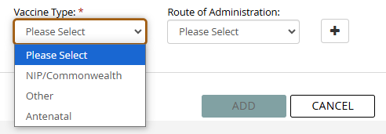

Figure 3. Screenshot of Vaccine Type and Route of Administration field from PRODA

Table 1. Method of reporting immunisation encounters to the AIR

|  |  |  |  |
| --- | --- | --- | --- |
| Method of reporting* | Date available | Where to report Antenatal Status | Options under ‘Vaccine Type’ field |
| Practice software – Updated to include new antenatal field | From 8 December 2024 | Antenatal field | * NIP/Commonwealth * Other |
| Practice software – Not yet updated | December 2024 to October 2025 | Vaccine Type field | * NIP/Commonwealth * Other * Antenatal |
| Manual reporting to AIR site | From 9 February 2025 | Antenatal field | * NIP/Commonwealth * Other |

* Immunisation providers wanting to know when these changes will be available with their clinical software are encouraged to speak with their software provider.

### RSV immunisation AIR code

Ensure you use the correct RSV immunisation AIR code, avoid using the generic RSV code.

Table 2. RSV immunisation AIR code

|  |  |
| --- | --- |
| Immunisation brand | Immunisation AIR code |
| ABRYSVO | ABRSV |
| Beyfortus (Nirsevimab) | BFRSV |

|  |
| --- |
| To receive this document in another format or email the [Immunisation Program](mailto:Immunisation%20Program) [<immunisation@health.vic.gov.au](mailto:%3cimmunisation@health.vic.gov.au)>.  Authorised and published by the Victorian Government, 1 Treasury Place, Melbourne.  © State of Victoria, Australia, Department of Health, February 2025.  Available at [Respiratory Syncytial Virus (RSV) immunisation](https://www.health.vic.gov.au/immunisation/respiratory-syncytial-virus-immunisation) <Respiratory syncytial virus (RSV) immunisation | health.vic.gov.au>. |