CDIS calendar process
Victorian Maternal and Child Health (MCH) Child Development Information System (CDIS)
December 2020

Contents
Overview 2
Calendar features and functions 2
Other hints and tips 8
CDIS calendar set-up process 9
Open new appointment – ‘Schedule Appointment’ window 9
1. Staff member or reliever allocation to site on any given day 10
2. Add admin, lunch and staff meetings to site calendar 13
3. Block out time for planned non-client appointments 16
Make a new client appointment from the calendar 19
Important note when making new client appointments 23
Start a client appointment from the calendar – KAS and Additional 24
Start a client appointment – telephone consult, case consult and clinical admin 25
Make a new client appointment from client history 26
Cancel or edit a client appointment from the calendar 30
Important note: Do not delete a client appointment from client history 34
Make a new non-client appointment from the calendar 35
Cancel or edit a non-client appointment from the calendar 37

Overview

Calendar features and functions
Figure 1: Calendar home screen
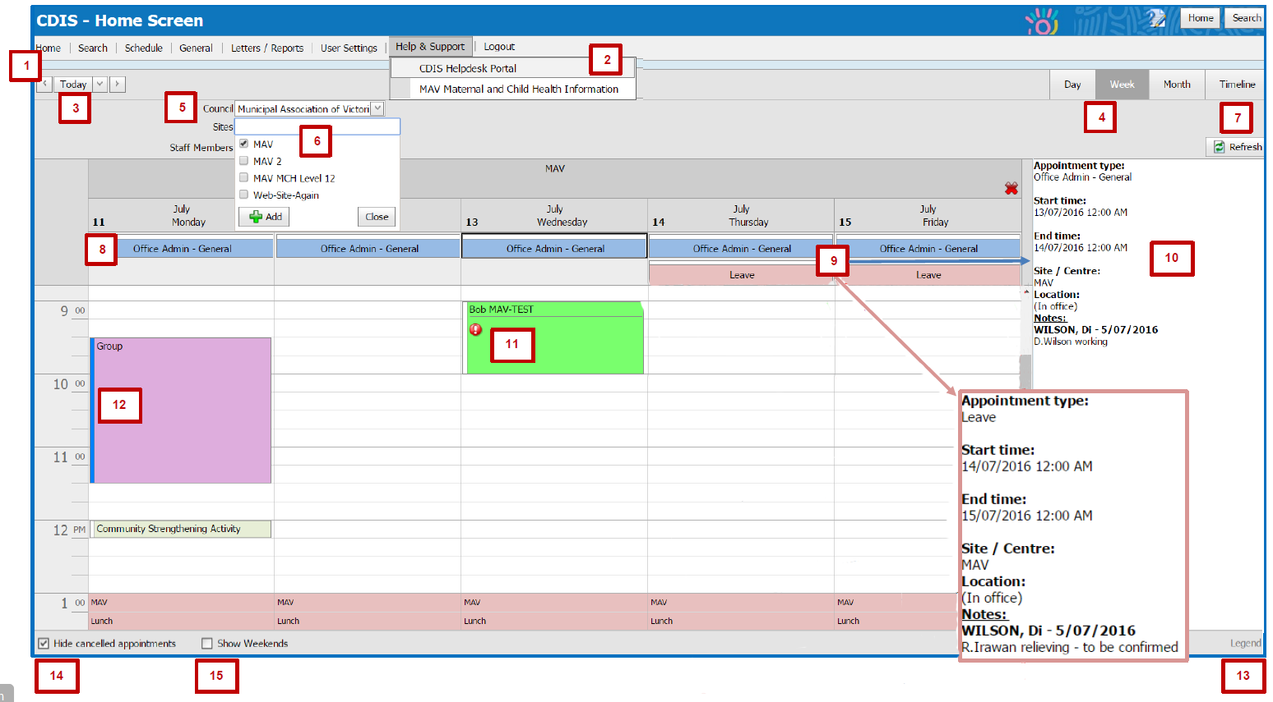

1. Home screen
- The home screen is where you will find the calendar.

2. Help and support menu
- Includes links to the CDIS Helpdesk portal and the MCH web page.

3. Date selection
Select the down arrow to display the calendar pop-up box for picking dates.
Figure 2: Calendar date picker
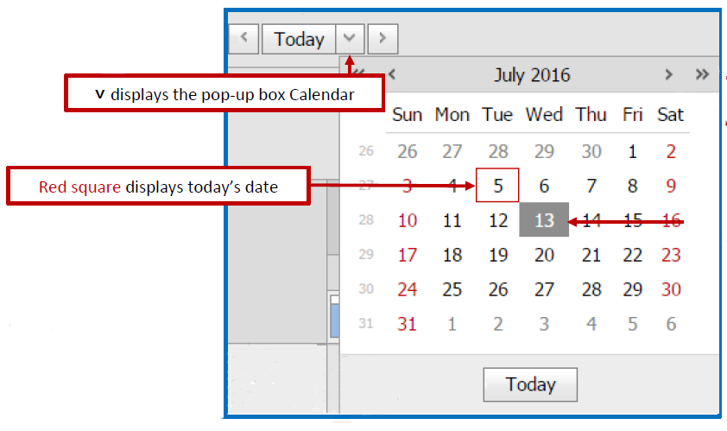
Calendar navigation buttons:
- left and right arrows: moves by one increment – a day, week or month depending on which calendar view is selected
- today button: displays today’s date in calendar view, whichever calendar display is selected
- Down arrow: displays calendar pop-up box.
Calendar pop-up box shows one month of dates and features:
- double left and right arrows: move back or forward one year
- left and right arrows: move back or forward one month
- reds square around today’s date
- shaded square on date selected in calendar view
- today button: select to go to today’s date in the calendar view for whichever calendar display is selected.

4. Calendar view
- ‘Calendar Week’ view is best for viewing and making appointments.
- You can view a number of different sites at the same time (select sites, then select the Add button)
- Site calendars can be closed (one at a time) if not needed to be viewed by selecting red X to close
- If you select a particular day while in Calendar Week view, then select day, month or timeline – it will display the day that was last selected (as per view selected).
- Select a day before changing to day, week or month view otherwise it will default back to the previous selected date.
- While Victorian Public Holidays are ‘greyed out’ in the CDIS calendar, appointments can still be booked. Be careful to check this when booking appointments. It is recommended that Victorian Public Holidays be ‘blocked out’ by making a new appointment from 8.00 am to 5.00 pm with appointment type as ‘Centre Closed’. This will make it more obvious that the centre is not open on that day.

5. Council
Council is set to default in your user settings.

6. Site and staff members
- CDIS calendar is by site (not staff member).
- Site is set to default in your user settings.

7. Refresh button
- If there is a problem with the calendar view after adding information, simply select the Refresh button.
- To view a newly made appointment in the ‘Appointment Summary’, select a blank space or the Refresh button and then select the appointment that you wish to view.

8. All-day appointments
- Appointments can be made as ‘all day’ appointments by selecting the ‘All day’ checkbox when scheduling an appointment.
- All day appointments are displayed at the top of the calendar and will hold this position even as the calendar scrolls down throughout the day.
Note: While it is an ‘all day’ appointment, it will not block out the calendar as such –appointments can still be made on that day. To ‘block out’ the day (if required), new appointment from 8.00 am to 5.00 pm with appointment type as ‘Centre Closed’. This will make it more obvious that the centre is not open on that day.

9. Staff member or reliever allocation
Note: There is a work around available forthe calendar with the ability to allocate staff members working on particular days at particular sites.
For staff member allocation at site (see Figure 3):
- Appointment type: Office admin – general
- All-day appointment box checked
- Notes: enter staff member’s name
For reliever allocation (see Figure 4):
- Appointment type: Leave
- All-day appointment box checked
- Notes: enter reliever’s name
See ‘1. Staff member or reliever allocation to site on any given day’.
Figure 3: Example appointment summary - staff member allocation
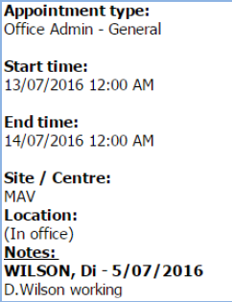

10. Appointment summary
- When an appointment is selected, an ‘Appointment Summary’ will be displayed in the summary details section on the righthand side of the calendar.
- To view a newly made appointment in the appointment summary, select a blank space or select the Refresh button and then select the appointment that you wish to view.
- To go to ‘Client History’ or start an appointment, select the client name hyperlink in the appointment summary.
Figure 4: Example appointment summary – reliever allocation
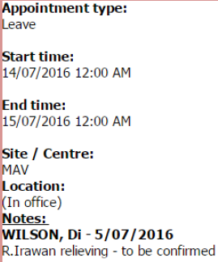

11. Appointment icons
Icons are displayed in appointments to signify alerts:
- –Risk factor flag or alert
- – Interpreter required
- – Email reminder sent
- – SMS reminder sent
- – Important note.

12. Appointment colour panels
Appointment colour panels:
- Blue – Unconfirmed appointment
- White – Confirmed appointment
- Red –Cancelled appointment
- Purple –Out of office location.

13. Legend button
Appointments are colour-coded, to see what the colours mean, select ‘Legend’. See Figure 5.

14. ‘Hide Cancelled Appointments’ checkbox
- Hide cancelled appointments is the default – that is, the calendar hides the cancelled appointments (unless the checkbox is unticked).
- Uncheck the ‘Hide cancelled appointments’ box to show cancelled appointments in the calendar.
- A red panel in an appointment slot indicates a cancelled appointment.
- Select a cancelled appointment to view the appointment summary – displays ‘Status: Cancelled on [date] – Reason:…’ The appointment summary also displays a note with the staff member and date of cancellation.

15. Show Weekends checkbox
- The ‘Show Weekends’ checkbox is unticked by default – that is, the calendar hides weekends.
- Select the Show Weekends checkbox to show weekends in calendar.
Figure 5: CDIS calendar legend

Additional Consultation

Student Supervision

Home Visit

2 Week Consult

4 Week Consult

8 Week Consult

4 Month Consult

8 Month Consult

12 Month Consult

18 Month Consult

2 Year Consult

3.5 Year Consult

Additional Consult

Family Consultation

Enhanced MCH

Sleep & Settling - Outreach

Telephone Consult

Case Consult

Enhanced

Clinical Admin

Office Admin - General

Office Admin - Group preparation

Office Admin - Reports

12 Month KAS

18 Month KAS

2 Week KAS

2 Year KAS

3.5 Year KAS

4 Month KAS

4 Week KAS

8 Month KAS

8 Week KAS

Home Visit

Immunisation Session

New Babies

Outreach

Team/Staff Meeting

Case Conference

External Meeting

Clinical Supervision

Professional Development

Travel

Leave

Community Strengthening Activity

Special Projects

Group

Centre Closed

Lunch

Consult - non CDIS client

Open Session

Interpreter Session

Tea Break

Public Holiday

Other hints and tips
- To book a Brigance or Council-funded appointment (such as six week, three month, six month), make a new client appointment with appointment type of ‘additional’. When the consultation is started, add a reason by selecting Brigance, Council-funded and so on.
- To start a new client appointment with an appointment type of ‘KAS appointment’ or ‘Additional Consult’, select hyperlink in Appointment Summary to go to Client History, then go to Clinical Activity – Consultations and select the booked appointment hyperlink.
- To start a new client appointment with appointment type of ‘Telephone Consult’, ‘Case Consult’ or ‘Clinical Admin’, select hyperlink in Appointment Summary to go to Client History, then go to Clinical Activity – Client Not Present.
- Remember: to exit yellow pop-up boxes, go to the end of pop-up box and select the Close button.

CDIS calendar set-up process
Figure 6: Calendar home screen
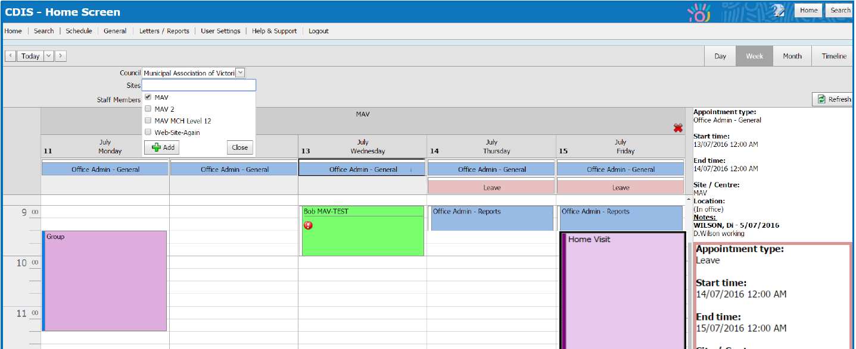

Open new appointment – ‘Schedule Appointment’ window
- Open the home screen
- Select view type (day, week, month, timeline)
- Council and site will auto-fill based on your user settings default
- Select the desired date
- Select the desired day
- Select the appointment slot and open the context menu (right click on the appointment slot). Select ‘New Appointment’.
Figure 7: 'New appointment'
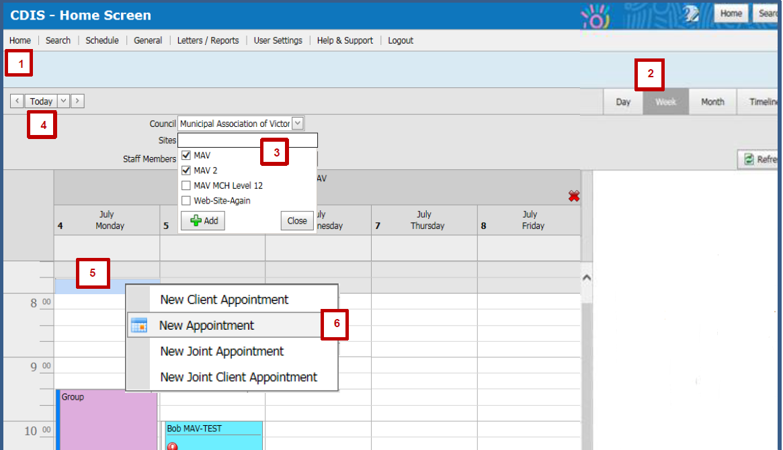

1. Staff member or reliever allocation to site on any given day
Note:
There is a work around available for the calendar with the ability to allocate staff members working on particular days at particular sites.
You can allocate staff the following way (this is the same as making a new appointment in CDIS Calendar).
- Follow ‘Open new appointment – ‘Schedule Appointment’ window’
- Enter ‘Appointment Type’ – choose either of the following from the look-up list
    - For staff member allocation: ‘Office Admin – General’
    - For reliever staff allocation: ‘Leave’
Figure 8: Schedule appointment (top)
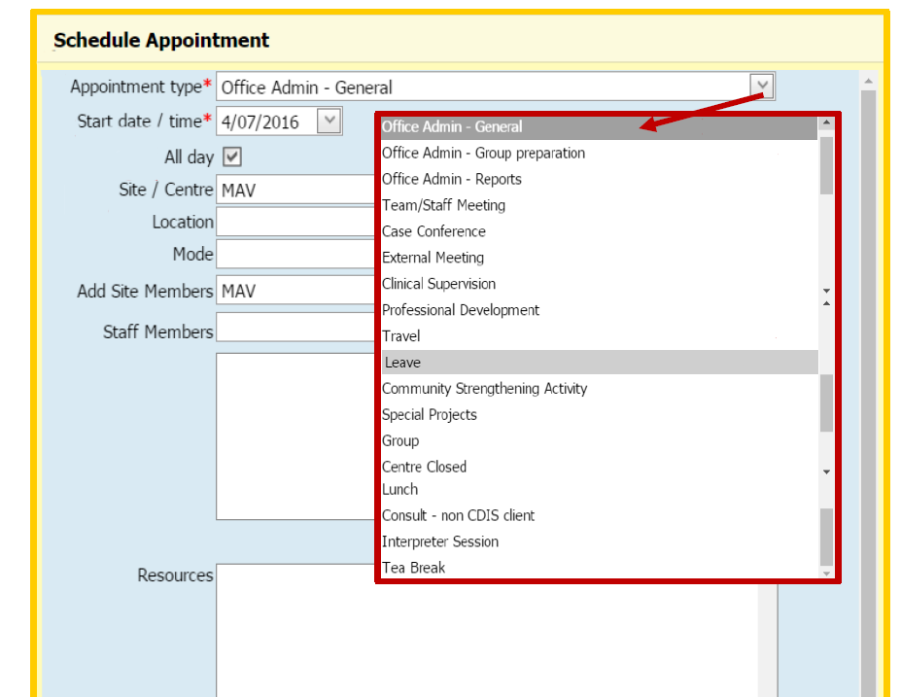
- Ensure date is correct
- If it is an all-day appointment, select the ‘All-day appointment’ checkbox – this will remove time fields
- Ensure ‘Site/Centre’ is correct – this is the site for appointment in the calendar
    - This is auto-filled from your user settings
- In ‘Important Notes’, enter the name of the staff member or reliever allocated to that site for the day – this will be displayed in the appointment summary.
- Select box for Recurrence if required (most effective when allocating staff members or relievers to the same site) – the following parameters will then be revealed
    - Select or enter required recurrence data
    - Select or enter end recurrence information (‘No end date’, ‘End after’ or ‘End by’)
    - Recurrent appointments can be cancelled singularly or as multiple appointments
    - Recurrent appointments can only be edited singularly and not as multiples
- Select Save
    - If you select Cancel, a pop-up box will ask ‘Are you sure?’
Figure 9: Schedule Appointment pop-up (bottom)
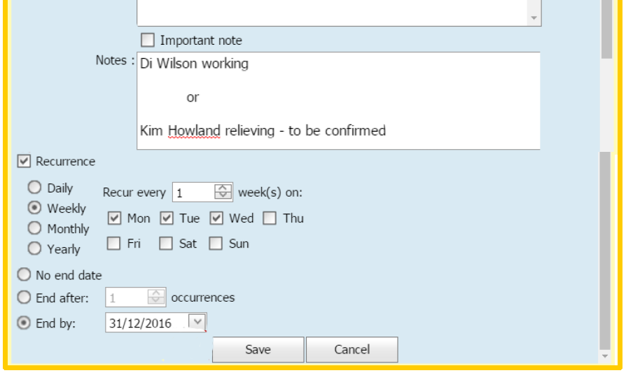
Figure 10: Completed staff member or reliever allocation
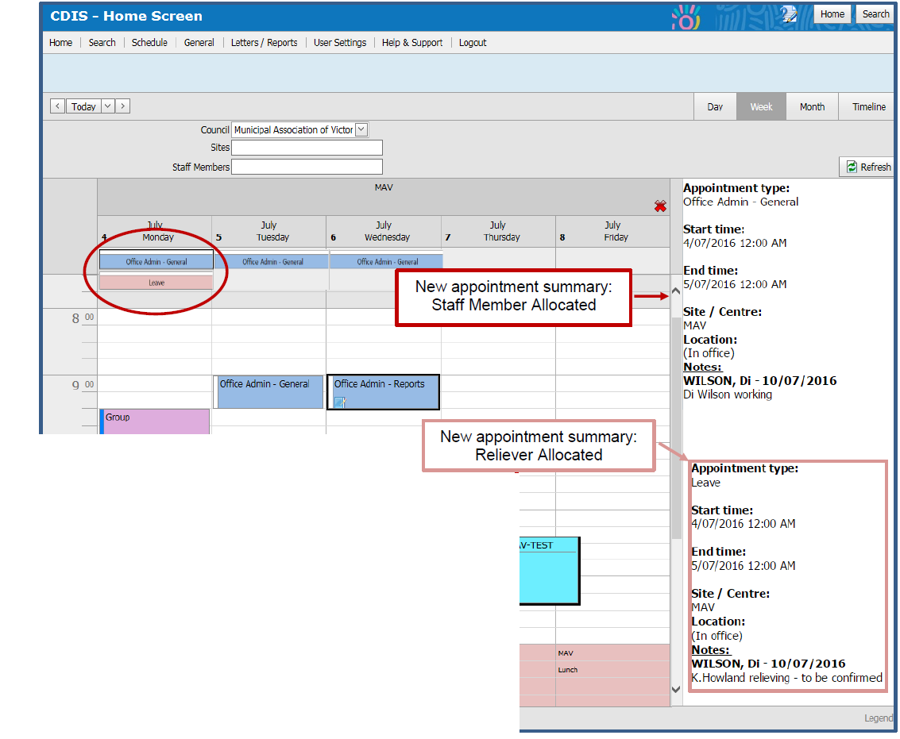
Note: All-day appointments are displayed at the top of the calendar.
Additional notes:
- See ‘Appointment summary’
- See ‘Appointment colour panels’
- See ‘Legend button’
- See ‘Hide cancelled appointments checkbox’

2. Add admin, lunch and staff meetings to site calendar
This is the same as making a new appointment in the calendar
- Follow ‘Open new appointment – ‘Schedule Appointment’ window’.
- Enter the appointment type – choose one of the following from the look-up list
    - for admin: Office Admin – ‘General’
    - for team or staff meetings: ‘Team/Staff Meeting’
    - for lunch: ‘Lunch’.
- Ensure date/time is correct – use digits or arrows to edit.
- Ensure the site or centre is correct – this is the site for appointment in the calendar – this is auto-filled from your user settings
- Select ‘Location’ and ‘Mode’ from look-up lists if required
    - all venues except ‘Office/MCH Centre’ will be displayed as ‘out of office’ in the calendar
Figure 11: Schedule admin, staff or lunch meeting (top)
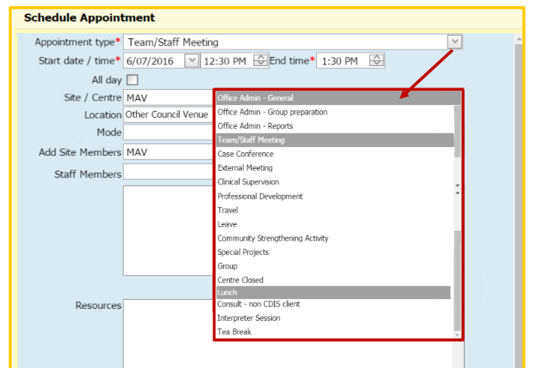

- Enter notes in the free-text field – these are displayed in the appointment summary
    - to make an ‘Important note’ – an icon is displayed on the appointment in the calendar –check the Important note box.
- If the appointment recurs, select the Recurrence checkbox (most effective when entering admin and lunch appointments for the same site) – the following parameters will then appear:
    - select or enter required recurrence data
    - select or enter end recurrence information (no end date, end after or end by)
    - recurrent appointments can be cancelled singularly or as multiple appointments
    - recurrent appointments can only be edited singularly and not as multiples.
- Select Save
    - if you select Cancel, a pop-up box will ask, ‘Are you sure?’
Figure 12: Schedule admin, staff or lunch meeting (bottom)
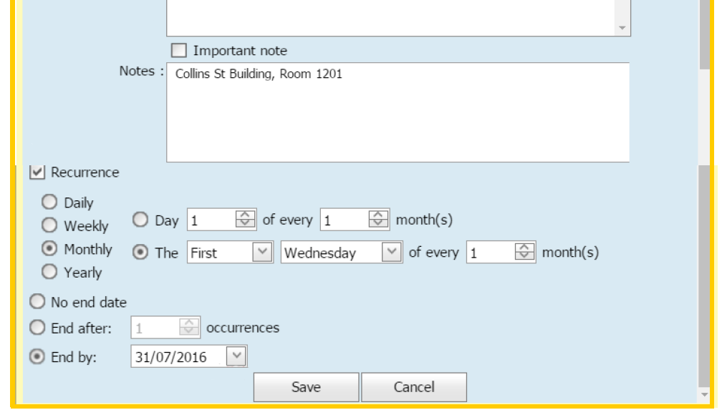
Figure 13: Completed team meeting in calendar
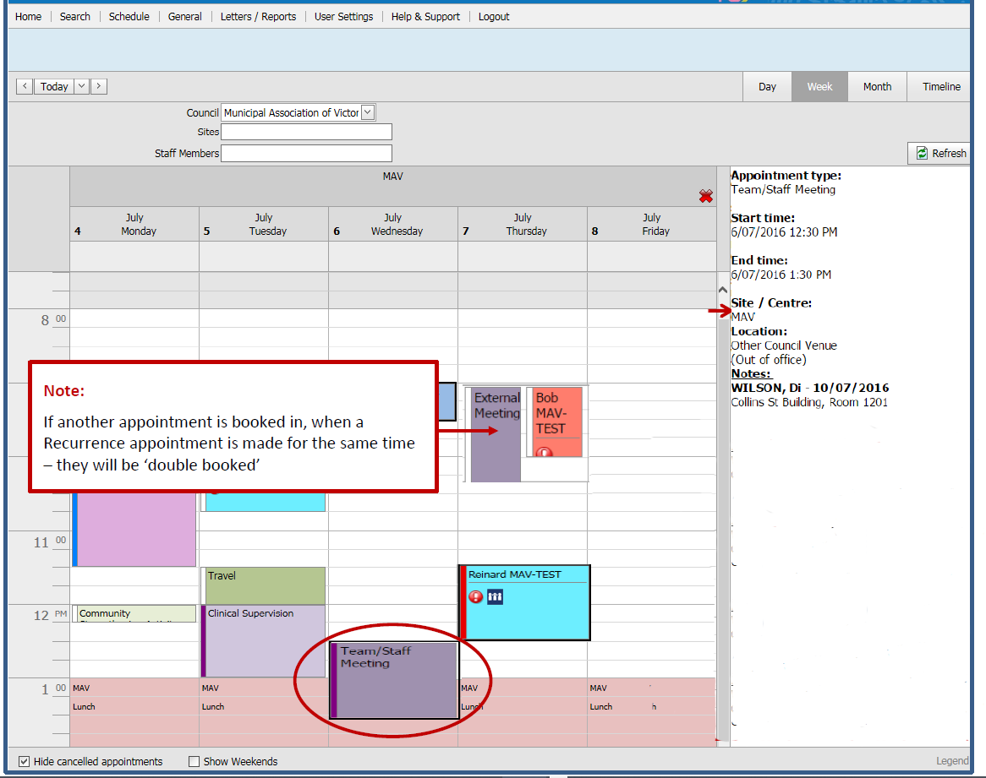
Note: If another appointment is booked when a recurrence appointment is made for the same time, they will be ‘double booked’.
Additional notes:
- See ‘Appointment summary’
- See ‘Appointment colour panels’
- See ‘Legend button’
- See ‘Hide cancelled appointments checkbox’

3. Block out time for planned non-client appointments
Blocking out time for home visits, particular appointments or groups without actually scheduling an appointment or group.
This is the same as making a new appointment in the CDIS Calendar
- Follow ‘Open new appointment – ‘Schedule Appointment’ window’.
- Enter the appointment type – choose from the look-up list (such as home visit, group and so on).
- Ensure the date and time is correct (use digits or arrows to edit).
- Ensure the site or centre is correct – this is the site for appointment in the calendar.
    - This is auto-filled from your user settings.
- Select location and mode from look-up lists, if required.
    - All venues except ‘Office/MCH Centre’ will be displayed as ‘out of office’ in the calendar.
Figure 14: Block out time for home visits or groups (top)
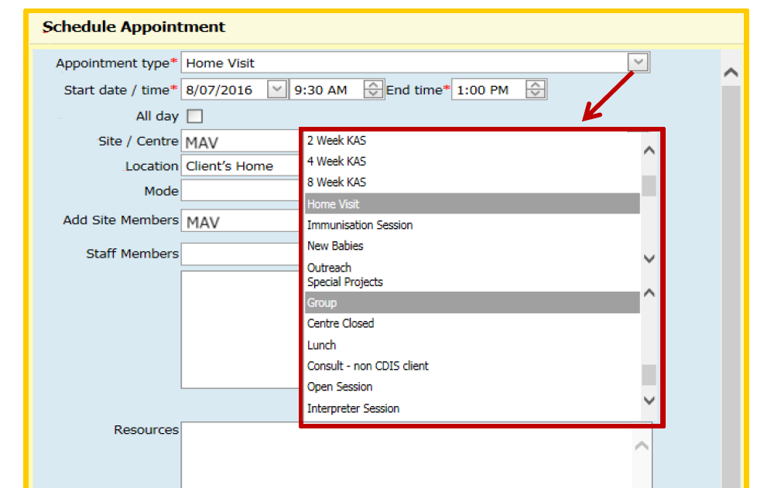
- Enter notes in the free-text field – these are displayed in the appointment summary
    - To make an ‘Important note’ – an icon is displayed on the appointment in the calendar – check the Important note box.
- If the appointment recurs, select the Recurrence checkbox (most effective when entering admin and lunch appointments for the same site) – the following parameters will then appear:
    - Select or enter required recurrence data
    - Select or enter end recurrence information (no end date, end after or end by)
    - Recurrent appointments can be cancelled singularly or as multiple appointments
    - Recurrent appointments can only be edited singularly and not as multiples.
- Select Save
    - If you select Cancel, a pop-up box will ask, ‘Are you sure?’
Figure 15: Block out time for home visits and groups (bottom)
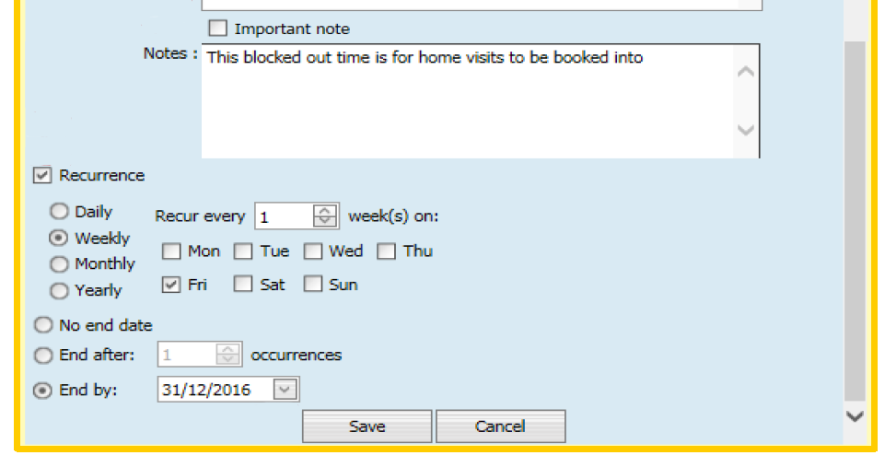
Figure 16: Completed home visit appointment to block out time in calendar
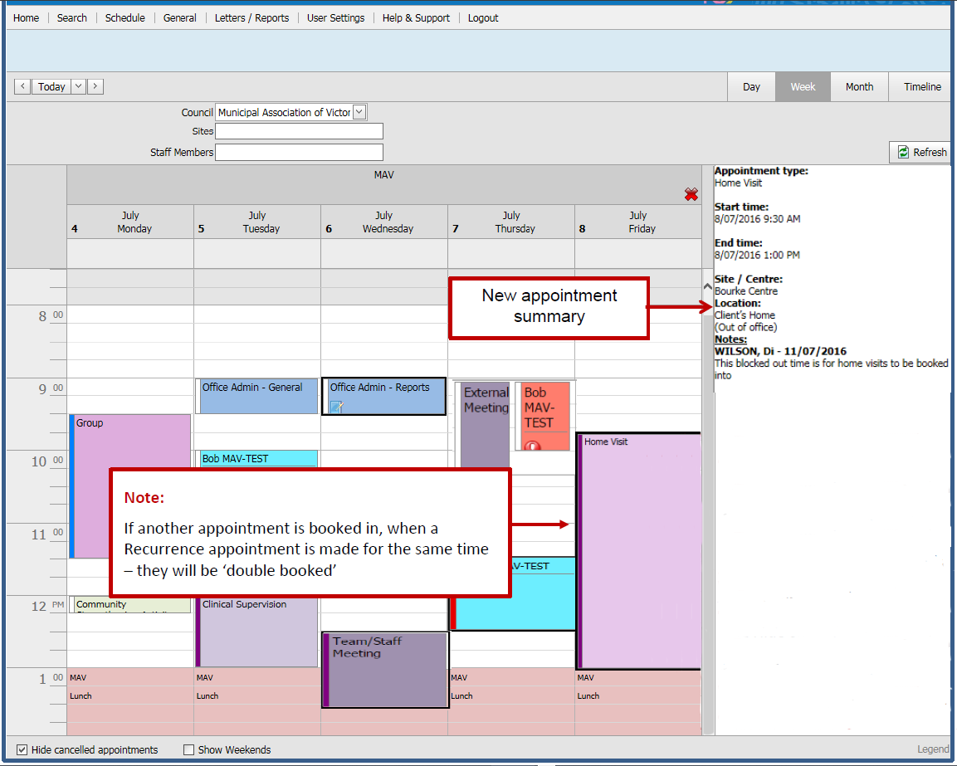
Note: If another appointment is booked when a recurrence appointment is made for the same time, they will be ‘double booked’.
Additional notes:
- See ‘Appointment summary’
- See ‘Appointment colour panels’
- See ‘Legend button’
See ‘Hide cancelled appointments checkbox

Make a new client appointment from the calendar
- Open the home screen
- Select view type (day, week, month, timeline)
- Council and site will auto-fill based on your user settings default
    - Only use ‘Staff Members’ and select the Add button if required
- Select Date
- Select desired start time
    - To highlight the whole appointment, hold and drag cursor down to the required end time
- Open the context menu (right click on the highlighted appointment slot) and select ‘New Client Appointment’
- Search for the client by entering the identifier or last name
- Select the Search button
- Select the client from the list of search results
- Note age to determine next KAS required
- Select ‘Create client appointment’ button
Figure 17: Client Appointment pop-up box
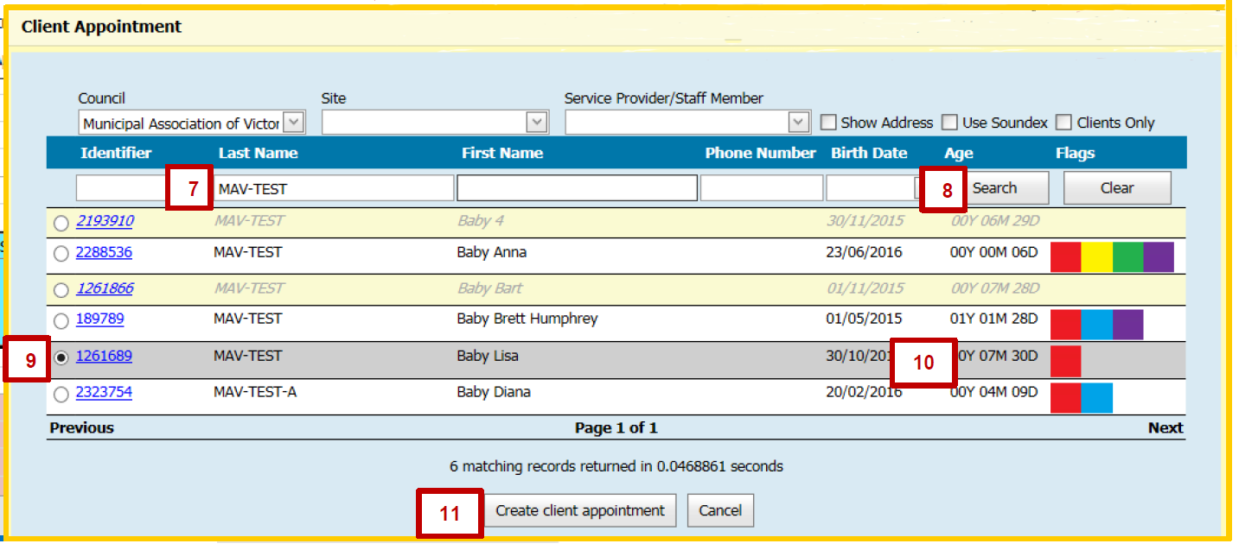
- Ensure the client name is correct (this is auto-filled from search).
- Select the appointment type from the look-up list.
    - The same appointment type apart from KAS appointments can be added multiple times.
- Ensure the date and time are correct (use digits or arrows to edit)
- Ensure the site or centre is correct – this is the site for appointment in the calendar (this is auto-filled from your user settings)
- Select location and mode from the look-up lists

- The ‘Interpreter Required’ checkbox is auto-filled tick if entered in the Client Details screen
    - This box can be unticked by selecting it again
Figure 18: Schedule 8 month consult (top)
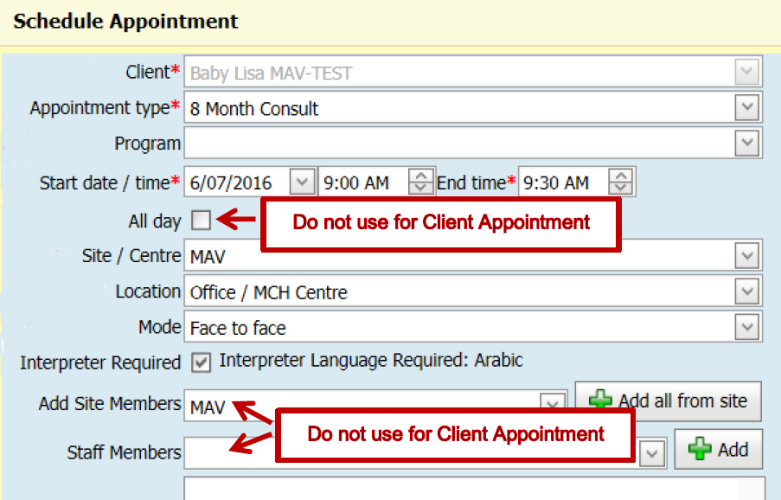
- Enter notes in the free-text field - these are displayed in the appointment summary
    - To make an 'Important note' – an icon is displayed on the appointment in the calendar – check the Important note box.
- The ‘Appointment confirmed’ checkbox is automatically checked – this is staff confirming the appointment
    - This box can be unticked by selecting it again
- Select the ‘Immediate send’ checkbox if the appointment is within three business days or select the ‘Generate reminder’ checkbox
    - SMS or emails will only be sent if primary contact or contact client details are entered
    - Select the relevant checkbox to select who receives the SMS or email reminder
    - Ensure the primary contact or contact update client details are correct
    - If you need to change the default reminder text, select the ‘Override default SMS text’ or ‘Override default email text’ checkbox
    - Important: Do not change the fields in square brackets []!
- Select Save
    - If you select Cancel, a pop-up box will ask, ‘Are you sure?’
Figure 19: Schedule 8 month consult (bottom)
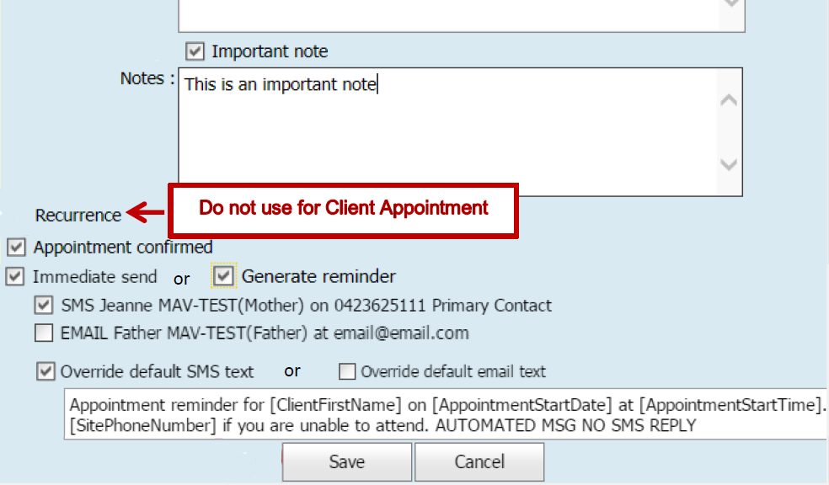
Note: For client appointments, do not use the following:
- All-day appointment checkbox – this is for non-client appointments only
- ‘Add site members’ and ‘Staff members’ – only for specific purposes
- Recurrence – for non-client appointments only
Figure 20: Completed 8 month consult
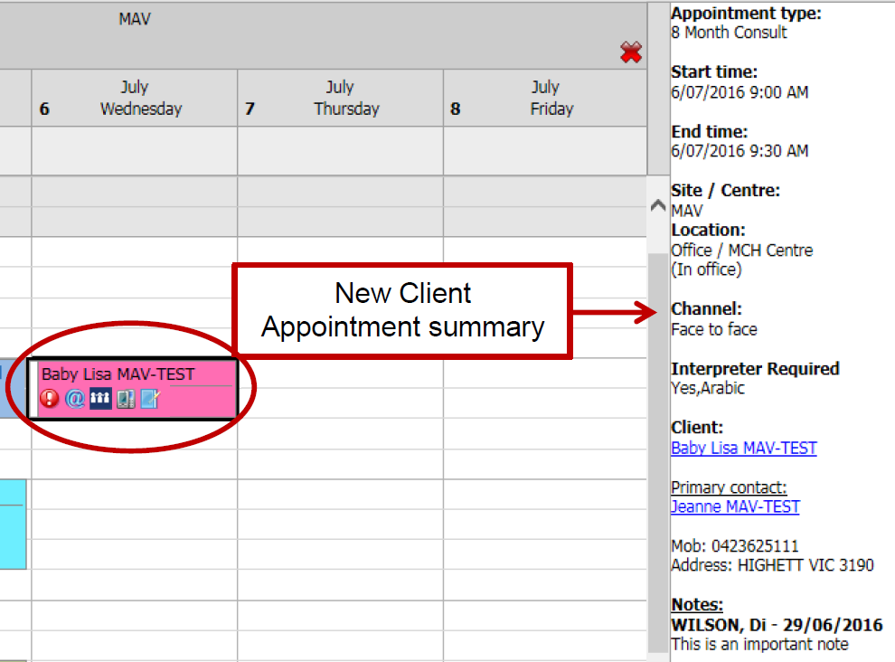
Additional notes:
- See ‘Appointment summary’
- See ‘Appointment icons’
- See ‘Appointment colour panels’
- See ‘Legend button’
- See ‘Hide cancelled appointments checkbox’

Important note when making new client appointments
Note: Any appointments outside of KAS (and these) are to be made as ‘Additional Consult’ or Family Consultation.
If the appointment type is:
- Telephone consult
- Case consult
- Clinical admin
Figure 21: Schedule telephone consult
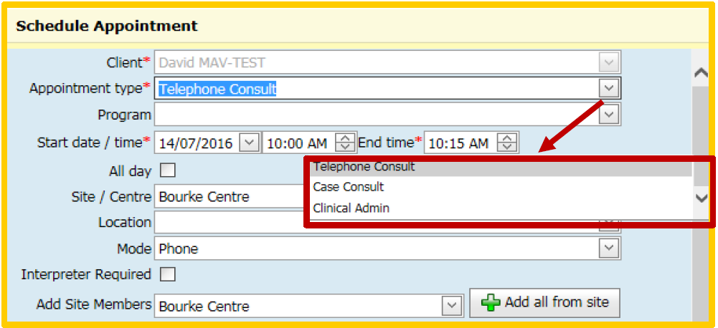
The appointment will be linked to the selected client and an appointment summary will be displayed in the calendar.
The appointment summary will contain a hyperlink to that client history.
Figure 22: Appointment summary for telephone consult
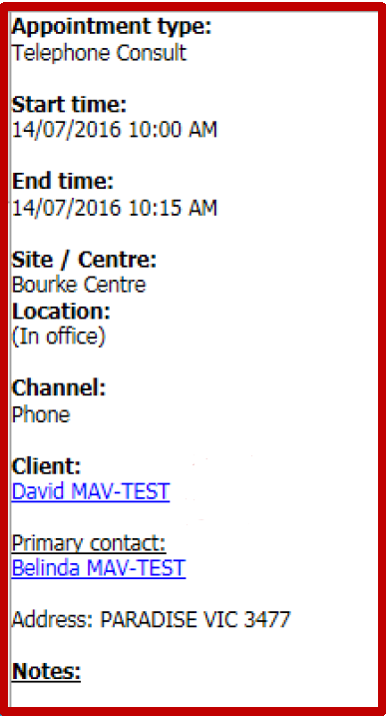
The appointment will then be displayed on the ‘Client Details – Summary Page’, under the heading ‘Future Appointments’.
Figure 23: Telephone consult under 'Future Appointments'
It will not be displayed in ‘Clinical Activity – Consultations’ as the consultation or appointment must be started as ‘Clinical Activity – Client Not Present’.
Figure 24: Client not present
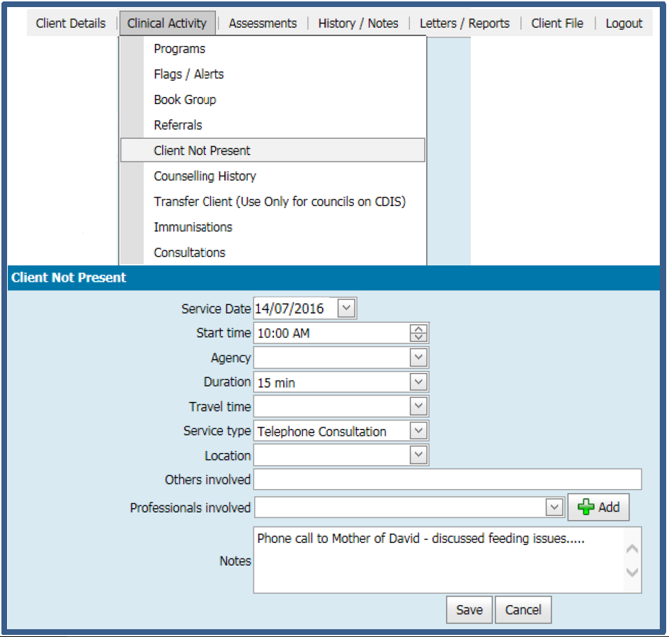
Note: If the client is present at the consultation, then an appointment type of ‘Additional’ needs to be made instead.

Start a client appointment from the calendar – KAS and Additional
[LEGEND REFERENCE – ADDITIONAL INFO AND ICONS IN APPOINTMENTS]
1. Select ‘Client Appointment’ to display the appointment summary in the calendar.
2. Select the client name hyperlink in the Appointment Summary – this opens ‘Client History’. (see Figure 20)
3. In ‘Client History’, select ‘Consultations’ from the Clinical Activity menu.
4. Select the appropriate Consultation hyperlink from the ‘Consultation List’ – this will open the selected consultation to be started.
Figure 25: Consultations list
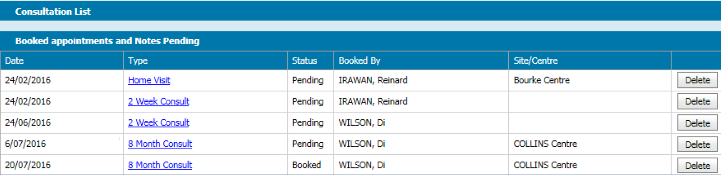
Additional notes:
- See ‘Appointment summary’
- See ‘Appointment icons’
- See ‘Appointment colour panels’
- See ‘Legend button’
- See ‘Hide cancelled appointments checkbox’

Start a client appointment – telephone consult, case consult and clinical admin
Refer to ‘Important note when making new client appointments’

Make a new client appointment from client history
- Open the ‘Client Details’ menu and select ‘Appointment Allocation’.
- Council will auto-fill as in your user settings default
    - Site: Only use ‘Show sites only’ – do not use the down arrow
Figure 26: Appointment Allocation
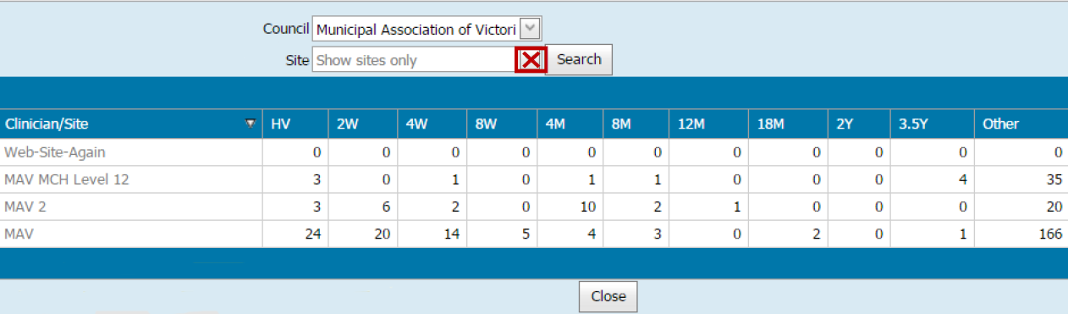
- Select the relevant site
- Select the date
- Ensure that the site is correct
- Select the desired start time
    - To highlight the whole appointment, hold and drag cursor down to the required end time
- Open the context menu (right click on the highlighted appointment slot) and select 'New Client Appointment'
Figure 27: Open context menu
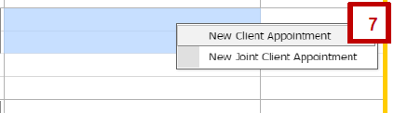
- Ensure the client name is correct (this is auto-filled from Client History).
- Select the appointment type from look-up list.
    - The same appointment type for additional consultations or Family Consultations can be added multiple times.
- Ensure the date and time are correct (use digits or arrows to edit).
- Ensure the site or centre is correct – this is the site for appointment in the calendar.
- Select location and mode from the look-up lists.
- The ‘Interpreter Required’ checkbox is auto-filled tick if entered in the Client Details screen.
    - This box can be unticked by selecting it again.
- Figure 28: Schedule 8 month consult (top)
- Enter notes in the free-text field - these are displayed in the appointment summary.
    - To make an 'Important note' – an icon is displayed on the appointment in the calendar – check the Important note box.
- The ‘Appointment confirmed’ checkbox is automatically checked – this is staff confirming the appointment.
    - This box can be unticked by selecting it again.
- Select the ‘Immediate send’ checkbox if the appointment is within three business days or select the ‘Generate reminder’ checkbox.
    - SMS or emails will only be sent if primary contact or contact client details are entered.
    - Select the relevant checkbox to select who receives the SMS or email reminder.
    - Ensure the primary contact or contact update client details are correct.
    - If you need to change the default reminder text, select the ‘Override default SMS text’ or ‘Override default email text’ checkbox.
    - Important: Do not change the fields in square brackets []!
- Select Save.
    - If you select Cancel, a pop-up box will ask, ‘Are you sure?’
Figure 29: Schedule 8 month consult (bottom)
Note: For client appointments, do not use the following:
- All-day appointment checkbox – this is for non-client appointments only
- ‘Add site members’ and ‘Staff members’ – only for specific purposes
- Recurrence – for non-client appointments only.

Figure 30: Completed 8 month consult
Additional notes:
- See ‘Appointment summary’
- See ‘Appointment icons’
- See ‘Appointment colour panels’
- See ‘Legend button’
- See ‘Hide cancelled appointments checkbox’

See ‘Important Note when making New Client Appointments’

Cancel or edit a client appointment from the calendar
Note: Use the Edit function to edit, reschedule and cancel client appointments
- Open the home screen.
- Select view type (day, week, month or timeline).
- Council and Site will auto-fill based on your user settings default.
    - Only use ‘Staff Members’ and select the Add button if required.
- Select the date.
- Select the client appointment you wish to edit or cancel, open the context menu (right click the appointment) and select ‘Edit’.
Figure 31: Edit appointment
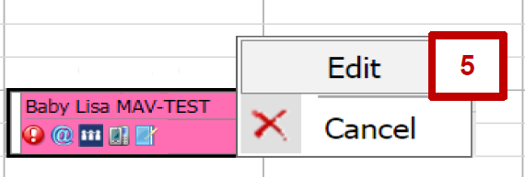
Note: Cancelling client appointments is best done through this Edit function. DNA appointments must be cancelled in the the calendar. By doing DNA appointments this way, it will be automatically recorded in ‘Client History Notes’ and ‘DNA History’. If DNA is completed via ‘Client Consultation’, it will only be recorded in ‘DNA History’.
- Ensure the client name is correct - this is auto-filled from search
- Edit the appointment type from look-up list if required
    - The same appointment type for additional consultations or Family Consultations can be added multiple times.
- Edit date and time if required (use digits or arrows to edit)
- Enter actual time if required (use digits or arrows to edit)
- Ensure the site or centre is correct – this is the site for appointment in the calendar
    - This is auto-filled from your user settings
- Edit the location and mode from look-up lists, if required
- The ‘Interpreter Required’ checkbox is auto-filled tick if entered in the Client Details screen.
    - This box can be unticked by selecting it again.
Figure 32: Edit Appointment box (top)
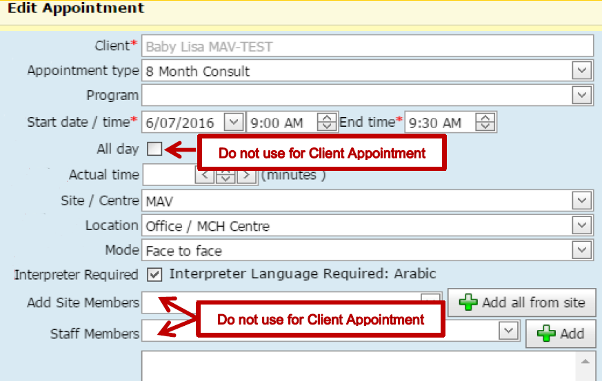
- Enter notes in the free-text field - these are displayed in the appointment summary.
    - To make an 'Important note' – an icon is displayed on the appointment in the calendar – check the Important note box.
- Select either the ‘Re-schedule’, ‘Cancel’ or ‘Data Entry Error’ radio buttons
    - By selecting Re-schedule or Cancel, a ‘Reason’ field will appear – select one from the look-up list.
- Select the ‘Record Did Not Attend’ checkbox – this records DNA in Client History Notes (Notes and DNA History)
    - Select the DNA type from look-up list
    - Select Yes under Send SMS?’ or ‘Follow-up contact made? (if staff member has done this) or both
    - Comments can be added in the free-text field (such as ‘message left for family to reschedule’)
- Appointment confirmed checkbox is automatically ticked – this is staff confirming the appointment
    - The checkbox can be unticked by selecting it again.

- Select the ‘Immediate send’ checkbox if the appointment is within three business days or select the ‘Generate reminder’ checkbox.
    - SMS or emails will only be sent if primary contact or contact client details are entered.
    - Select the relevant checkbox to select who receives the SMS or email reminder.
    - Ensure the primary contact or contact update client details are correct.
    - If you need to change the default reminder text, select the ‘Override default SMS text’ or ‘Override default email text’ checkbox.
    - Important: Do not change the fields in square brackets []!
- Select Save.
    - If you select Cancel, a pop-up box will ask, ‘Are you sure?’
Figure 33: Edit appointment box (bottom)
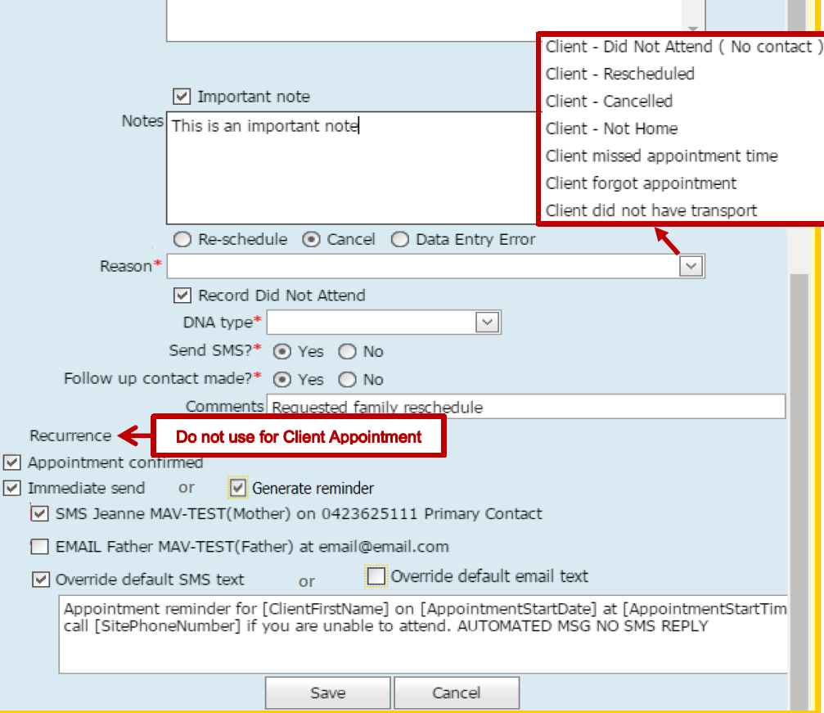
Figure 34: Appointment summary for a cancelled appointment
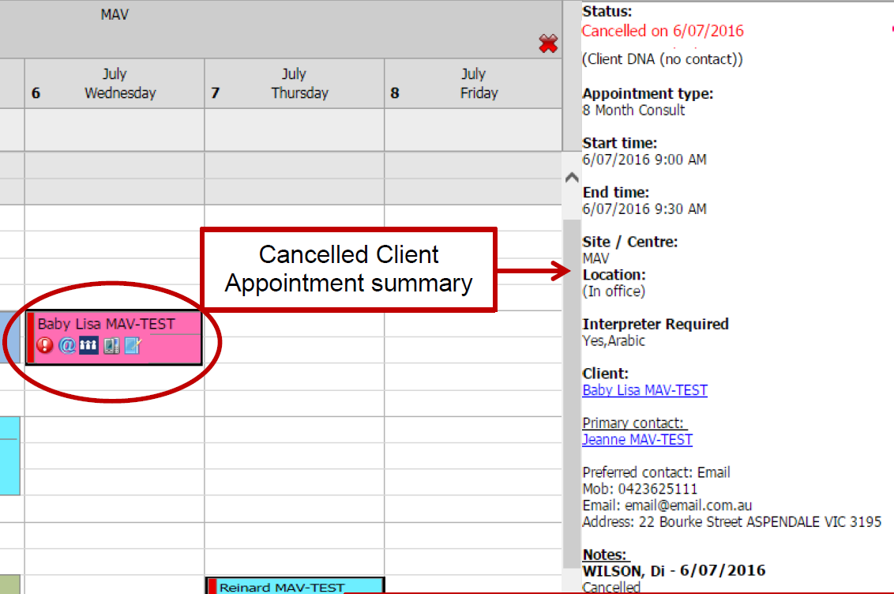
Additional notes:
- See ‘Appointment summary’
- See ‘Appointment icons’
- See ‘Appointment colour panels’
- See ‘Legend button’

Cancelled client appointment in Client History
Figure 35: Note for cancelled client appointment in 'Notes'
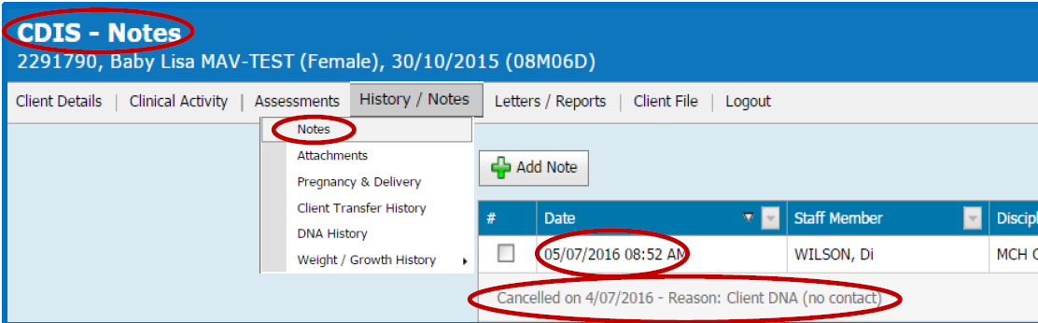
Figure 36: Cancelled appointment note in 'DNA History'
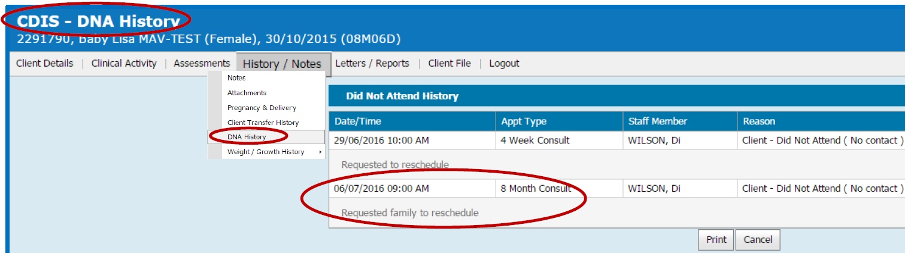

Important note: Do not delete a client appointment from client history
Client appointments can be viewed from Client History – open the Clinical Activity menu and select Consultation (Figure 37).
Figure 37: Consultations list with delete options (do not use!)
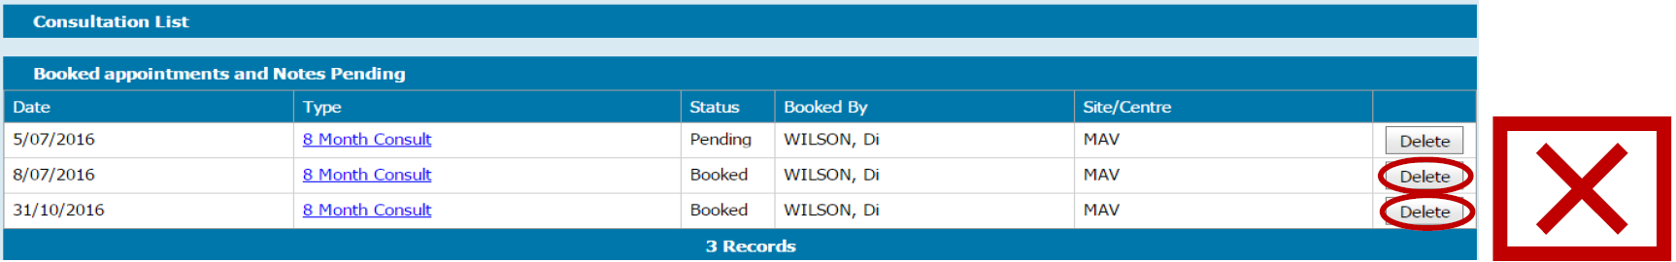
An option to delete an appointment is available; however, if deleted here, it will be displayed on the ‘Client Details – Summary Page’ under ‘Service History’ as ‘Cancelled/Client Re-scheduled (Client DNA (no contact)’ even if this is not the reason for the deleted appointment. It will not be recorded in ‘DNA History’ or ‘Notes’.
Figure 38: Service History section
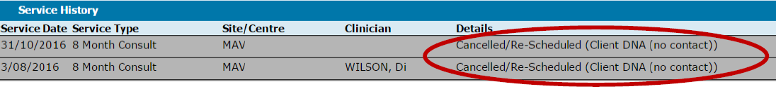

Make a new non-client appointment from the calendar
- Follow ‘Open new appointment – ‘Schedule Appointment’ window’
- Enter Appointment Type –choose from the look-up list
- Ensure the date and time are correct (use digits or arrows to edit)
- If it is an all-day appointment, select the ‘All-day appointment’ checkbox – this will remove time fields
- Ensure ‘Site/Centre’ is correct – this is the site for appointment in the calendar
    - This is auto-filled from your user settings
- Select location and mode from look-up lists, if required.
Figure 39: Schedule office admin - reports appointment (top)
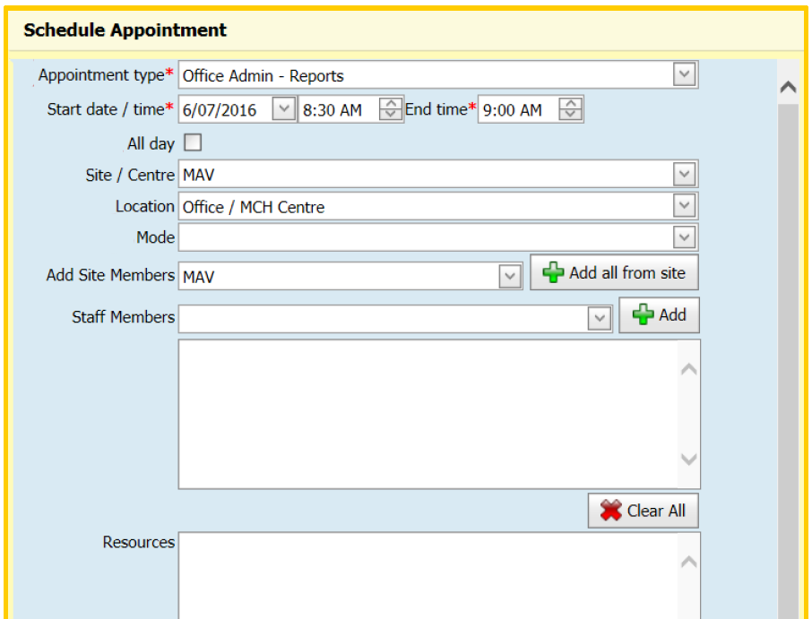
- Enter notes in the free-text field - these are displayed in the appointment summary.
    - To make an 'Important note' – an icon is displayed on the appointment in the calendar – check the Important note box.
- Select box for Recurrence if required (most effective when allocating staff members or relievers to the same site) – the following parameters will then be revealed
    - Select or enter required recurrence data
    - Select or enter end recurrence information (‘No end date’, ‘End after’ or ‘End by’)
    - Recurrent appointments can be cancelled singularly or as multiple appointments
    - Recurrent appointments can only be edited singularly and not as multiples.
- Select Save.
    - If you select Cancel, a pop-up box will ask ‘Are you sure?’
Figure 40: Schedule office admin - reports appointment (bottom)
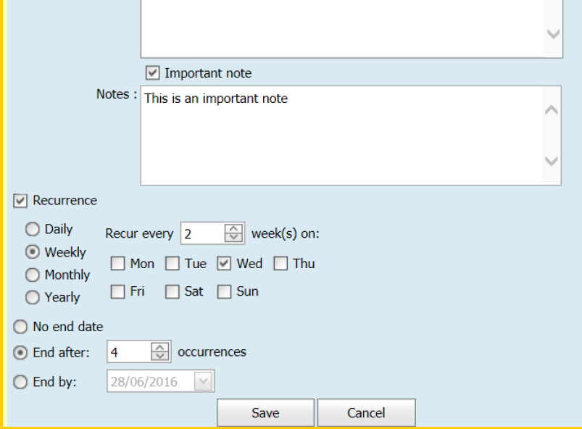
Figure 41: Completed office admin - reports appointment in calendar
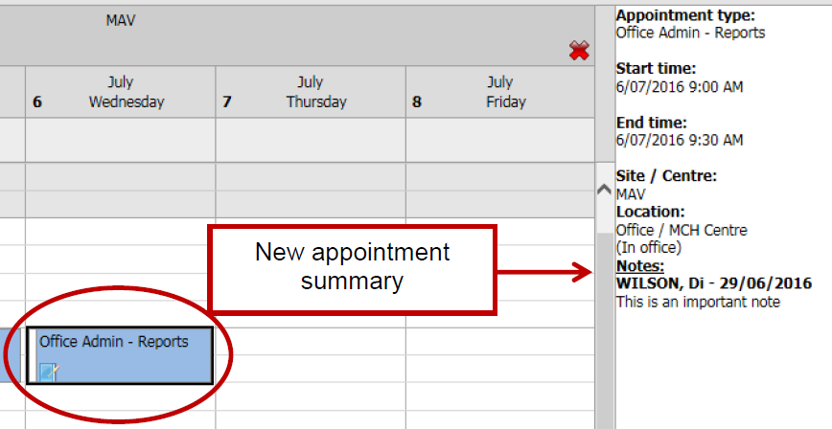
Additional notes:
- See ‘Appointment summary’
- See ‘Appointment icons’
- See ‘Appointment colour panels’
- See ‘Legend button’

Cancel or edit a non-client appointment from the calendar
- Open the home screen.
- Select view type (day, week, month or timeline).
- Council and site will auto-fill based on your user settings default.
    - Only use ‘Staff Members’ and select the Add button if required.
- Select the date.
- Select the client appointment you wish to edit or cancel, open the context menu (right click the appointment) and select ‘Edit’ or ‘Cancel’.
Figure 42: Step 5 – Edit or cancel appointment
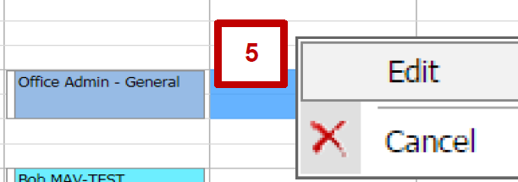
- If selecting Cancel, select ‘Cancel current appointment’ or ‘Cancel all appointments from…’
    - Note: ‘Cancel all appointments from…’ will only be an option if it is a recurrent appointment (non-client appointments only)
Figure 43: Step 6 – Cancel Appointment box
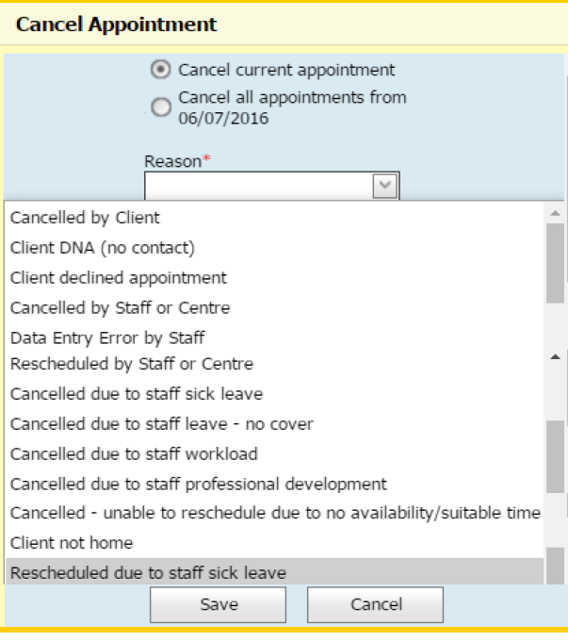
- Select Save
    - If you select Cancel, a pop-up box will ask, ‘Are you sure?
- Edit Appointment Type from the look-up list if required
- Edit date and time if required - use digits or arrows to edit
- If it is an all-day appointment, select the ‘All-day appointment’ checkbox – this will remove time fields
- Ensure ‘Site/Centre’ is correct – this is the site for appointment in the calendar
    - This is auto-filled from your user settings
- Select location and mode from look-up lists, if required.
- Enter notes in the free-text field - these are displayed in the appointment summary.
    - To make an 'Important note' – an icon is displayed on the appointment in the calendar – check the Important note box.
- Select either the ‘Re-schedule’, ‘Cancel’ or ‘Data Entry Error’ radio buttons
    - By selecting Re-schedule or Cancel, a ‘Reason’ field will appear – select one from the look-up list.
- Select box for Recurrence if required (most effective when allocating staff members or relievers to the same site) – the following parameters will then be revealed
    - Select or enter required recurrence data
    - Select or enter end recurrence information (‘No end date’, ‘End after’ or ‘End by’)
    - Recurrent appointments can be cancelled singularly or as multiple appointments
    - Recurrent appointments can only be edited singularly and not as multiples.
- Select Save.
    - If you select Cancel, a pop-up box will ask ‘Are you sure?’
Figure 44: Edit Appointment pop-up box
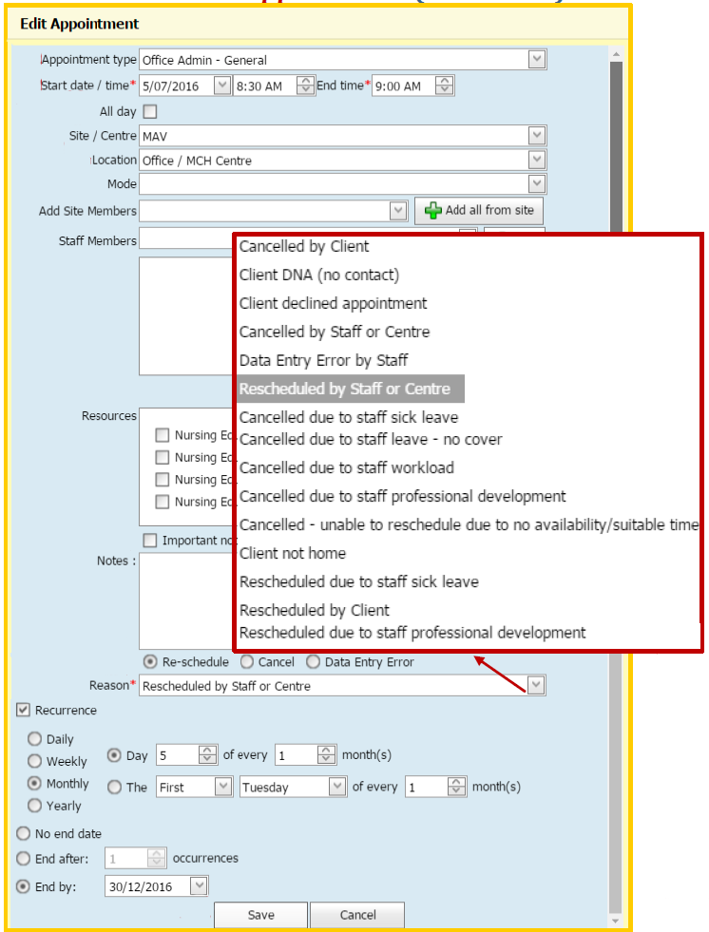
Figure 45: Completed cancelled or rescheduled appointment in calendar
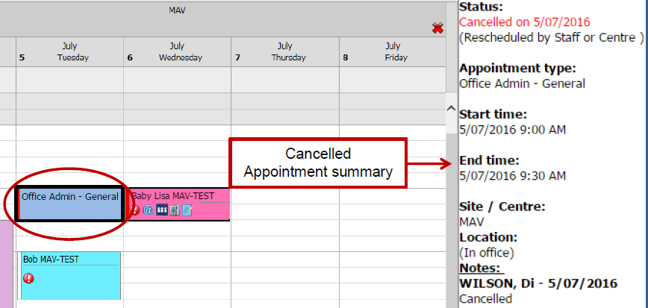
Additional notes:
- See ‘Appointment summary’
- See ‘Appointment icons’
- See ‘Appointment colour panels’

To receive this publication in an accessible format phone 1300 650 172, using the National Relay Service 13 36 77 if required, or email Commissioning Performance and Improvement Aged and Community Based Health Care and Cancer Services <mch@dhhs.vic.gov.au>
Authorised and published by the Victorian Government, 1 Treasury Place, Melbourne.
© State of Victoria, Australia, Department of Health and Human Services June 2020.
Except where otherwise indicated, the images in this publication show models and illustrative settings only, and do not necessarily depict actual services, facilities or recipients of services. This publication may contain images of deceased Aboriginal and Torres Strait Islander peoples.
In this document, ‘Aboriginal’ refers to both Aboriginal and Torres Strait Islander people. ‘Indigenous’ or ‘Koori/Koorie’ is retained when part of the title of a report, program or quotation.
ISBN 978-1-76096-017-9 (pdf/online/MS word)
Available at health.vic – Child Development Information System <https://www2.health.vic.gov.au/primary-and-community-health/maternal-child-health/child-development-information-system>

