Getting started in Child Development Information System
Victorian Maternal and Child Health (MCH) Child Development Information System (CDIS)
Contents
Logging into CDIS for the first time 1
Important tips 2
Saving data 2
Best practice when saving consultations 3
Spellcheck in CDIS 5
Zooming in and out 5

Logging into CDIS for the first time
- Please consult your council officer if you haven't received your username credential.
- Check your email for your initial login password.
- Open the CDIS homepage <https://cdis.dhhs.vic.gov.au>
- Type in your username and your password and select the Log In button. Don't select the Reset password link.
Figure 1: Login screen
- You will get a prompt to set a new password and secret question and answer.
- Passwords must be between 6 and 10 characters.
- Passwords must not be the word ‘password’.
- Passwords are case sensitive.
- Usernames can’t be used as passwords.
- User accounts must have a secret question and secret answer set.

Important tips
Do not use the Backspace key except when your cursor is in a data entry field or you will lose any data entered but not saved.
You can navigate through screens using typical hot keys (such as Tab and Enter).
No horizontal scrolling is needed on 1024 x 768 screens
You can hold the Ctrl key while moving your scroll mouse up or down to zoom in or out
Always remember to select the green plus icon to add data.
Figure 12: Plus icon
For example: If you progress without selecting the icon, this language exposure data will not be included when you save the client record.
Figure 13: Language exposure data
If you lose connectivity – you will not lose data on the screen that you have entered but haven’t been able to save. Leave your machine on, stay logged on and try to save every 30 minutes or so.

Saving data
The concept of saving work to prevent data loss is central to all computer programs.
CDIS has a Save button at the bottom of all screens when you are adding or editing information.
Note: some screens may be long – you may need to scroll to reach the end and access the Save button.
Figure 14: Save button
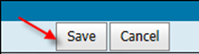
Once you select the save button, you will see the following confirmation message:
Figure 15: Success message
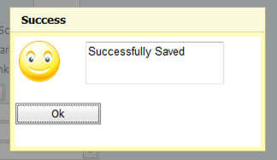
Select Ok to close the message box.
If at any time you select the Cancel button, you will be prompted with a warning box. If you are sure you want to cancel and therefore lose any information entered or edited, select the Yes button (otherwise, select No).
Figure 16: Cancel button
Figure 17: Cancel warning message
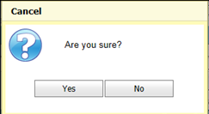
Always take the time to read warning screens.

Best practice when saving consultations
When you are doing a consultation, always make sure to triple check the data you have entered. Once you select save, you won't be able to edit the consultation.
Figure 18: Consultation form
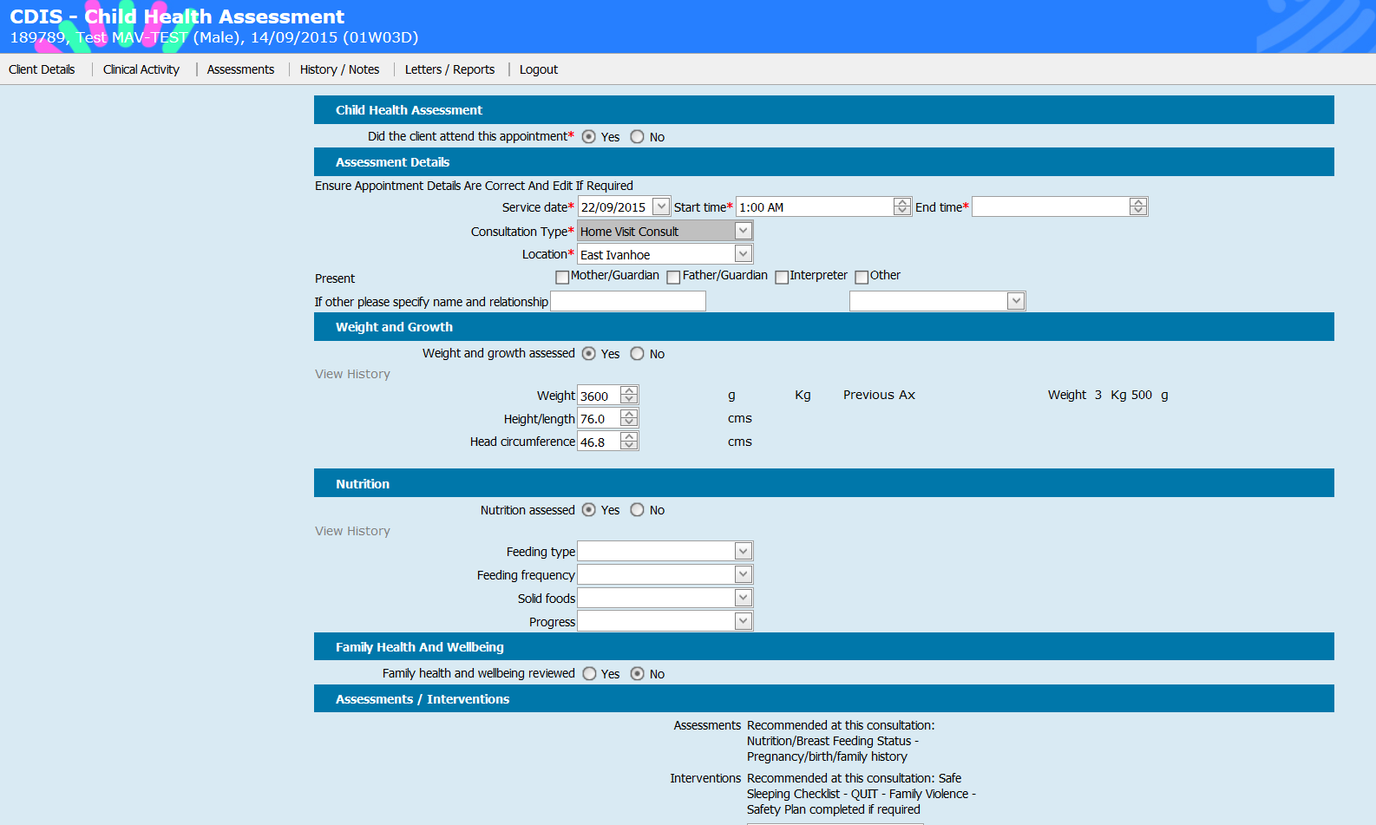
If you don't have the time to check the data that you have entered is correct, select Save as draft first
Figure 19: Save as draft button
When you are ready to save the consultation permanently:
- go to the Consultations screen (Figure 20)
- under Incomplete consultations, choose the consultation
- select Continue to open the consultation
- review and check the data
- Once satisfied, select Save.
Figure 20: Consultations screen
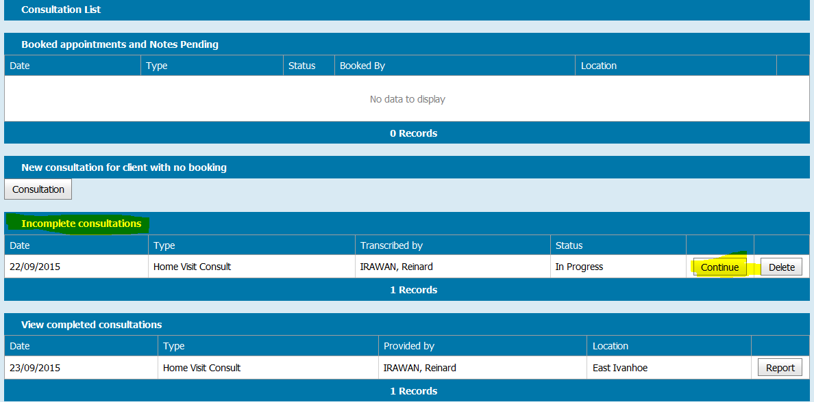

Spellcheck in CDIS
CDIS relies on web browser (Internet Explorer, Safari, Firefox or Chrome) spell check add-on for spell check.
Contact your IT Council Coordinator or Administrator to install the spell check add-on for your web browser.

Zooming in and out
You can zoom out to view everything in one screen (if you have a big resolution monitor, this will be an advantage) or you can zoom in to enlarge fonts to your preference.
Using your keyboard and mouse, hold down the Ctrl key and use:
- Mouse Wheel Up to zoom in
- Mouse Wheel Down to zoom out
Figure 21: Using a mouse scroll wheel to zoom
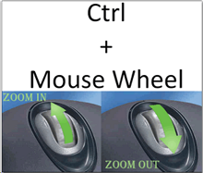

To receive this publication in an accessible format phone 1300 650 172, using the National Relay Service 13 36 77 if required, or email Commissioning Performance and Improvement Aged and Community Based Health Care and Cancer Services <mch@dhhs.vic.gov.au>
Authorised and published by the Victorian Government, 1 Treasury Place, Melbourne.
© State of Victoria, Australia, Department of Health and Human Services June 2020.
ISBN 978-1-76096-015-5 (pdf/online/MS word)
Available at health.vic – Child Development Information System <https://www2.health.vic.gov.au/primary-and-community-health/maternal-child-health/child-development-information-system>

