Better at Home initiative - Webinar Q&A
Home-based and community care models for mild and moderate COVID-19 – the UK experience, presented by Dr. Matthew Inada-Kim
OFFICIAL

Questions from webinar attendees

- Do you have an age breakdown of the people who were managed at home as opposed to those who ended up in hospital? Was it all ages or particular age groups?
The national guidance was 65 or above or under 65 for clinically extremely vulnerable groups, which was those with co-morbidities. Those with diabetes, hypertension, ischemic heart disease, cancer, immunosuppression, or immune-suppressive treatments, learning disabilities, mental health and we’ve accompanying risk factor guidance that suggest people look out for patients who are obese and of risks associated with ethnicity.
There was variability about how this was implemented, in some parts of the country there was a greater onboarding rate of those who were lower risk from those criteria. This is not a criticism of what they did, because a huge amount of the guidance was also based on clinical judgement.
It was communicated to health care professionals (and this is where the variability came in), if you’re really worried about a patient, and if they don’t fit the criteria you can monitor them. If this is something the healthcare professional wants to do, what we tried to introduce is a light touch pathway. Not all patients need daily phone calls, or three times a week phone calls. A lot of patients just need to be given an oximeter and guidance as to what to do, and how to use it and then just be left to their own devices.

- Were all patients given oximeters, or only those in certain groups?
As we were trying to preserve the stock, we only gave oximeters to the high-risk patients, as a national guidance. There are lots of examples in regions where they used the lighter touch pathway, to give patients oximeters to just let them get on with it, or patients were told to buy their own, and monitor oxygen saturations on their own.

- Are there any groups that could not use oximeters or who were disadvantaged by the system? For example, for those who do not have English as a first language, people from lower socio-economic groups or people with learning disabilities etc.
At the moment, the evidence shows that we got to the right groups with our high-risk criteria. Looking at the patients that were enclosed, there were huge numbers, and the national reporting is only coming back now that we targeted quite effectively those who did not have English as a first language, particularly those who are older and those who learning disabilities or mental illness.
Digital exclusion is a big thing, and it is undoubtedly easier to look after someone who is fully conversant and gets electronic tech. We found that we try to use this program to focus on those who could not use the tech. Those are the people that we did drop-in calls with, we had care navigators, potentially in the community settings, or relatives or carers to do the care for.
Unsure of the numbers nationally, but we tried to put in strategies to mitigate against that including suites of learning disability, mental illness, and different language safety netting guidance. Resources including how to use an oximeter and translated YouTube videos as well as narrated in a ton of different languages.

- What about the vulnerable patients? Where were they managed, where were they cared for in their usual place or were they moved to facilities to be looked after?
The idea of a positive diagnosis was to isolate them where possible, within their own environments. Disability patients often cohabit, particularly community learning disability houses, where there are four or five of them together. Unfortunately, COVID spread like wildfire amongst those groups of patients. We did our best isolate them, but we did keep them in their own home environments. We didn’t step them up into admission units in the community.

- How did you go about trying to communicate to a whole population about the symptoms to watch out for COVID and the concept that if you had mild symptoms it was okay to be at home and not contact the health service system?
Although many of us absolutely hate doing TV, radio, newspaper - we had to do it, it’s quite simple. We had to take one for the team and do the interviews. We wrote articles for the popular press and allow our research and validation findings to get out there quicker, and sooner rather than later.
In a direct reversal of the medical model, we know we shared what we did early, and the press were obviously clamouring for early information to help us, and we worked in partnership, and it was a rapid change. A change in the usual NHS common structure, which is usually very guarded and conservative because we knew we had to get it out there quick because it would make a difference in terms of life saved.
We got our safety netting guards together quickly, in terms of publications, we got the films done and the translations of the YouTube videos and e-learning resources for patients and healthcare professionals. This was done within two months and was undertaken aggressively.

- Was the system in England an opt-in or an opt-out system, where patients had to contact the health system to get into the oximetry at home program, or whether if you get a positive test you were automatically contacted and put into a care system?
It was both, although our pathway was supposed to be seamless, using digital means of getting positive patients with high risk onto GPs and it then demanded an action to onboard patient by GPs or community health care professionals. That was variable, but we also had a big contingent who just found out they were positive or symptomatic and went straight through to our hubs either referred by GPs or as walk-ins.

- Did you implement any therapeutic interventions, apart from home monitoring in the people managed at home? For example, anticoagulation, or steroid use, or was that reserved only for people who went to hospital?
Those drugs were only reserved for hospital because obviously if you were severe enough to be hypoxic and qualify for dexamethasone, you’re going to be in hospital. We did write guidance for the palliative care of patients in the community settings, and this mainly applied to elderly stroke nursing home patients.
As a backup, just in case, we had clinicians who wanted to go off license and give dexamethasone, for instance, in those community settings and low molecular weight heparins. Thankfully, not many people did go down that route, because a lot of patients and carers wanted a more palliative route without those sorts of interventions.
We also thought about fluids in the same document, several regions wanted to trial budesonide inhalers, obviously with the advent of those trials and recently published in the New England Journal of Medicine and the Lancet about the use of budesonide. The overall evidence does not show a life-saving improvement in mortality rates. It shows an improvement in patient reported recovery time. This may in part be placebo, because it mirrors what we know with asthma, in placebo inhalers versus non placebo.
The jury is still out on this, and again, it’s not a national recommendation and I think for a variety of reasons, mainly to do with the fact that the evidence isn’t there. It’s mainly about the monitoring, it’s been a bit about the palliative-type treatments if you really need it and the third element that a lot of regions have tried to embrace is the self-pruning.

- Did you think about exercise or exertional oximetry as an early sign of deterioration as opposed to resting oximetry?
In the hospital or in an assessment in the community stroke ambulance setting, but we had an ongoing discussion about whether we would get patients doing it remotely using tele-medicine. There was about a 50/50 split between clinicians not deeming that safe versus some thinking we need some sort of test to see how people do when they try and exert themselves. There was variation in how it is applied with remote telemonitoring or teleconsultations.
We initially released guidance that suggested using the Roth test, which is a kind of exertional talking test that should be used on a telephone consultation to assess breathlessness. Wefound out it there was no relationship between predictiveness of COVID or severity. So, we quickly abandoned this.

- Have you found differences in oxygen saturation depending on the position of the patients, whether they are sitting up or whether they are in the supine position, whereas in the supine position that saturation tends to fall?
It’s a good observation, and we recommended being erect when you are doing it non supine at rest for at least 5 minutes with our guidance. Although, it was not the variance of positions that influenced it, it was common sense. I’d be interested in the research for that because I bet there is some truth in it.

- What about saturation monitors in children? At what age do you not recommend using oxygen saturation monitors?
This is a good question, because we have not seen the evidence that backs up their use in children. We are toying with this at the moment as we look at our acute breathing at respiratory assessment hubs.
Thankfully, there are very few bad outcomes in children, generally with COVID, very few admissions, very few deaths, and very few ventilations. So, it is not a problem that has been large in our heads.
We shy away from the question, in terms of using adult oximeters on children, and obviously there are risks in doing so. We need to be pragmatic in this, but if you’ve got a reasonably moderate sized child who is above the age of 10-12, then you are in safe territory. Equally, I know a lot of GPs had been using them at five plus as well.
The use of finger oximeters on children’s earlobes is a no-go in terms of accuracy. We are toying with the idea at the moment, kids’ oxygen saturation is slightly different from adults, so I don’t think I am going to be able to standardise what we do for kids with adults.

- Do you use any other methods for holistic assessment? For example, a patient reported fatigue score, or have you taught patients to use breathlessness scales like Borg or MRC?
We sought for funding to look at these specific questions, because the answer is nationally, we haven’t found the evidence to back up their use. We did manage to get a mandate in every single app, for those designing an app for COVID, to ensure they asked patient reported wellness scores. But because of the dearth of evidence of the Borg scale in COVID recovery and patient reported fatigue, we haven’t managed to put it in there yet.
It is very much a part of our long COVID apps, for symptom tracking but it isn’t a part of our general COVID oximetry apps at the moment.

- What about patients who might be classified as mild but actually have quite severe DMV, where they admitted to hospital, or did you try to manage those in the home with fluid replacement therapy?
If it got to the severe point, where we were hitting criteria where if someone would have come in with normal gastroenteritis, they came in. The line in the sand was all about clinical judgement, and it was not hard and fast that we kept everyone at home, for instance, who had normal oxygen saturations. Clinical judgement is paramount. Clinical judgement overrode all the other criteria in our admissions for onboarding for COVID oximetry.
We were in that realm of an evidence-light area, where sometimes our wits and our experience, even though it is a new condition, were the best tools we had at our disposal.

- If people with pre-existing conditions, with mild COVID which pushed them over the edge, you would still admit those as well?
Yes, that came from our ambulance data. When we didn’t have the COVID oximetry and virtual wards up and running in every single region, it was an organic process in terms of implementation. There wasn’t the confidence for an ambulance technician at the side of the road to say, you will be safe if you monitor yourself because sometimes these services were not set up.
There is a change developing, there are pulse oximeter packs for all ambulances in regions. The idea was if they were not going to convey a patient with suspected COVID, they gave them a pack with instructions of what to do, what to look out for, and when to seek help.

- If a patient comes in who is COVID positive, but their main symptoms are not related to respiratory failure of low oxygen level, were they placed into a separate area – a COVID ward for non-respiratory patients or were they put into the general respiratory wards or into an admissions unit?
There were two streams, with a grey area in between. In my hospital, if you were suspecting COVID or suspected infection disease that included respiratory systems and breathing-type presentations and using that mild and severe list in the presentation, you were put into red areas and then the green was all those with other non-suspected conditions.
In my hospital, we were very fortunate in being able to divide people into red and green categories very early on. We then transfer the technology used into the community, into our assessment hubs for COVID, to do the same there.

- For people who started off on a COVID pathway, but then decided they wanted instead to go on an end-of-life pathway, how did you manage that transition?
We had palliative teams working hand in hand with our COVID virtual ward teams in the community and it was part of a personalised care plan. We had very enthusiastic and amazing community practitioners, all throughout the first peak and the second peak who went out asking patients the dreaded question, what do you want to happen if things go downhill? They knew how disastrous it would be if patients tipped up in an emergency department or in the back of an ambulance if that decision had not been made.
They really went above and beyond to try and get that decision making from our population early, with the idea of trying to intercept a pathway that was kinder. There were different types of troubles in terms of end of life, drugs in the community, particularly in the rural areas where it was miles from a hospital or a general practitioner. We equipped all our cars with end-of-life packs as well and created regional-type policies about how end of life was activated through that pathway.

- Now you’ve had a chance to reflect on how it all came around and what you did, is there something you would have done very differently now, having that retrospective advantage and related to this – what advice would you give to clinicians on the call who are facing an exponential rise at moment in cases and hospital admissions?
Distil this into the slide with the five key headings, critical points where we seem to get the support going (see below). I can be impatient when it comes to these things and the way in which politics, and big structures work and cultural leadership.
The biggest challenge was getting national support from the healthcare leaders to get this underway. They have to be our gatekeepers for a variety of reasons, for money, for funding but also because there needs to be scrutiny and overview of what is being planned. What we found is that most of the country just cracked down and did it through the network of sharing stories.
Although I work for the national body, it was the guerrilla movement that was behind it that made it happen and the key was, don’t wait for permission – just get on with it. Our patients and clinicians know it’s the right thing to do.

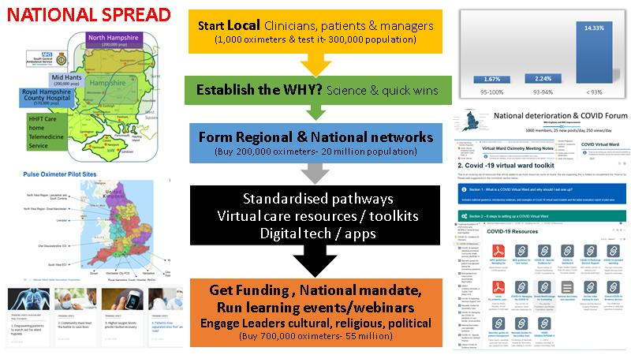

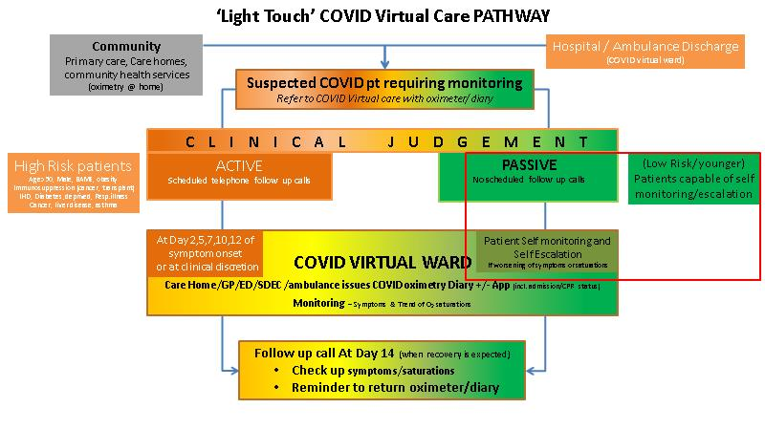

Commentary from the audience
“The NSW documents [on protocols for supported discharge and remote monitoring and O2 dependence] are fantastic: https://aci.health.nsw.gov.au/covid-19/communities-of-practice. I’m also told NSW has made oximeters available to the community via pharmacies to pick up when advised. This would be great.”

“Approach aligns well with the North Western Melbourne COVID+ Pathway, which has had a GP-led low risk pathway from the beginning i.e., since the second wave last year. Keen to understand impact of vaccination so we can evolve the pathway over time and engagement of culturally diverse communities with remote monitoring.”

“Thanks for your presentation Matthew. A great challenge for us all to think about the virtual models we develop as the patient being a key member as the healthcare team who is driving and leading the work.”

“So glad to see the spread across non-COVID conditions as there is so much to gain and better patient experience.”

“We ran a similar remote monitoring project here in Vic using similar easy to use oximeters and using risk stratification and AI to help with monitoring and decision support. Scalability and being able to support in remote environment were essential, as well as ensuring we had scalable ratios between health care workers and patients. We also found symptoms capture integral.”

“Greater consistency in the implementation of the Victorian COVID+ Pathway across health services and integration with primary care, supported by self-monitoring, would be very much welcomed.”

“Strong collaboration between primary and tertiary care will assist stratification monitoring. Sats monitor and remote monitoring of low risk can be monitored by primary care nurses at general practice who are used to monitoring those with chronic conditions.”

“We have started to work with service partners to source & develop translated resources for self-care etc it would be wonderful if we can centralize good quality information ASAP.”

“Would be nice to have resources in a central repository and to share them around. Totally agree that we reinvent the wheel too often.”

“I like your simple Oximeter patient info https://www.england.nhs.uk/coronavirus/wp-content/uploads/sites/52/2020/06/Pulse-Oximeter-Easy-Read-final-online-v4.pdf. This is what we used in locally as well. Patients found it easy to use and quite straightforward.”

