Purpose: This guide is for pharmacies and medical clinics who require installation of the SafeScript Notification App in order to receive SafeScript notifications on their computers.
SafeScript notifications are red, amber, or green messages that pop up on the screen when you prescribe or dispense a medication that is monitored in SafeScript. The notifications help to identify when there is information you should view in SafeScript.
Key point: To receive SafeScript notifications, install the Notification App on every prescribing or dispensing computer at your practice or pharmacy.

Before you start
- Ensure your clinical software is connected to a Prescription Exchange Service (PES).
For more information, contact SafeScript Technical support on 1800 723 379.
- Ensure you are running the latest version of your clinical software.
- Depending on your practice or pharmacy’s computer setting, you may require a person who has administration permissions on your computer to install the notification app (for example, this may be your practice manager, pharmacist-in-charge, or IT administrator).

Download and install the Notification App
- Download the SafeScript Notification App installer by choosing one of the following links;
    - To install on a Windows PC:
      - https://download.safescript.vic.gov.au/notificationclient/integrated/setup.exe
    - To install on a MAC:
      - eRx Customers: https://download.safescript.vic.gov.au/notificationclient/integrated/osx_setup.dmg
      - MediSecure Customers: https://download.safescript.vic.gov.au/notificationclient/zerointegration/osx_setup.dmg
    - If you are using terminal services:
      - https://download.safescript.vic.gov.au/notificationclient/terminalservices/setup.exe
Note: If you are not sure which file to download. Please check with your clinical software vendor.
- From your download location, double-click the SafeScript Notification App Setup.exe file to launch the installer.
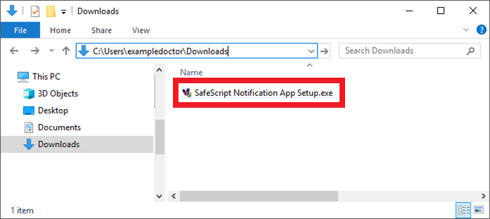
Result: You are prompted "Do you want to allow this app to make changes to your device?".
- Click Yes.
Result: The SafeScript Notification App is installed on your computer, the Notification App logo appears in your taskbar, and a test notification is displayed.
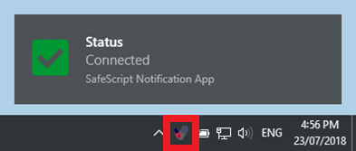
Note: The Notification App will now run automatically on this computer whenever it is restarted.
- Repeat the installation process on all of the prescribing or dispensing computers at your practice or pharmacy.

How the Notification App works
The Notification App runs in the background. When you prescribe or dispense a prescription for a monitored medicine, SafeScript displays a pop-up notification to help you quickly identify when you need to view information in SafeScript.
SafeScript notifications will start appearing when SafeScript becomes available, from October 2018.
Notification colour | Example | Details
Red | 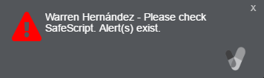 | There is a clinical alert which requires review.  The notification stays on the screen until you click it.
Amber | 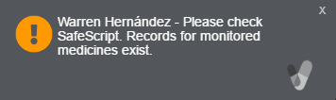 | There is information in SafeScript which requires review.  The notification stays on the screen until you click it.
Green | 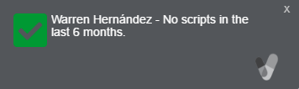 | The patient has no recent history; or has only had monitored medicines prescribed by a single prescriber and there are no alerts.  The notification disappears after a short time.

Access SafeScript from a notification
Pre-requisite: Each practitioner needs to register for access to SafeScript.
- Click the notification to launch SafeScript in your browser.
Result: You are prompted to log into SafeScript.
- If you have already logged in on that computer that day, you are prompted to enter your six-digit PIN. Otherwise, you are prompted to authenticate, and create a PIN for the day.
Result: After you log in, the patient’s prescription record is displayed. Use this information to determine the appropriate course of action for the patient’s care.

Connectivity to SafeScript
The Notification App automatically connects to SafeScript. If this connection is interrupted (for example, if you disconnect from the internet), the SafeScript icon in your Windows taskbar turns red, and a status notification is displayed. It will continue to display periodically while you are offline.
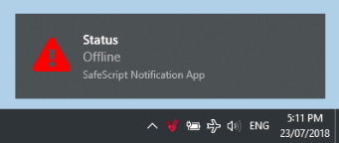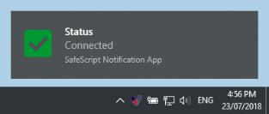
When the connection is restored, the icon returns to its normal colour, and a notification is displayed.
If you performed any prescribing or dispensing while offline, you will now receive any SafeScript notifications for those prescriptions.

Check for updates
The Notification App will normally update itself automatically. If you need you can also update it manually.
- Right-click the Notification App icon in your Windows taskbar, then click About.
Result: The About screen is displayed.
- Click Updates.
Result: The Notification App checks whether a newer version is available.
  - If you are already up-to-date: A message is displayed.
  - If an update is available: Click Install.
Results: The Notification App downloads and installs the update, then restarts.
Note: Repeat the above steps on each computer with the Notification App.

Test whether notifications are working
In some cases, Windows settings may interfere with notifications. To check whether notifications can be displayed:
- Right-click the Notification App icon in your Windows taskbar, then click About.
Result: The About screen is displayed.
- Click Test Now.
Result: If you see the following test notifications, there should be no issue with your Windows settings.
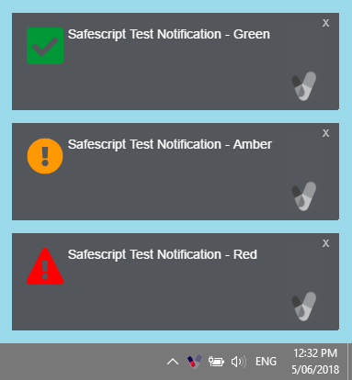
If the test notifications do not display, please contact SafeScript technical support on 1800 732 379.

