Department of Health and Human Services
The Director’s Toolkit
A resource for Victorian health service boards
Chapter 2: Clinical Governance

This document is available as a PDF on the internet at <https://www2.health.vic.gov.au/hospitals-and-health-services>
© Copyright, State of Victoria, Department of Health and Human Services, December 2020.
This publication is copyright. Apart from any use permitted under the Copyright Act 1968, no part may be reproduced by any process, nor may any other exclusive right be exercised, without the permission of the Department of Health and Human Services, 2020.
Authorised and published by the Victorian Government, 50 Lonsdale Street, Melbourne.
Except where otherwise indicated, the images in this publication show models and illustrative settings only, and do not necessarily depict actual services, facilities or recipients of services.
This Toolkit is provided for general information only. The State of Victoria does not represent or warrant that the content of this Toolkit is accurate, authentic or complete or that the information contained in this Toolkit is suitable for your needs. You must not rely on this Toolkit as a statement of Government policy, except where clearly stated. You should assess whether the information is accurate, authentic or complete and where appropriate, seek independent professional advice.
To the extent permitted by law, the State of Victoria excludes liability for any loss caused by use or reliance on this Toolkit. The Department of Health and Human Services may amend or withdraw material contained in this Toolkit at any time without notice.
This Toolkit provides links to external websites. The State of Victoria does not control and accepts no liability for the content of those websites or for any loss arising from use or reliance on those websites. The State of Victoria does not endorse any external website and does not warrant that they are accurate, authentic or complete. Your use of any external website is governed by the terms of that website. The provision of a link to an external website does not authorise you to reproduce, adapt, modify, communicate or in any way deal with the material on that site.

About this Toolkit
This Toolkit is a resource to assist public health service board directors and other interested parties to better understand the role of directors of health service boards and the operating environment of the public sector health service entities they govern.
The development of the Toolkit is in response to DHHS recognising the need for a stronger emphasis on public sector health governance and enhancing the support tools available to directors of health services. Recent reports such as the ‘Targeting Zero’ review of quality and safety in the Victorian public health service have highlighted the need for greater oversight of clinical care systems across the state in the delivery of high quality, safe, person-centred care.
This accountability starts with the board.
The board of directors is held to be ultimately responsible for virtually every aspect of the health service’s activities. However, it is impractical and undesirable for a board to attempt to supervise minutia associated with the health service’s operation.
Good corporate governance requires a balance between compliance (with codes, regulations and standards) and oversight of operational and financial performance. The core purpose of good governance in health services is ensuring the delivery of high quality, safe and effective person-centred care.
Boards of high performing health services:
- understand the board’s role in governance
- discharge their legal duties
- ensure accountability to stakeholders
- understand stakeholder and management expectations
- effectively use board committees to enhance governance
- build a talented management team
- champion a productive and ethical culture
- make informed decisions
- actively contribute to strategy, and closely monitor strategic effectiveness
- ensure a disciplined approach to risk governance
- receive independent assurance
- actively engage externally on current and emerging issues relevant to their organisation and the political, social, and economic environment in which it operates.
By understanding the environment and the pressures the health service and its management face, the board can assure itself that the material risks are being identified and, most importantly, being managed. Such an approach enables the board to exercise its responsibilities in an active rather than a reactive manner and minimises ‘surprises’. The board should be alert to the red flags or risk indicators that may impact the organisation’s performance.
In preparing this Toolkit, DHHS, in its stewardship role, has not attempted to establish a model or pattern for the optimum composition and conduct of a health service board and instead has provided insight and guidance as a practical resource for health service directors.
For guidance, on the initial pages of chapters 1–14, there are a number of red flags, plus a list of pertinent questions that directors of health services may ask.
In addition, the Toolkit documents and summarises information on roles and responsibilities and consolidates statutory and policy-based elements, including those in the Health Services Act 1988 (Vic), the Ambulance Services Act 1986 (Vic), the Mental Health Act 2014 (Vic), other acts, and policy and administrative documents.
Although this Toolkit sets out material of key importance to health service boards, the boards of other entities, such as, ambulance services, mental health services, aged care services, community health centres, and other private and not-for-profit entities delivering Victorian Government health services, may also find the material useful.

Historically, health service boards focussed on financial issues and chief executive performance. Quality of care was assumed, its oversight was left to clinical leaders and it tended to be poorly measured. That approach is being rewritten today, spurred by mounting evidence that organisational factors, including high-level leadership, influence quality of care.*

*Source: Bismark, Marie M, Walter, Simon J and Studdert, David M, The role of boards in clinical governance: activities and attitudes among members of public health service boards in Victoria, Australian Health Review, (2013), 37, p682–687. Available from the CSIRO here: http://www.publish.csiro.au/ah/pdf/AH13125

Acronyms and definitions
The following acronyms and definitions were current at date of publication.
Acronym | Full description
AACC | Aged Care Complaints Commissioner
AAQHC | Australasian Association for Quality in Health Care
AAS | Australian Accounting Standards and Interpretations
AASB | Australian Accounting Standards Board
ABF | Activity based funding
ACAS | Aged Care Assessment Services
AGM | Annual General Meeting
AHPRA | Australian Health Practitioner Regulation Agency
AMA | Australian Medical Association
ASA | Ambulance Services Act 1986 (Vic)
ASIC | Australian Securities and Investments Commission
AV | Ambulance Victoria
BBCAC | Building Board Capability Advisory Committee
BCV | Better Care Victoria
BMAC | Boards Ministerial Advisory Committee
CBC | Council of Board Chairs
CEO | Chief Executive Officer
CFO | Chief Finance Officer
COO | Chief Operations Officer
DHHS | Department of Health and Human Services
DMS | Director of Medical Services
DPC | Department of Premier and Cabinet
DPI | Declaration of Private Interests
DRG | Diagnosis Related Groups
DSM-V | Diagnostic and Statistical Manual of Mental Disorders, 5th revision. This the manual used primarily in the USA (but also widely used in Australia in addition to the ICD-10) for classification of mental disorders.
DTF | Department of Treasury and Finance
FMA | Financial Management Act 1994 (Vic)
GiC | Governor in Council
HCC | Health Complaints Commissioner
HEER | Health Executive Employment and Remuneration Policy
HMI | Hospital Mortality Indicator
HPV | Health Purchasing Victoria, trading as HealthShare Victoria
HSA | Health Services Act 1988 (Vic)
HSMR | Hospital Standardised Mortality Ratios
IBAC | Independent Broad-based and Anti-Corruption Commission
IHPA | Independent Hospital Pricing Authority
ICD-10 | International Statistical Classification of Diseases and Related Health Problems, 10th Revision. This is the disease classification used in Australia cf. DSM-V  Notes:  - a CM suffix refers to Clinical Modification  - an AM suffix refers to Australian Modification  - a different number instead of 10 will refer to a different revision e.g. 9th revision
KPI | Key performance indicator
LHN | Local hospital network
LOS | Length of Stay
LTI | Lost Time Injury
MHA | Mental Health Act 2014 (Vic)
MHCC | Mental Health Complaints Commissioner
MPS | Multi Purpose Service
NAESG | Non Admitted Emergency Services Grant
NDIS | National Disability Insurance Scheme
NEP | National Efficient Price (as determined by IHPA)
NSQHS Standards | National Safety and Quality Health Service Standards
NWAU | National Weighted Activity Unit against which NEP is paid (national equivalent of WIES)
OH&S | Occupational Health and Safety
OHSA | Occupational Health and Safety Act 2004 (Vic)
OVA | Occupational Violence and Aggression
PAA | Public Administration Act 2004 (Vic)
PDA | Protected Disclosures Act 2012 (Vic)
PFG | Policy and Funding Guidelines (updated every year)
PMF | Performance Monitoring Framework
PRISM | Program Report for Integrated Service Monitoring
PSRACS | Public Sector Residential Aged Care Services
SCV | Safer Care Victoria
SoP | Statement of Priorities
SRHS | Small Rural Health Services
TRP | Total remuneration package (for an executive salary)
VAGO | Victorian Auditor General’s Office
VAHI | Victorian Agency for Health Information
VCC | Victorian Clinical Council
VGRMF | Victorian Government Risk Management Framework
VHA | Victorian Healthcare Association
VIFMH | Victorian Institute of Forensic Mental Health, also known as ‘Forensicare’
VMIA | Victorian Managed Insurance Authority
VMO | Visiting Medical Officer
VPSC | Victorian Public Sector Commission
WIES | Weighted Inlier Equivalent Separation

Key definitions used in this Toolkit
Definition | Full description
Consumers | ‘patients’ and ‘consumers’ are terms often used to describe users of health services. In this Toolkit, ‘consumers’ has been used, unless it is part of a publication title or a quotation, as patients are not the only users of health services.
Directors | In this Toolkit, all board directors are referred to as directors or chairs as applicable, and the roles and responsibilities are outlined as applying to all boards. This includes members of the board of Health Purchasing Victoria, (trading as HealthShare).
Enabling Acts | Health Services Act 1988 (Vic) (HSA), Mental Health Act 2014 (Vic) (MHA), Ambulance Services Act 1986 (Vic) (ASA) (in some circumstances other acts may also be applicable).  If one Enabling Act is referenced such as the HSA, the reader should presume the other Enabling Acts may also apply and should check the other Enabling Acts for clarification.
HLA Bill | Health Legislation Amendment (Quality and Safety) Bill 2017 was introduced into Parliament in June 2017 in response to the Targeting Zero report and the Government’s response, Better, Safer Care. This Bill amends the Enabling Acts for health services, in particular relating to obligations for board directors and the composition and conditions of appointment of boards.
HPV | Health Purchasing Victoria (HPV) is the organisation established to assist the Victorian health sector ease cost pressures through collective, strategic purchasing for all health services. From 1 January 2021 HPV trades as HealthShare Victoria.
Minister | In this Toolkit, Minister refers to the Victorian Ministers for Health, Ambulance Services, and Mental Health where applicable.
Patient Experience Survey | Collects data from consumers of health services in Victoria and is used as a key feedback mechanism in clinical governance to identify areas for improved provision of service or management of risks. It is a critical stakeholder engagement and performance management / monitoring tool.
People Matter Survey | Regular survey of health service staff undertaken by health services to identify workforce engagement, participation, concerns or other feedback. It is a critical stakeholder engagement and performance management / monitoring tool.
Health services | The term ‘health services’ is used to refer to both the ‘public hospitals’, ‘public health services’ and multi-purpose services listed in the HSA, as well as Ambulance Victoria (ASA) and VIFMH (MHA) unless otherwise specified.
Secretary | The Secretary of the DHHS.
Victorian Clinical Council | Victorian Clinical Council is a council of clinicians and consumers whose purpose is to provide leadership and direction to make the health system safer and provide better care to all Victorians.

- Institute of Public Finance and Accountancy, United Kingdom. Available from the Joseph Rowntree Foundation here: https://www.jrf.org.uk/report/good-governance-standard-public-services

Clinical governance
A health service’s core product is to provide safe, effective, person-centred care to patients across a range of service types. Clinical governance must therefore be central to the board’s role, with compliance requirements and duty of care obligations paramount to strategy, risk and performance oversight

Questions that directors of health services should ask
- Am I fully aware of my responsibilities with respect to the provision of clinical services?
- How does the board comfort itself that clinical governance is being managed effectively throughout the organisation?
- What are the major clinical risk areas that the health service is exposed to?
- Does the board, and do I, have the appropriate clinical and governance skills to monitor the provision of safe clinical care services and identify any emerging risks?
- Is the information reported by management relevant to the health service’s key clinical risks?
- How does the board visibly support consumers, clinicians, managers and staff to achieve safe, effective care?
- Does the board have an understanding of clinical risk thresholds and tolerances, to enable identification and escalation of risk mitigation actions?
- Does the board have a clear view of how our clinical services perform against other services?
- What does this information/data mean? Is it good or bad?
- How does it compare to ‘normal’ performance?
- If there is a problem identified:
- What is being done to remedy the problem and/or improve performance?
- How will the board and the health service be able to monitor this?
- What milestones or targets could monitor improvement/success?
- When is the next report on it?
- Does the board regularly engage with clinicians to detect and understand issues?
- Does our health service have the required accreditation in place to enable it to provide the relevant clinical services?
- What checks and balances are in place to monitor the effectiveness of our clinical risk management strategies?

Red flags
- Directors are unable to articulate the top clinical risks faced by their health service.
- Clinical reports from management are approved by the board without question.
- The board rarely, or never, hears from clinical staff about clinical matters.
- Staff / workplace culture issues are not recognised as risks to clinical safety (for example, low response rates to staff surveys and/or poor rates of engagement with safety culture questions in the People Matter Survey).
- There are no board directors with clinical practice skills on the board.
- Variances and trends in clinical risk performance data is not discussed or questioned by directors.
- Performance reports are provided in an ad hoc manner and/or an inconsistent format.
- The majority of the board’s directors leave questioning of clinical performance data to the 1 or 2 clinical specialists on the board.
- No benchmarking of clinical performance is undertaken.
- Clinical risk issues emerge ‘without warning’ and the board spends too much time dealing with emergency clinical risk situations.
- No director is inducted or trained in clinical governance.
- Report acronyms and variances are not explained or annotated.

Introduction to the chapter
Safe, high quality, person-centred care is the core objective of Victorian health services. In response to clinical governance failures across not only Victoria, but other states and countries, the focus on ensuring high quality care as a health service’s number one priority has been re-emphasised through the establishment of SCV and the update of the Clinical Governance Framework.
Effective leadership, risk oversight, clinical practices and consumer and workforce engagement have been highlighted as critical to achieving the policy objectives of the Victorian Government’s ‘Targeting Zero’ policy are met.
This chapter contains:
- details of the board’s role in clinical governance
- the Victorian Government’s Clinical Governance Framework (as developed and published in June 2017 by SCV).

2.1 The role of the board in clinical governance
The board has ultimate accountability for the safety and quality of care. The development of the Victorian clinical governance framework is based on several key principles:
- excellent consumer experience
- clear accountability and ownership
- partnering with consumers
- effective planning and resource allocation
- strong clinical engagement and leadership
- empowered staff and consumers
- proactive collection and distribution of critical information
- openness, transparency and accuracy
- continuous improvement of care.

Together, boards and management are responsible and accountable for ensuring the systems and processes are in place to support clinicians in providing safe, high-quality care, and in ensuring clinicians participate in governance activities. Boards are responsible for monitoring the effectiveness of systems and processes at a higher level than health service management.
Every staff member has a role in the patient’s journey however the board has ultimate accountability for ensuring the safety and quality of care provided within their health service.
The responsibility for designing and implementing systems and monitoring the effectiveness of clinical care is appropriately delegated to managers and healthcare professionals with specific expertise. Clinicians and clinical teams are responsible and accountable for the safety and quality of care they provide. Kitchen staff, cleaners, suppliers, contractors and allied health workers also play a key role in ensuring safe and effective, person-centred care. Everyone has a part to play, but the board has ultimate accountability.

What is clinical governance?
Clinical governance is the integrated systems, processes, leadership and culture that are at the core of providing safe, effective, accountable and person-centred healthcare underpinned by continuous improvement. As health services go about providing care to consumers, the clinical practices, the culture of the organisation and the checks and balances in place to ensure this care is of the highest quality – all form part of the clinical governance framework.
SCV developed a clinical governance framework titled Delivering high-quality healthcare – Victorian clinical governance policy framework. This framework explains and details the importance of providing safe, quality care and the key elements of an effective clinical governance system.

Clinical performance reporting
As a key source of information, clinical performance reporting should be a regular item on a board’s meeting agenda. There is a range of clinical governance reports that health service boards should regularly monitor. The board should ensure management provide systematic reports across the range of quality and safety assurance activities. Examples of clinical reports are provided in Appendix 8. For additional guidance, contact SCV.

Reading and interpreting clinical reports
Boards must review and interpret clinical data on a regular basis. Whilst many board directors do not have a clinical background, directors should ask various questions to assure themselves and discharge their obligations and duties. Some questions are set out below:
- What are the variances (differences or changes) in current performance against previous performance/actuals? (i.e. how do the results compare to this time last year, last month?)
- What are the variances (differences or changes) in the actual performance against targets or budgets?
- Is the variance good/favourable or bad/unfavourable (noting that an increase in one measure can be good or bad depending on the measure)? Am I satisfied with the explanation for the variance?
- Has management provided me with enough information to understand the reason for a good/favourable outcome? Do I understand how good outcomes relate to other aspects of health service governance (e.g. DHHS funding, monitoring)?
- Has management provided me with enough information to understand the reason for a bad/unfavourable outcome?
- Am I confident that the steps being taken to address an unfavourable performance outcome, including the process/tracking in place to monitor the effectiveness of the steps, are working?
- Am I satisfied with the explanation of the context of the variance (e.g. trends over time, comparison with peers, comparison with state average, comparison with benchmarks and targets)? Do management’s explanations seem reasonable based on what I know about the health system and key clinical risks?
Further guidance on understanding data is in Chapter 14: Understanding Data of this Toolkit.

DHHS’ role in clinical governance
DHHS has overall responsibility for ensuring that health services achieve the Ministerial policy objectives for Victoria’s public health sector. Their role is to:
- establish and communicate the policy objectives of all health services, of which safe, effective clinical outcomes is a priority
- provide appropriate mechanisms to support health services meet these clinical objectives, including resources, training and tools (such as this Toolkit) to assist boards, directors and management fulfil their duties
- work with relevant agencies to provide guidance and support on key areas of priority:
  - SCV is responsible for monitoring and improvement of the quality and safety of case delivered across the Victorian health system, with the goal of achieving zero avoidable patient harm.
  - BCV is responsible for advising the Minister on health sector innovation that will support the State’s healthcare reform agenda in light of increasing pressure on health services.
  - VCC comprises senior clinicians from across the State – including representatives from SCV – responsible for establishing a forum for clinicians to provide clinical expertise the Government, DHHS and health services on how to make the system safe and provide better care for all Victorians.

2.2 Victorian Clinical Governance Framework
Safer Care Victoria published an updated and revamped Victorian Clinical Governance Framework in June 2017 titled Delivering high-quality healthcare – Victorian Clinical Governance Framework. Providing the most up to date guide for clinical governance in Victoria the framework is centred on safe, effective, person-centred care, with five domains of good clinical governance:
- Leadership and culture
- Consumer partnerships
- Workforce
- Risk management; and
- Clinical practice.

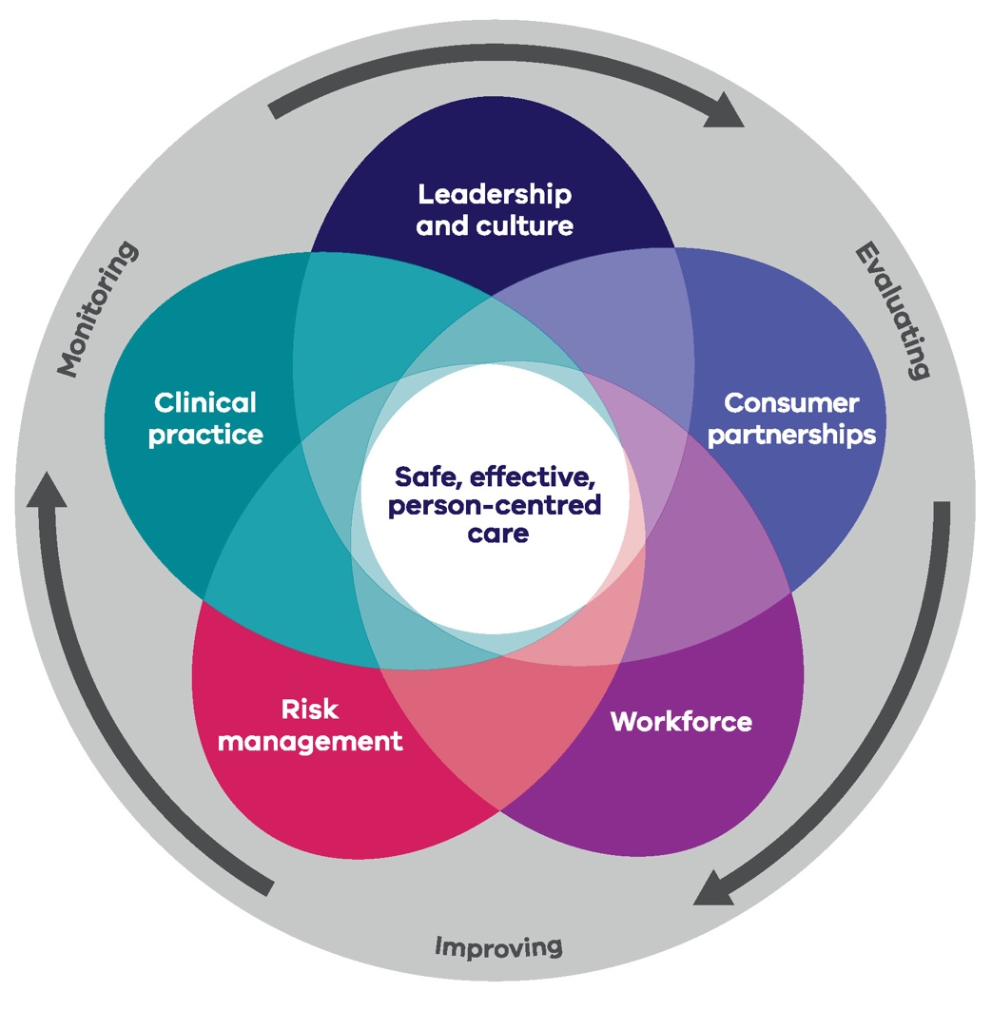

Under the framework boards should:

Review their clinical governance structure to ensure it is consistent with the framework

frequently evaluate their clinical governance systems and processes to drive continuous improvement

ensure adequate internal documentation in line with the framework.

Please note, these acts may have been amended and/or updated after this Toolkit was published. When reviewing, please review the most recent version.
Available from: https://www.dhhs.vic.gov.au/publications/targeting-zero-review-hospital-safety-and-quality-assurance-victoria
SCV. Delivering high-quality healthcare – Victorian clinical governance framework. 2017 June. Available from: https://www2.health.vic.gov.au/hospitals-and-health-services/quality-safety-service/clinical-risk-management/clinical-governance-policy
Available from: https://www2.health.vic.gov.au/hospitals-and-health-services/quality-safety-service/clinical-risk-management/clinical-governance-policy
Available from: https://www2.health.vic.gov.au/hospitals-and-health-services/quality-safety-service/clinical-risk-management/clinical-governance-policy

